PROCEDURE FOR QSE TRADING AND CHECKING ENRON PORTFOLIO

Ercot Portal Illustrations

All trading, whether hourly, next day or term, will take place between Qualified Scheduling Entities, QSE’s. In the hourly market, trades must be submitted 2 hours before hour ending. We will refer to this as Hour ahead QSE trading. This means, for example, that you must submit trades before 8 am for hour ending 10. We may simply buy from Dynegy and sell to Reliant for hour ending 10. That would be an example of a back to back QSE trade. These, of course can be entered into for balance of the day, or , just one hour.
Remember that all schedules that are sent in must be balanced.

Our company will be buying to cover obligations in various areas of the state. These obligations may be retail load, or may be term sales agreements. In this case, you may recognize that we have entered a QSE purchase, then we will increase our load zone in a given area to achieve a balanced schedule.

An example of hourly trading would include buying from Dynegy then selling to Reliant, or, buying from Dynegy and increasing our load by the same amount. Bottom line is that you must be balanced.

We can submit these trades through the Ercot Portal. Enron is also developing our own system (QSE Market Operating System) that will interface with Ercot’s Portal. We will eventually be submitting bids though this platform.

See Below:

Make sure that you change the date and the correct hour that you are trading.

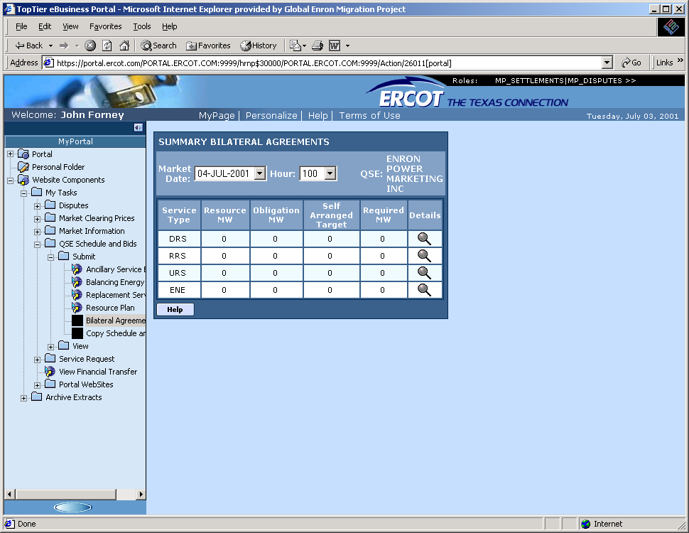

Hilight the ENE row by clicking on the hour glass in the detail column. This gives you access to our existing QSE trades, which may have been day ahead or hour ahead in nature.

See the following illustration:

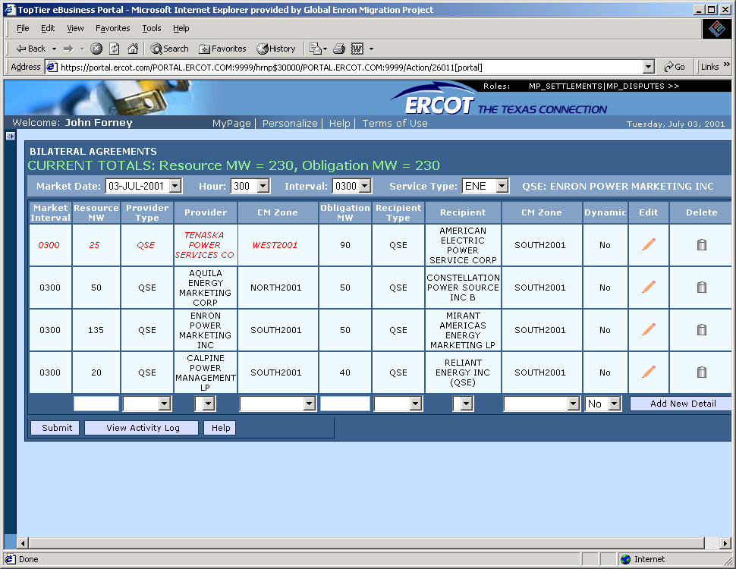

If you are looking to buy an additional 30 mw’s of energy from Calpine for hour ending three, you will notice that we already have an existing 20 mw purchase from them. You will edit this purchase by clicking on the pencil on the line corresponding to Calpine.
Increase the purchase by 30 to the new total of 50 mw’s.
You should be temporarily out of balance, as you havent put in your sale. You can check this by reviewing your totals at the top of this page.

See the illustration:
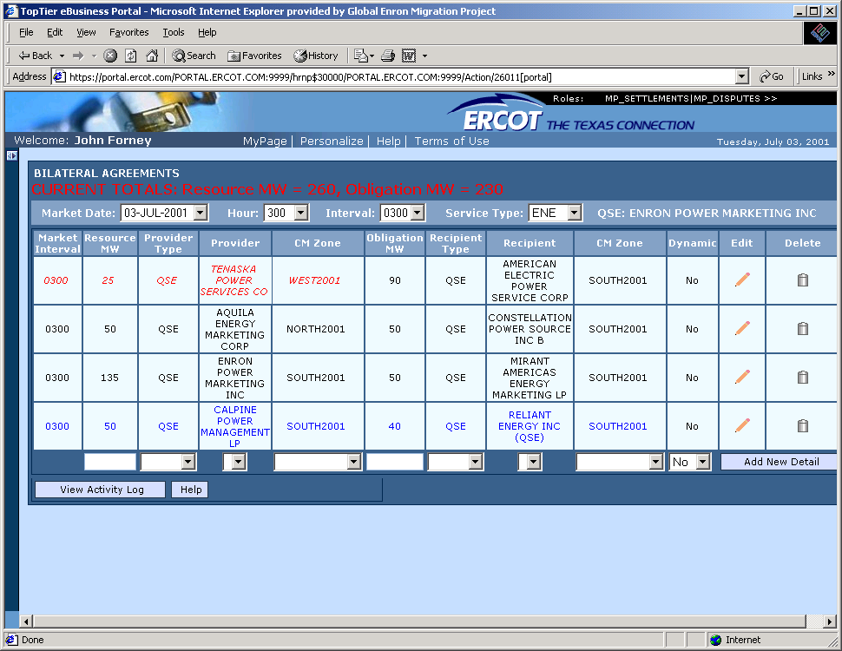

Now you must put in your load side. If you are doing a QSE sale to an existing counterparty listed above, simply increase their volume in the same way as your supply.
You must add to an existing counterparty either on a supply or market side. You cannot send a new, duplicate “CALPINE” entry if one already exists.
If you need to add a new counterparty to either the sales or the supply side, you may do so in the fields at the bottom of the page and press ADD NEW DEAL.

See below where I have added a sale to Dynegy:

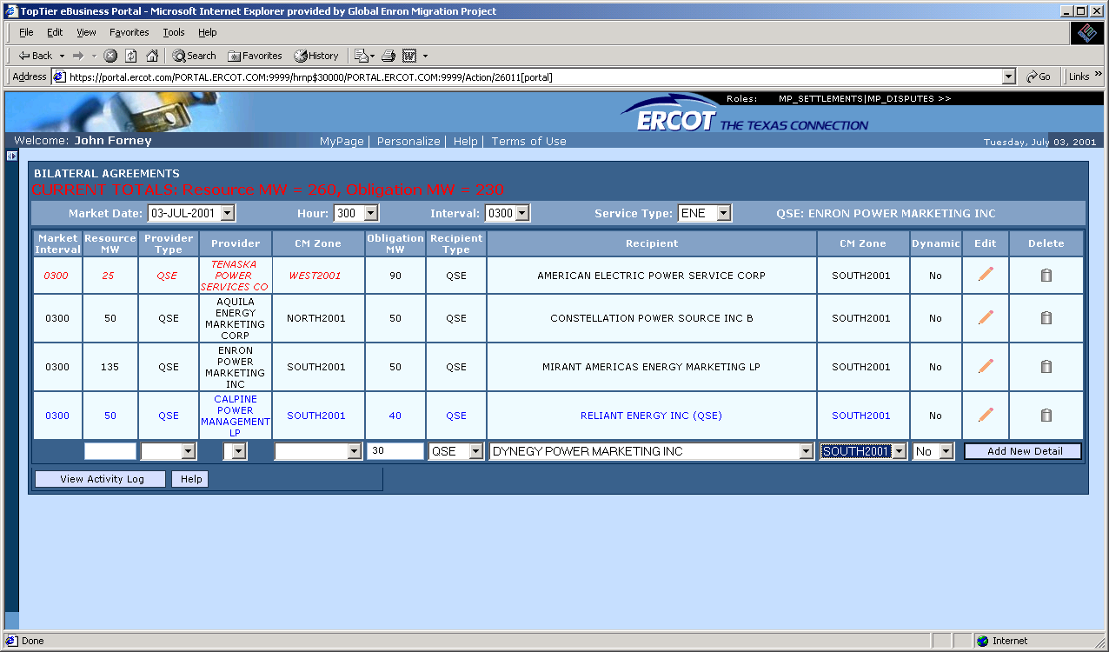

Remember to indicate volume, QSE, and counterparty. Press the ADD NEW DEAL and SUBMIT. UNFORTUNATELY, YOU MUST SUBMIT A SCHEDULE FOR EACH QUARTER HOUR. SEE INTERVAL AT TOP OF PAGE. IN OUR EXAMPLE, WE WOULD HAVE TO SEND ONE FOR HOUR ENDING 0300, 0245, 0230, AND 0215. ERCOT ISO SETTLES EACH QUARTER HOUR AND NEEDS TO SEE THESE SCHEDULES MATCH.

REMEMBER THAT ALTHOUGH CALPINE AND RELIANT EXIST ON THE SAME ROW, THEY ARE NOT NECESSARILY “ROUTED “ TO EACH OTHER. THE ERCOT ISO APPARENTLY JUST GROUPS THESE ON THE SAME LINE ACCORDING TO SOME INTERNAL PROTOCOL . PLEASE REMEMBER THAT THIS IS A POOL AND SPECIFIC PATHS DON’T EXIST, EXCEPT ACROSS THE TIES LEAVING/ ENTERING ERCOT. AN EXCEPTION TO THIS RULE EXISTS WHEN YOU SEND ENERGY ACROSS A CONGESTED PATH – THIS TO BE COVERED LATER.

COLOR CODING: Any line that you edit turns blue. After you have balanced and you have submitted to the ISO, then this line will turn green.

Day ahead/ hour ahead schedules for a given counterparty are black if they are in balance.

Day ahead/Hour ahead schedules for a given counterparty are red if they are not in balance.

Please remember that for every transaction that we enter, our counterparty has to enter a like transaction (BY THE DEADLINE FOR THE APPLICABLE TRADE HOUR).
If you have submitted your purchase from Calpine and notice that we are out of balance with them, then you should infer from this that they have not submitted their schedule. If they don’t make the deadline then Enron is subject to balancing penalties imposed by the ERCOT ISO. We need to report any such incidents to me or Smith in order to track and uinderstand the settlements and to possibly bill Calpine for non-performance.

THE FOLLOWING IS AN EXAMPLE OF HOW TO INCREASE OUR LOAD:
We would want to do this to cover a retail or Service customer sale in a given region.
For example, if we have higher usage from a retail customer than scheduled, we may want to take additional power to them in order to avoid balancing penalties.

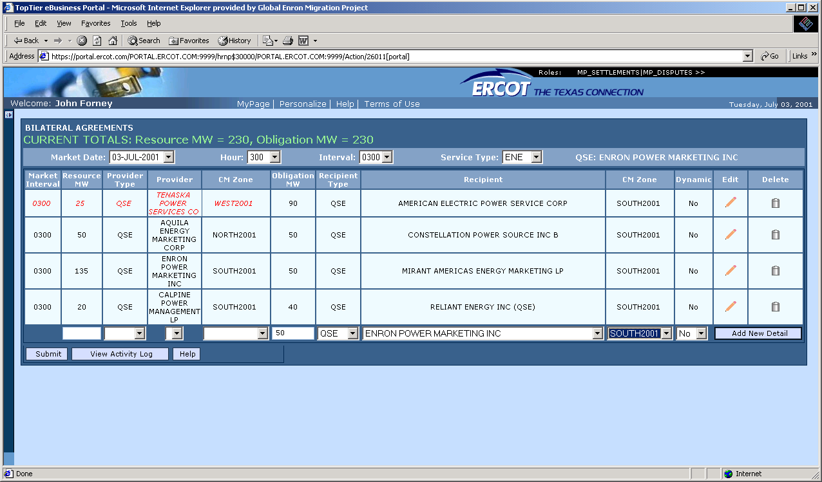

Please note that we have added a sale to ourselves, Enron Power Marketing, in the proper load zone. In the example above, we have not yet hit Add New Deal.
If we had, then we would temporarily be out of balance, as no supply side had been added yet.
Make sure that you schedule in the correct ZONE. For example , if you purchase power from Calpine in South Zone, and put in your sale to either load, or another counterparty in the North, then you are ,effectively, scheduling power from South to North.
This path South to North, may become congested and we would be subject to congestion fees.
Conversely, if you buy power in the North, and schedule to load or sale to another QSE in the South, you may be collecting money for congestion relief if you are counterflowing.

AN IMPORTANT REMINDER WHEN SUBMITTING SCHEDULES:

The ISO settles and publishes balancing energy prices for each quarter hour. That requires us to submit QSE trades for each quarter hour. Currently, you must add new deals for each quarter hour. There is no copy function that I know of. This replication will be eliminated when Enron’s system , QSE MOS (Market Operating System) has been completed. More info no this system is to follow.

This is cumbersome and annoying and our counterparties will have to do this as well.

