Product Improvement BULLETIN 2000-004

Blade Tip Clearance Probes
Rev. No: | 0 | Rev. Date: | 08/31/00 | Created: | 08/31/00

Notice to Product Improvement Bulletin Users
This Combustion Turbine Product Improvement Bulletin has been distributed to customers of Siemens Westinghouse, without charge, as a Proprietary document. The purpose of this publication is to provide combustion turbine users with information considered useful in the maintenance and operation of Siemens Westinghouse combustion turbines. The information in this bulletin represents a compendium of ideas and experiences by Combustion Turbine Engineering, Operating Plant Service, other Siemens Westinghouse Divisions, Siemens Westinghouse suppliers, and customers. These publications are provided to the user so that they will ultimately be translated into improved reliability, efficiency, and maintainability.
Siemens Westinghouse reserves the right to withdraw any publication at any time without notice. Siemens Westinghouse does not warrant applicability to any specific combustion turbine engine (or system) since bulletins are written to apply to most, not necessarily all, combustion turbines in most circumstances. In addition, Siemens Westinghouse has no control over the implementation of a product improvement bulletin or the mechanical configuration of customer-owned and maintained equipment.
It is the sole responsibility of the user to carefully consider the data set forth in the product improvement bulletin, to determine if the information is specifically appropriate to the user’s specific engine (or system) in a particular circumstance, and to exercise reasonable care and skill in the implementation of the suggestions provided therein.
NO WARRANTY, EXPRESSED OR IMPLIED, IS MADE FOR THE INFORMATION AND DESCRIPTIONS CONTAINED HEREIN WITH RESPECT TO TITLE, FITNESS FOR A PARTICULAR PURPOSE, OR MERCHANTABILITY.
Siemens Westinghouse will not be responsible in contract, in tort (including negligence), or otherwise for loss of use of equipment or plant, cost of capital, infringement of patents, loss of profit or revenues, cost of replacement power, ADDITIONAL expenses in the use of existing power facilities, claims against the user by his customers or any special, indirect, incidental, or consequential damage or loss whatsoever. Under no circumstance will any information in this product improvement bulletin become part of, modify, or negate in any way any previous agreements, contracts, or commitments unless both the user and Siemens Westinghouse agree in writing.
While Siemens Westinghouse does sincerely attempt to eliminate errors and inaccuracies, on occasion Siemens Westinghouse finds it necessary to correct, clarify, and even withdraw information as experience is gained and feedback is received from the field. Your constructive criticism and comments can help us to provide more useful publications in the future.

Product Improvement BULLETIN 2000-004

Blade Tip Clearance Probes
Rev. No: | 0 | Rev. Date: | 08/31/00 | Created: | 08/31/00

THE PRODUCT CHANGE OR FEATURE
This modification will provide access for blade path tip clearance probes to be temporarily placed at four axial locations in W501F compressors. The probes will aid in field alignment of the compressor blade rings to the compressor rotor upon initial installation or as part of compressor maintenance when the blade rings are removed or the rotor is realigned.

APPLICATION
Frames: W501F

BENEFITS PROVIDED

Rotor to Cylinder Alignment

Blade Tip Clearances
The horizontal alignment of the rotor to the blade rings has been set with measurements at the casing splitline upon assembly. The vertical alignment of the rotor has been achieved with measurement at the top of the rotor. With this improvement, blade tip clearances can be better verified as equalized around all 360 degrees of the blade ring. This will help maintain optimum compressor performance. With tighter blade tip clearances in the W501F engines, blade ring alignment in the compressor is important in reducing the potential for heavy tip rubs in the compressor. Implementation of this modification can increase the accuracy of the blade ring alignment, lower the potential for blade tip rubbing, and reduce performance degradation associated with increased compressor blade tip clearance due to alignment.

DESCRIPTION
The modification will provide radial holes at four planes through the compressor and compressor-combustor cylinders. At each plane, four radial holes are distributed around the machine’s circumference and pass through cylinder and compressor blade rings. The clearance probe fits into a counterbore in the compressor blade ring to provide the exact radial location of the flowpath surface relative to the blade tips. Probes will be provided for field alignment of the blade rings to the rotor. The probes will only be used during the installation of a new machine or during an outage when compressor covers and blade rings are removed. The probes will be removed after the field alignment is complete. Plugs will be provided to close every hole in the blade rings and cylinders during operation of the unit.

DETAILED INFORMATION

Technical Data

Probe Axial Location
This modification will add holes for alignment probes at compressor blade rows 7, 9, 13, and 15 as shown in Figure 1. The holes for rows 7 and 9 will extend through the compressor cylinder and the row 7-10 blade ring. The holes for row 13 will extend through the compressor-combustor cylinder and the row 11-13 blade ring. The holes for row 15 will extend though the compressor-combustor cylinder and the row 14-16 blade ring.
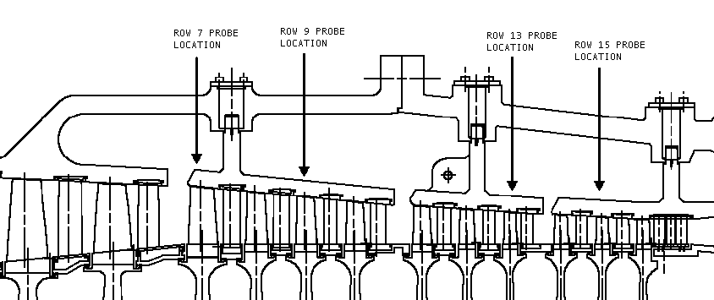

Figure 1. Probe Axial Locations

Probe Circumferential Location
Four probes will be added at each axial location. The approximate angular positions of the probes at each blade ring are shown in Figure 2. A boss must be built up by welding at each probe location on a blade ring. No welding is required on the cylinders. After the bosses are built-up, the cylinders and blade rings are drilled to accept the probes and threaded plugs.
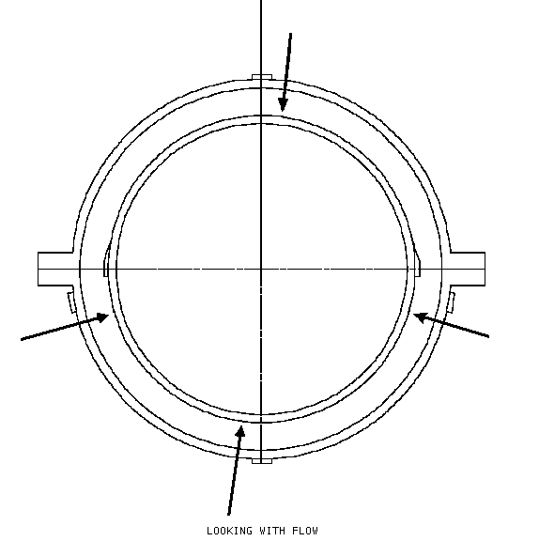
Figure 2. Approximate Probe Angular Positions

Alignment Equipment
The probes are contact dial indicators. The dimensional reference point is the counterbore on the OD of the blade rings. The conterbore is a specific distance from the flow side of the blade. The rotor is placed on turning gear during the alignment operation to get measurements at all positions around the blade path. Because the clearance checks are performed with the rotor on turning gear, the clearance checks will account for variations in blade tip radii.

Cost and Time Considerations
SWPC field personnel will do the initial modifications to the compressor cylinders and blade rings. The initial modifications to the blade rings are precision machined holes and counterbores for the alignment equipment. The time estimated to do the modifications is two weeks. Field alignments will also be performed by SWPC personnel. Estimated time to do a field alignment with this improved method is 3days.

Unit Specific Considerations

New Applications
This modification will become an integral feature of new engines. The effectivity date has not yet been determined.

Service
Units will be addressed on a customer-specific basis.

Contact your Siemens Westinghouse representative for additional information, pricing and terms, and site suitability evaluation.

END OF BULLETIN

