Product Improvement BULLETIN 2000-003

Improved Borescope Access
Rev. No: | 0 | Rev. Date: | 08/31/00 | Created: | 08/31/00

Notice to Product Improvement Bulletin Users
This Combustion Turbine Product Improvement Bulletin has been distributed to customers of Siemens Westinghouse, without charge, as a Proprietary document. The purpose of this publication is to provide combustion turbine users with information considered useful in the maintenance and operation of Siemens Westinghouse combustion turbines. The information in this bulletin represents a compendium of ideas and experiences by Combustion Turbine Engineering, Operating Plant Service, other Siemens Westinghouse Divisions, Siemens Westinghouse suppliers, and customers. These publications are provided to the user so that they will ultimately be translated into improved reliability, efficiency, and maintainability.
Siemens Westinghouse reserves the right to withdraw any publication at any time without notice. Siemens Westinghouse does not warrant applicability to any specific combustion turbine engine (or system) since bulletins are written to apply to most, not necessarily all, combustion turbines in most circumstances. In addition, Siemens Westinghouse has no control over the implementation of a product improvement bulletin or the mechanical configuration of customer-owned and maintained equipment.
It is the sole responsibility of the user to carefully consider the data set forth in the product improvement bulletin, to determine if the information is specifically appropriate to the user’s specific engine (or system) in a particular circumstance, and to exercise reasonable care and skill in the implementation of the suggestions provided therein.
NO WARRANTY, EXPRESSED OR IMPLIED, IS MADE FOR THE INFORMATION AND DESCRIPTIONS CONTAINED HEREIN WITH RESPECT TO TITLE, FITNESS FOR A PARTICULAR PURPOSE, OR MERCHANTABILITY.
Siemens Westinghouse will not be responsible in contract, in tort (including negligence), or otherwise for loss of use of equipment or plant, cost of capital, infringement of patents, loss of profit or revenues, cost of replacement power, ADDITIONAL expenses in the use of existing power facilities, claims against the user by his customers or any special, indirect, incidental, or consequential damage or loss whatsoever. Under no circumstance will any information in this product improvement bulletin become part of, modify, or negate in any way any previous agreements, contracts, or commitments unless both the user and Siemens Westinghouse agree in writing.
While Siemens Westinghouse does sincerely attempt to eliminate errors and inaccuracies, on occasion Siemens Westinghouse finds it necessary to correct, clarify, and even withdraw information as experience is gained and feedback is received from the field. Your constructive criticism and comments can help us to provide more useful publications in the future.

Product Improvement BULLETIN 2000-003

Improved Borescope Access
Rev. No: | 0 | Rev. Date: | 08/31/00 | Created: | 08/31/00

THE PRODUCT CHANGE OR FEATURE
Additional borescope inspection ports can be added to the W501F compressor cylinders to enhance the flow path inspection capabilities. In this modification, as many as 34 additional borescope access holes can be located over the rotating blades to improve visual access to the compressor blades and diaphragms.

APPLICATION
Frames: W501F

BENEFITS PROVIDED

Improved Compressor Inspection
Moving the holes to a position directly over the center of the blades, and increasing the number of circumferential inspection ports will allow more thorough compressor inspection without removing compressor cylinders. The new access hole locations will provide more diagnostic information to support decisions relating to the operation and maintenance of the power plant (e.g. inspecting for compressor fouling, wear, or damage of compressor components).

DESCRIPTION
Borescope access ports on the W501F engines are located at the 1:30 position above the compressor diaphragms at rows 1-4, 6, 8, 9, 11, and 13-15. The proposed upgrade will add four borescope access holes to each of the first four compressor blade rows. The remaining rows where no obstructions exist will have two holes added. Hole size will be common with the original holes.

DETAILED INFORMATION

Technical Data

Hole Location
Holes will be added to compressor blade rows 1-4, 6-11 and 13-16 as shown in Figure 1.

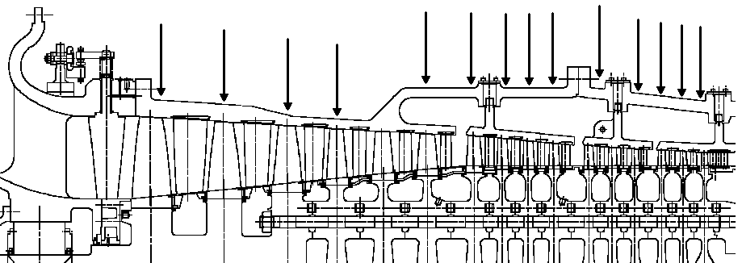
Figure 1. Borescope Hole Locations
Each of the first four rows will have holes added at the approximate positions of 12:00, 1:30, 10:30, 6:00. On rows 6-11 and 13-16, holes will be added at the approximate positions of 12:00 and 6:00. The holes in rows 7-11 and 13-16 require drilling through the compressor or compressor-combustor cylinder and the respective blade ring. Plugs will be used to close the holes in the cylinders and the blade rings. This modification requires the compressor and compressor-combustor cylinder upper halves be removed, and removal of some compressor blades to keep them from being damaged during machining operations.

Unit Specific Considerations

New Applications
The borescope positions described will supersede the original locations and will become an integral feature. The effectivitity date has not yet been determined.

Service
Units will be addressed on a customer-specific basis. The borescope inspection modifications will be included as part of any future W501F compressor upgrade proposals. Timing this modification with a major overhaul (e.g. rotor removal) would facilitate the installation.

Contact your Siemens Westinghouse representative for additional information, pricing and terms, and site suitability evaluation.

END OF BULLETIN

