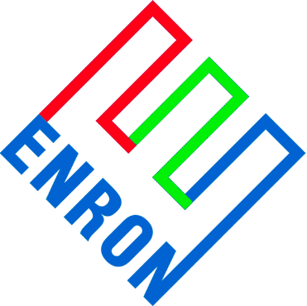

October 29, 2001

Mr. Dave Wear
Mgr., Gas Supply Administration
Peoples Energy Corporation
150 N. Michigan Ave.
Suite 3900

Dear Dave:

Thank you for providing Enron Midwest (EMW) the opportunity to respond to The Peoples Gas Light and Coke Co.’s (PGL) & North Shore Gas’ (NS) recent request for proposals for winter supply. Please find attached EMW’s response.

Our responses are valid through October 29, 2001 and they are subject to final management approval. If you have any questions or comments, please contact me at (312) 541-1231 or via e-mail at richard.tomaski@enron.com.

Sincerely,

Richard Tomaski
Director

Product A: Firm Citygate Supply

Option 1
10 day, $3.00 Fixed Price Call
Term: December 1, 2001 through January 31, 2002
Primary Delivery Point: PGL Citygate

Price: $2.05 per MMbtu per exercise day
(i.e. – 10,000 MMbtu = $2.05 x 10,000 x 10 = $205,000)

Option 2
Everyday (62 day) FOM Call
Term: December 1, 2001 through January 31, 2002
Primary Delivery Point: PGL Citygate

Price: $0.365 per MMbtu
(i.e. – 10,000 MMbtu = $0.365 x 10,000 x 62 = $226,300)

Option 3
At the money monthly baseload Chicago call
Term: December 1, 2001 through January 31, 2002
Primary Delivery Point: PGL Citygate

Strike: ATM
Price: $0.43 per MMbtu
(i.e. – 10,000 MMbtu = $0.43 x 10,000 x 62 = $266,600)

