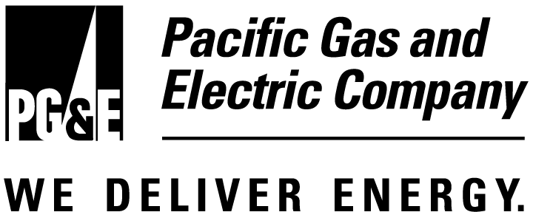 |  | Rate Stabilization Plan  Fact Sheet

State law and California Public Utilities Commission (CPUC) regulations require the current freeze on electric rates to expire as soon as early next year, forcing customers to pay the full wholesale price of power. Right now, the wholesale cost of electricity is more than three times higher than it was last year at this time.

Should California electric customers be exposed to the full cost of power at this stage of the state’s energy crisis, it would be a devastating blow to our economy, and cause needless suffering among consumers, especially low-income customers and seniors on fixed incomes.

Pacific Gas and Electric Company is committed to protecting its customers from exposure to these current, record-high prices. The company has volunteered a proposal to regulators – a Rate Stabilization Plan – which would cushion customers from dramatic price hikes, protect low-income customers from budget-busting energy bills, and allow for gradual repayment over time, once the cost of power comes back down to fair and reasonable levels.
______________________________________________

Protecting Customers From the Current Wholesale Cost of Power
- Under this Rate Stabilization Plan (RSP), customers would be protected from dramatic price swings in the volatile wholesale markets, where prices have shot up 300- to 450-percent higher than they were last year.
- Without this proposal, customers would face an overall immediate increase of 100 percent or more in system-wide electric rates when the rate freeze is lifted. Monthly summer electric bills could easily be 200 percent higher than last summer’s bills.
- Under Pacific Gas and Electric Company’s proposal, low-income families would receive a 25 percent discount off their electric bill, instead of the 15 percent they traditionally have received in the past.

How the Rate Stabilization Plan Works
- The Rate Stabilization Plan would set residential customers’ cost for electricity at 6.5 cents/kWh, higher than the amount available for such costs under the frozen rate (4.5 cents/kWh), but much lower than the current wholesale price (15.2 cents/kWh in November). The system-wide cost of power (the average of all residential, business, agricultural, and other customers) would average just 6.9 cents/kWh.
- Under this plan, the average residential customer electric bill would increase from $54.50 to about $63.50 per month, a $9.00 increase. Without a rate stabilization plan in place before the rate freeze ends, customer bills could immediately shoot to more than $108.00, and would easily reach $162.00 or more by next summer.
- To protect low-income customers, the assessment to subsidize public purpose programs would increase slightly, from the current level of $1.79 to roughly $1.89 per month for the average residential customer.
- This proposal would provide a way to begin to pay down this past summer’s uncollected energy costs, very gradually over time. Less than 20 percent of the total increase is to pay for the uncollected costs, and the remaining 80 percent is for the current high prices in the wholesale market.
- The plan is intended to keep the uncollected amount – which represents a potential balloon payment owed by customers – under $4.5 billion, which will allow PG&E to continue to borrow money to finance this cost. Any higher, and the company will exceed its credit capacity, and will not be able to obtain financing.
- The proposal protects customers should power costs skyrocket next year or the year after, and also protects customers from daily and monthly swings in prices, which have been dramatic this year. At the same time, it prevents the balloon payment for undercollected power costs from becoming too large, as it appears it may become in San Diego.
- At the end of each year, the energy cost charged to customers will be reviewed, and could be adjusted, based on the projected energy costs for the coming year. If energy costs appear to be falling, rates could be adjusted downward. If energy costs appear to be increasing, rates could be adjusted upward.
- Should power costs continue to skyrocket during the year, despite the best efforts of regulators and policy makers to rein in prices, the proposal calls for a modest 1 cent/kWh increase – triggered only in extreme circumstances, and at most only twice per year.

Pacific Gas and Electric Company – Doing Its Part in This Crisis
- The company is willing to continue to act as bank for our customers (as much as our creditors will allow) for a reasonable period of time, during this crisis. The company will continue to finance the undercollection, and will gradually pay this debt down over time, thereby avoiding a massive balloon payment for customers.
- The company will postpone receiving most of its post-transition share of profits from its generation facilities, and allow those funds to ease the burden on customers for the first two years of the plan, until electric prices come back in line.
- California is in the midst of an energy crisis, and everyone must do their part to help. Just as we need help from regulators and policy makers to fix the broken marketplace, and get supply and demand back in balance, so too can we offer ways to help shield our customers from the full wholesale cost of power.

What Electric Customers Can Do to Help
- Residential and business customers can employ common sense energy conservation measures at home and at the workplace that help restore balance to the current supply-and-demand equation. For a comprehensive list of energy conservation tips for home and office, visit www.pge.com.
- Make sure your elected representatives know you need to be protected from outrageously high electricity prices currently being charged by out of state power generators.

Other Steps We Are Taking
Pacific Gas and Electric Company is working collaboratively with regulators, policy makers and its customers to find solutions to address the entire electricity price crisis in California. While there is no single silver bullet that will fix the broken marketplace and restore balance to the supply-and-demand equation, the company has undertaken the following steps to do its part to address the critical energy crisis facing the state:

Increase supply
- Surveying substations to identify any that could accommodate small generation plants that could be used in times of very high demand.
- Advocating for successful legislation that will allow the state to cut through bureaucratic red tape and site power plants more quickly, as long as they meet all environmental and local permitting requirements.

Moderate demand
- Spending more than $125 million in 2001 on programs that emphasize the peak reduction benefits of energy efficiency.
- In addition to new energy efficiency programs and services to both residential and business customers, the company has also made changes to several programs to capture more megawatt savings during times of peak energy usage.

Repair the broken wholesale market
- Asking the Federal Energy Regulatory Commission to provide regulatory relief from the unjust and unreasonable power prices charged by independent power generators, including price caps, as well as refunds of unreasonable prices.
- Asking the California Independent System Operator (CAISO) to adopt price caps and market restructuring mechanisms to try to repair – at least on a temporary basis – the broken wholesale power markets in California.
- Supporting a successful legislative measure that asks the CPUC to investigate high prices and find equitable solutions to the crisis.

Fight for fair, reasonable rates for our customers
- Using the limited authority granted by the California Public Utilities Commission to “hedge” against higher prices.
- Locking in the lowest prices available for future electricity needs through the use of bilateral contracts with power generators.

