IntercontinentalExchange, Inc. July 10, 2000
2100 RiverEdge Parkway, Suite 500
Atlanta, Georgia 30328
USA

October 26, 2001

Dear Participant:

This letter serves as advance notice of IntercontinentalExchange’s (“Intercontinental”) intent to amend the Participant Agreement. The primary reason for amending the Agreement is to recognize and incorporate changes to U.S. commodity trading regulation. Other changes reflect Intercontinental’s recent transition from a limited liability company (LLC) to a corporation (INC), the introduction of new services, and the application of special terms, including UK governing law, for EU Participants.

The amended Agreement will become effective on December 1, 2001 and is not expected to impact Participants in any materially adverse way. Participants’ use of the Exchange on or after that date will constitute ratification of and agreement to the amendment.

Attached is the amended Participant Agreement and Service and Pricing Schedules and black-lined versions of each highlighting all additions, changes, and deletions.

If you have any questions concerning any of the changes to the Agreement, please contact your Intercontinental sales representative, or Jim Falvey, General Counsel, at 312-674-4924 or e-mail: jim.falvey@intcx.com.

Thank you for your business and we look forward to continuing to serve you.

Sincerely,

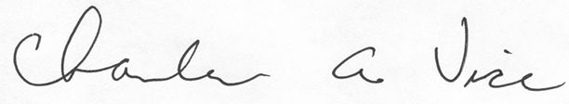
Charles A. Vice
Chief Operating Officer
Senior Vice President

