Problem – Error Addressing Outlook personal contacts:
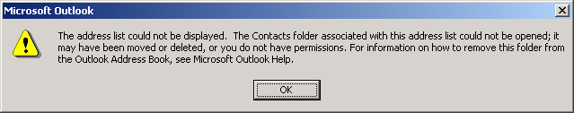

Resolution
1) From the outlook inbox, click the Tools menu, and choose Services. Highlight the Outlook Address Book and click “Properties”.
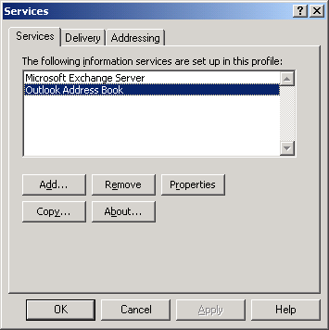

As shown below, highlight the contacts entry and click the “Remove Address Book”button.
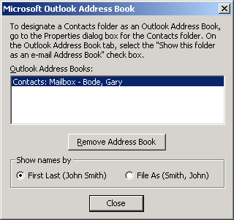

Click “Close”.

Close Outlook.

Open Outlook.

Right-click “Contacts” in the folder list, choose properties, then click the Outlook Address Book tab, and check “Show this folder as an email address book”.
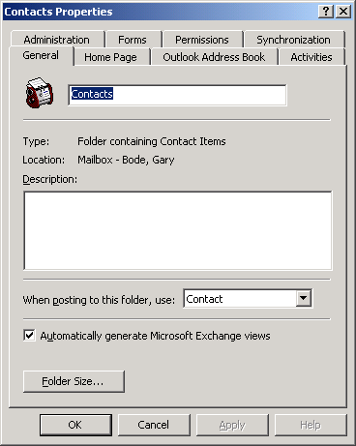

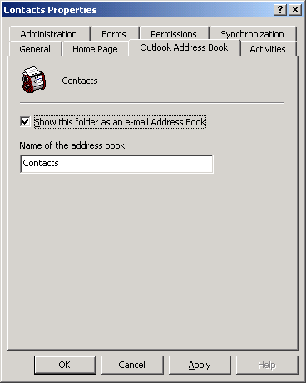

Press OK and your Contacts should be available for addressing.

