Organizational Statistics

As of

June 30, 2001


Enron
At-A-Glance

Headcount

Job Growth

Direct Costs Due to Hiring and Separations
Starters and Leavers

Bench Strength

- Headcount

- Job Growth

Although Enron has lost almost 2,000 employees YTD, with about 50% due to discontinued operations or business reorganizations, the company is still growing on a net basis for talent with about 2,500 (inclusive of the NBP acquisition) new hires this year. This net growth of 502 employees equates to an annual growth rate of 4.6%.

- About 1,000 jobs have been eliminated and severance or separation payments made due to business reorganizations (including EBS, EECC, HPL and some international regions like South America and India) and poor performance.

- The business unit with the highest net growth is EWS, primarily in Houston (15.3%) and London (22.2%).

- Both the commercial support and specialized technical peer groups show the largest YTD increase at 16% each; commercial grew 13%.

Job Growth by Job Function:

The job functions exhibiting the highest YTD growth are:

- IT (12%)
- Analyst/Associate (9%)
- Trading (6%)

The job function experiencing the largest net reduction are

- Corporate Services – Community Relations, Public Relations and Govt. Affairs (-7%)
- Origination (-6%)

The following table summarizes Net Job Growth by Job Function for each of Enron’s major job functions:

- Direct Costs Due to Hiring and Separations

Enron's total cost of hiring and separating employees for 2001 YTD is approximately $61M. At this rate, annualized costs in this category could be twice that of last year’s. The $61M represents 2% of total compensation and benefits costs. The largest cost component is severance and separation payments, which make up 46% of the total cost for 2001:

IV. Starters and Leavers

Despite a softening labor market, voluntary turnover is increasing, especially in recent months. More good performers than poor performers are leaving voluntarily in exempt and commercial positions.

A significant factor impacting involuntary turnover has been business changes and divestures related to EBS, EECC, HPL, and International regions. Many good performers, particularly in EBS and HPL, have left due to business reorganization and divestiture.

Contribution Loss:

What is Contribution Loss? A new HR metric that allows Enron to assess which performers are leaving. This metric is simply separations weighted by performance level (as indicated in the parentheses) in accordance with the 2000 Year-end distribution: Superior (3.0); Excellent (2.5); Strong (2.0); Satisfactory (1.0); Needs Improvement (–2.0); Issues (–3.0); No Rating (1.0).

Starters and Leavers Detail Summary:

Contribution Loss Trend:

Since the beginning of 2001, Enron has seen a significant increase in the separation of employees rated in the bottom two categories. At year-end, 130 employees rated Issues and 616 rated Needs Improvement were employed; these figures now stand at 5 and 118, respectively. However, in recent months, there has been an increase in separations of performers with ratings of Superior to Strong, with both voluntary and involuntary separations. On average, 36 employees per month rated above Strong left Enron prior to March. Since then, this average has risen to 70 employees per month.

For voluntary separators, more good than poor performers are leaving Enron. The area showing the most significant loss is commercial and commercial support functions in ECT Resources (EWS), with 146 separations. For those separating due to planned reductions, contribution loss (CL) now exceeds the separation rate. In EBS, where 194 employees separated due to business reorganization, CL exceeded separation rate in May and June but not year-to-date. The divestiture of HPL in May (203 separations) showed that CL exceeded separation.

Analysis of Starters and Leavers:

It should be noted that Enron is not materially hiring and terminating employees in the same areas. It is evident in the following analysis that this high voluntary turnover is spanning across many of the key job functions within Enron:

- Risk Management: Largest group of new hires (25% or 92) came to ENW (mainly pulp, paper and financial commodities) and EEL (24% or 88). About 40% (110) of separations were due to re-orgs, mainly the HPL divestiture in May. Voluntary separations spanned across EES, EEL (Enron Power Operation) and ENW (transaction support).

- Origination: 33% (42) of new hires came to EEL, with the next largest area being EES (22% or 28) and EGM (16% or 21). About 50% (98) of separations were due to re-orgs, mainly EBS (32), Global Assets (17 - South America, India) and HPL divestiture (10). 22% (15) of voluntary separations were in EEL (mainly Enron Power Operation), with other voluntary separations spread across the company.

- Trading: About 47% (42) of growth in Trading is due to EEL (Metals Recycling and Enron Power Operation) and EGM. 67% (41) of separations in Trading were voluntary, with most occurring in EEL.

Why do Employees Leave?

51% of those who left voluntarily stated "Personal Reasons" as the driver. Personal Reasons is a vague reason used to describe difficulty in balancing work with family, conflicts with supervisors, dissatisfaction with work environment or opportunities for advancement, etc. It is also used when employees don’t want to address leaving to work for a competitor.

An initiative has been undertaken to refine and enhance the exit interview process in order to better capture the reasons why employees leave and where they go.

V. Bench Strength

Enron experienced a large influx of new talent last year of 6,223 employees globally. While impressive with the tight labor market, the company also lost over 2,000 employees. With this activity, a significant change in bench strength and company tenure was seen.

Tenure:

Prior to 2000, the average tenure of an employee was close to 8 years; without ETS, it was 4 years. Currently, the average tenure of an employee is 5 years with the mode at 1 year and median at 2 years.

Average tenure of voluntary separators is currently 4.02 years. EWS makes up 63% of the voluntary separations, mainly due to EEL (40% of EWS separations) with Personal Reasons being the most frequent term reason.

Average tenure of involuntary separators is 4.69 years. Reorganization, divestitures, discontinued positions, and reduction in force were the major contributors to involuntary separations, accounting for 83%. EWS had the most separators by reason of reorganization (83%) with HPL contributing 27% to this figure.

Internal Migration:

There have been 2,208 employees who have moved from one company to another this year, representing a 10% churn rate. Enron Wholesale Services - Domestic had the largest internal churn volume.

181 employees have been redeployed through the redeployment team. This represents a 32% successful placement rate versus 41% for last year; aging for those placed is about 15 days. The top business unit sending employees through redeployment is EBS (52% of redeployment candidates). The top business unit utilizing employees from redeployment is EWS (36% of placed redeployment candidates).

Internal Migration Metrics:

Tenure Metrics:

¹ Median years of tenure w/ current employer for wage and salary workers in the Financial Services Industry is 3.5 years

² Non-Caucasion Ratios: US Pool (19%); Houston Pool (35%)

³ Female Ratios: US Pool (47%); Houston Pool (50%)

… Bureau of Labor Statistics, 1998

Success of New Hires:

Based on a review of new hires from Q1 2000 (20% of 6,223 new hires), it is evident that they have quickly added value to Enron. This is indicated by the significant increase in percentage of Q1 new hires ranking Superior (67% increase) and Excellent (61% increase) from mid-year to year-end.

PRC Trends

(Q1 2000 New Hires)

Of the 6,223 new hires hired in the year 2000, approximately 4,800 are still active today, a retention rate of 77%. Of those who received PRC ratings, 3% were rated Superior, 22% rated Excellent and 35% rated Strong at Year-end.

Retention of HIPO:

Another indication of bench strength is the retention rates for our high performers. The following chart indicates the percentage of employees rated in the top-two categories (Superior and Excellent) at year-end who are still active employees:

* Includes Analyst/Associate, Finance, General Management

- Recruiting Metrics

The following recruiting metrics were reported by the Enron Recruiting Council and cover domestic activity only.

Staffing Activity Summary:
*The major reason given for declined offers is compensation.

Analysis of Hiring Sources:
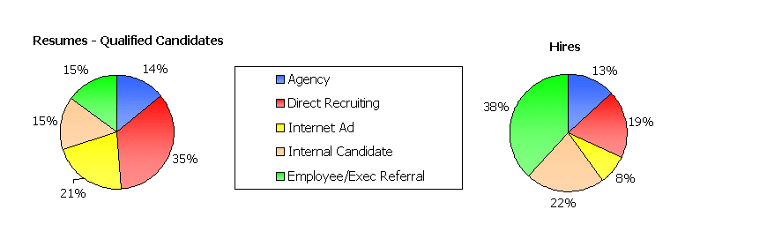
(Per Enron Recruiting Council)

Recruiting Trends:

A Return to the Tried and True -- Only 12% of new college graduates are interested in joining a start-up company, down from 26% in 2000, according to Kiplinger's Personal Finance magazine.

VII. Industry Trends

U.S. Labor Statistics

Houston Workforce Statistics

Houston's economy continues to show signs of slowing down. For June, Houston's unemployment rate jumped to 4.9 percent from May's 3.9 percent. The most recent job growth report from the Texas Workforce Commission indicates that Houston added 51,200 jobs in the past 12 months for a 2.4 percent rate of growth. That's the same year-over-year rate of growth as a month earlier. However, the job growth may be inflated because last year's data included 6,000 temporary Census Bureau workers.

Though the overall economy appears to be slowing down, some sectors are gaining ground, according to the June report. The local energy sector continued to add workers, gaining 1,400 in the last month.

Performance Management

Ford said it will abandon major elements of its "Performance Management Process," including the practice of assigning a fixed percentage of managers every year to a "C" category that meant no bonus, no merit raise and potentially no job.

People close to the company's chairman, William Clay Ford Jr., say he has expressed concern about the system's impact on morale.

Attorneys for Ford workers who are suing the company maintain that a disproportionate number of older workers have received C's. A second suit charges that the system has also been used to promote women and minorities at the expense of older white male workers.

Experts said Ford’s decision to retreat from the quotas and letter grades is likely to lead other companies to reexamine their own employee-appraisal systems.

Ford will stop designating a certain fixed percentage of employees as "C" or unsatisfactory performers who can be demoted or terminated if they receive the rating two years straight. Further, the A-B-C letter grades will be replaced by the designations "Top Achiever," "Achiever" and "Improvement Required." Workers ranked "Improvement Required" will "receive coaching and counseling to enhance their performance." They may also get raises.

Even GE revised its rating system after it realized its impact on morale. Originally GE ranked employees on a one to five scale, but then it found that nearly everyone except the top 10% felt demoralized. It streamlined its ratings to three grades, assigning 70%, or the vast majority, the middle grade and rewarding some of them with stock options.

Health Care Costs

Houston-area employers have been hit with double-digit increases in health-care costs for the second consecutive year, and many companies appear inclined to raise their employees' contributions to the premiums to cover rising costs.

A smaller number of employers, however, are evaluating decreased benefits to mitigate the higher costs. That's generally not a good option because it hurts efforts to attract and retain workers.

Average overall health-care costs shot up 12.8 percent this year over last year for all types of health plans. That's more than the 11.8 percent increase last year and the highest in the survey's six-year history.

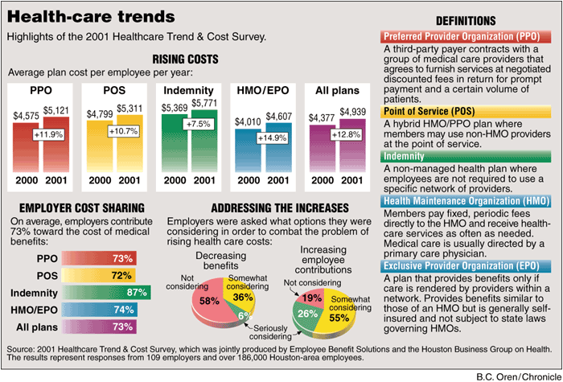
The 2001 Healthcare Trend & Cost Survey was conducted by Employee Benefit Solutions, a local consulting firm, and the Houston Business Group on Health.

Benefits Rising Cost Outpaces Compensation Increase

Benefit costs now represent 27% of the total compensation costs paid by private industry employers, according to figures released by the Bureau of Labor Statistics (BLS).

Average total compensation increased 4.8% to $20.81 per hour from March 2000 to March 2001, while benefit costs outpaced wage increases and now average $5.63 per hour, the BLS found.

When compensation figures for state and local government workers are added, the figure increases to $22.15 per hour, with wages and salaries accounting for 73% of total costs.

Average health benefits costs in private industry were found to be $1.16 per hour, or 5.6% of total compensation. The costs varied across region – from $1.05 per hour in the South to $1.37 in the Northeast – and occupation, where health benefits accounted for 6.9% of total compensation for blue collar workers versus 5.1% for white collar workers.

The average cost for retirement and savings benefits in private industry was 62 cents per hour, or 3% of total compensation, according to BLS employment cost index data.

Attachment 1

Commercial Separations

by

Job Function
&
Business Unit

1&2 = PRC Rating at Year-end 2000

Attachment 2

Commercial Separators
PRC Rating 1&2

Note: A comprehensive initiative has been undertaken to refine and enhance the exit interview process in order to better capture and record the reasons why employees leave and where they go.

