Black-Scholes meets Seinfeld
Uncertainty defines the television business. Who really knows whether a show will be a hit or a dud, or at what time or on which day it must be broadcast to reach the biggest audience and thus capture the largest advertising premium? TV executives have been struggling with these questions since the industry’s creation. Although TV programmers put their faith in pilots and market research, they also rely heavily on instinct. Much rides on their judgment, since programming accounts for 55 to 65 percent of a TV channel’s expenses. Is there a way to improve the odds of success or at least to minimize the damage caused by disappointing shows?
McKinsey has found that applying options theory to TV programming decisions can improve returns from programming investments. The holder of a financial option has the right, but not the obligation, to buy or sell a stock at a fixed price within a fixed period. In recent years, many companies have begun to apply options theory and the Black-Scholes pricing formula to nonfinancial, or “real,” investment decisions. Options used in this way—known as real options—have found ready acceptance in the mining, petroleum, and pharmaceutical industries, where uncertainty is high and the need for flexibility at a premium.1
Nothing can ever replace human instinct in a business like television, in which creativity plays such a predominant role. But real options have a place in the tool kits of TV broadcasters because of the high uncertainty and costs of a program series. Indeed, TV executives informally exercise options whenever they yank underperforming shows or otherwise modify schedules. What they must now do is institutionalize the process of recognizing, evaluating, and exercising the options embedded in TV programs.
In the cases McKinsey has studied, the application of real options has led to an average increase of 25 to 50 percent of the original value to be captured in a program’s life cycle. In other words, real options are every bit as valuable in TV as in industries such as mining. Of course, some programs don’t embed large option values, because they are either very profitable or very poorly designed.2 Nevertheless, for a majority of programs, whose returns are likely to be close to the minimum, options are very profitable; indeed, they can contribute an additional five to ten percentage points of EBITDA (earnings before interest, taxes, depreciation, and amortization) margin. Since the TV industry has generated total returns to shareholders of about 18 percent, exercising real options could increase shareholder value by more than one-third (Exhibit 1).
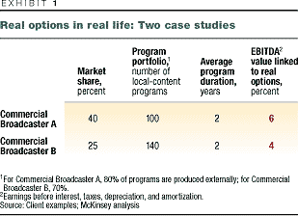
Using options means coming to grips with risk. The risk of a program series lies in its uncertain ability to generate high ratings and therefore high advertising revenue. Fortunately for broadcasters, enough information is available to provide at least clues to the likelihood that a series might succeed. In the United States, for example, a series that has already been granted a second season is up to three times as likely to be renewed as one that has yet to be granted a second season (Exhibit 2). Moreover, content tends to cluster in genres, each with its own characteristic range of performance: national-team soccer in Europe, for example, does very well, with market shares of 45 to 55 percent. An option for a show can thus be valued by referring to the performance of other shows in its genre.
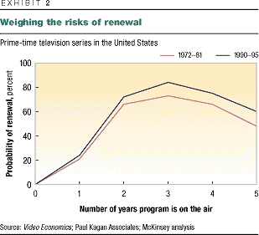
Television programming involves several kinds of options, such as “scale,” “temporary,” “kill,” and “switch.” The range of options for a TV series depends on its genre, and the same program can embody more than one option. A scale option projects the life (including reruns and sequels) of a high-performing show. A temporary option might make a channel refrain from scheduling a high-cost series during typically low-ratings months such as July and August. A kill option identifies struggling programs with no future. And a switch option might suggest changing the time slot of a program to improve its ratings or demographics.
In the United States, the NBC television network exercised a switch option when it moved Seinfeld to Thursday night. Most people forget that this enormously popular series performed poorly during its first two seasons, ranking in the bottom quartile. By shaping stronger characters and moving the show—thus exercising an option embedded in it—NBC eventually created a sensational program. The option to shift Seinfeld to another time slot could be valued as a call option, which gives the network the right (but not the obligation) to adapt its schedule after experimenting with a program’s performance in various time slots. That flexibility has a monetary value.
Real options in TV will probably become even more relevant in the years to come. Digitization and the Internet are heightening uncertainty in the broadcast industry by creating more competition and further fragmenting audiences. But even with the help of options, TV programmers will have to rely on their sixth sense and on luck. Who would have guessed that Hogan’s Heroes, a 1960s US situation comedy about World War II prisoners of war, would spend years in production and many more in syndication?

