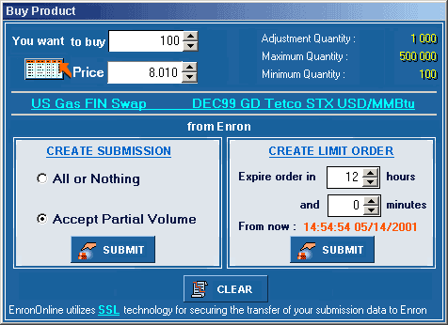
Clicking on this link will result in a pop-box with the “Create Submission” explanation.
Clicking on this link will result in a pop-box with one of the “Create Limit Order” explanations, depending on which type of limit order this product allows.

The presence/absence of the screen icon to the left of the Price field indicates which sort of limit order is in effect.

Create Submission
Clicking Submit in the Create Submission panel sends an order to EnronOnline for immediate processing at your specified price.
Selecting All or Nothing indicates that your order should be executed by EnronOnline only if the entire volume you specified will be bought/sold.
Selecting Accept Partial Volume indicates that the order should be executed even if the entire volume is not available.

Create Limit Order
Clicking Submit in the Create Limit Order panel creates an order that will remain in the EnronOnline system until the order is either filled at your specified price or expires at the designated time.
You can cancel an existing limit order at any time before it is filled by highlighting the order in the Price Limit Order screen and clicking Cancel.
You can modify the price of an existing limit order at any time before it is filled by clicking on the (+) and (–) buttons next to the price.

Create Limit Order
Clicking Submit in the Create Limit Order panel creates an order that will remain in the EnronOnline system until the order is either filled at your specified price or expires after a specified time limit. If, during that time, the price you entered falls between the Bid and Offer posted on EnronOnline, then EnronOnline will show a new market with a tighter spread that reflects your limit order price*.
You can cancel an existing limit order at any time before it is filled by highlighting the order in the Price Limit Order screen and clicking Cancel.
You can modify the price of an existing limit order at any time before it is filled by clicking on the (+) and (–) buttons next to the price.
*Multiple limit orders for the same price will be prioritized by time of submission. Only limit orders that are between EnronOnline’s Bid and Offer prices will create a new EnronOnline market on the Quotes screen.

