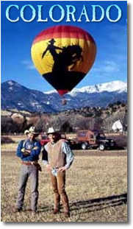

Hot Air Balloon Flight

Description: Explore beautiful Colorado from the basket of a hot air balloon. At the highest levels, snow-capped mountains, rivers and high plains are visible for over 100 miles in all directions. Floating lower over the foothills and ranch land you will often see mule deer, coyotes, jack rabbits and antelope. Your flight celebration also features a champagne toast, juices, fruit and pastries.

Pick up time: 6:00 a.m.
Drop off @ hotel: 10:00 a.m.

$350.00 per couple

This includes hotel pick up, one hour balloon flight, champagne celebration/breakfast, flight certificate and return transportation to hotel.

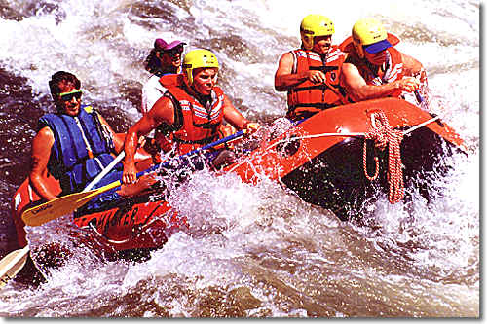

Big Horn Sheep Canyon Raft Trip

Description: The Big Horn Sheep Canyon Trip is so named for the bighorn sheep that are often seen grazing along the canyon walls. This is a wider part of the river that provides exciting whitewater rapids mixed with calmer stretches that let you relax and enjoy the scenery. The majority of this stretch is rated Class II, with about 20 rapids that are rated Class III. This is suitable for both beginners and intermediates.

Pick up time: 7:00 a.m.
Drop off @ hotel: 2:00 p.m.

$150.00 per person

This includes breakfast, hotel pick up, wet suit and all equipment, lunch and return transportation to hotel.

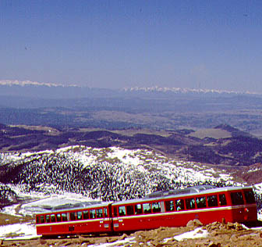 | 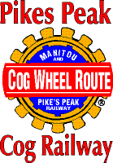 | 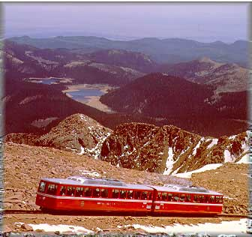

Foothills Jeep Tour and Cog Railway Train Tour

Description: Escape for a few hours to take in the beauty and history of Colorado Springs. You will head out of town via North Cheyenne Canyon past Seven Falls, Helen Hunt Falls and into the foothills of Pikes Peak. 2000 feet above Colorado Springs you will follow the old Shortline Railroad grade down through two tunnels to the Old Colorado Springs and Manitou Springs Historic District. There you will board the world’s highest cog railway and sit back and relax as you are taken to the top of America’s best-known mountain, Pikes Peak, 14,110 feet! The sights you will see here are what inspired Katherine Lee Bates to write “America the Beautiful”.

Pick up time: 9:00 a.m.
Drop off @ hotel: 3:00 p.m.

$125.00 per person

This includes breakfast, hotel pick up, Jeep tour, train ride on the Cog Railway, lunch and return transportation to hotel.

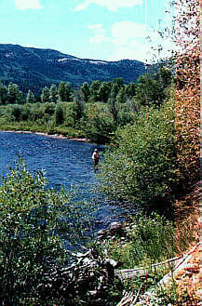

River Fly Fishing

Description: Embark on an awesome scenic tour and fishing adventure. These guides have been offering professional fly-fishing instruction for over 17 years. Most of the waters have a Gold Medal designation that sustain a high quality aquatic habitat, of trout 14 inches or larger, with the potential for trophy trout fishing. You will fly-fish some of the most beautiful rivers and lakes in Colorado Springs. All you have to do is relax and enjoy the fishing.

Pick up time: 8:00 a.m.
Drop off @ hotel: 2:00 p.m.

$180 per person

This includes breakfast, hotel pick up, 45 minute scenic tour to river, all equipment, instruction from a professional fishing guide, lunch and return transportation to hotel.

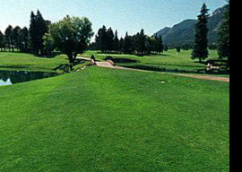

Broadmoor Golf – East Course

Description: The East Course was designed to delight the eye and challenge even the most seasoned player. When this course was completed in 1918, it was the highest 18-hole golf course in the United States. Numerous tournaments have been held on this course over the years, most recently the 1995 U.S. Women’s Open Championship.

Tee times: Around the 9:00 a.m. hour
(Times will be sent to each participant after sign-up.)

$200 per person

This includes breakfast, green fees, cart, lunch, use of course and range.

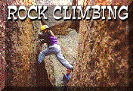

Pikes Peak Rock Climbing

Description: Your guide will take you to Glenn Cove (11,425 ft.) for rock climbing in a beautiful alpine setting behind the historic Glenn Cove Inn on the Pikes Peak Highway. The Pikes Peak region offers some of the greatest variety of climbing found anywhere. You will have exclusive use of this area. This event is set up for the complete novice to the intermediate climber.

Pick up time: 8:00 a.m.
Drop off @ hotel: 4:00 p.m.

$110.00 per person
(limited to 18 climbers)

This includes breakfast, hotel pick up, all equipment, lunch and return transportation to hotel.



The Spa At The Broadmoor

Description: From high in the Colorado Rocky Mountains come the natural elements of earth and sky: Clay, rich in minerals; Aqua Vita, pure spring water; arbor botanicals and soothing aromatics. Here in the grandeur of the Rockies, you’ll find the elements essential to the well-being of body and soul. Your personal odyssey will take you to one of the most luxurious spas in the world – the extraordinary Spa At The Broadmoor.

Enclosed please find a brochure listing all spa services. Please contact the 1-800 number listed to reserve your individual treatments. These charges will be billed directly to your room upon completion of your appointment.

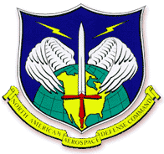
North American
Aerospace Defense Command
(NORAD)

Description: This is an event not to be missed. This involves a tour and briefing at the NORAD Combat Operations Center in Cheyenne Mountain. The Cheyenne Mountain Operations Center comprises the largest and most complex command and control network in the world. Cheyenne Mountain operations are conducted by six centers manned 24 hours a day, 365 days a year. The centers are: Command Center, Air Defense Operations Center, Missile Warning Center, Space Control Center, Combined Intelligence Watch Center, and the Systems Center. For the past 29 years, Cheyenne Mountain has sustained a constant vigil over the North American continent, guarding against attacks from land, sea, air and space. The mountain continues to evolve in an ever-changing environment effectively and efficiently, supporting not only critical national defense missions for the U.S. and Canada, but also space support and theater defense missions worldwide.

When you sign up for this off-site, please provide your social security number in the space provided. Clearance for all participants must be completed six weeks prior to September 15, 2001. IMPORTANT: there are no exceptions, you MUST be cleared six weeks prior in order to enter NORAD.

Cost: No cost.

Pick up: 9:00 a.m.
Drop off @ hotel: 12:00 Noon

