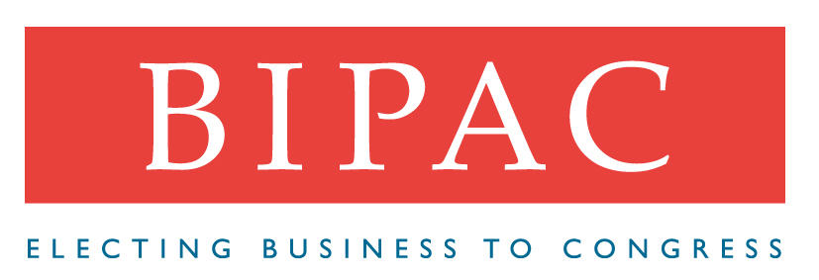

BUSINESS BRIEFS
Election Activities You Can’t Miss!
Election Night Preview  BIPAC provides the best election coverage for the business community – check out our “sneak preview” www.bipac.net\election.  We’re providing ‘round-the-clock coverage to keep you up-to-date on races across the country. Look for our by district, Election Analysis Reports on our website at www.bipac.org. Our coverage includes:  Real-Time Website Updates put election results at your fingertips  Open Phones with BIPAC Analysts ready to answer your questions throughout the evening  Freshman Class Reports, including profiles, photos and business box scores | BIPAC/NAM  Post-Election Briefing Breakfast  This is not your average “morning after” election briefing. Wednesday morning marks the beginning of a new era in politics – a new Administration, a new House and lots of new Senators. We’ll tell you how American business fared.  Join BIPAC’s Greg Casey, Bernadette Budde, Darrell Shull and the NAM’s Mike Baroody for a lively exchange tailored to address American business concerns.  Have you reserved your seat? If not, contact Heather Ireland at Ireland@bipac.org. Time is running out and space is limited!
Cleaning Up in the Aftermath
It’s November 8.  Your list of federal and state legislators is now obsolete. While the districts are the same, you need to get names of the new representatives entered into your system.  Who do you call? | 

Cleaning Up in the Aftermath (Cont’d.)

One of our Partners, Legislative Demographic Services, can provide you with the representative matching services you need – at the state and federal levels.

How many fundraising invitations do you receive in a day? In a week? How much time does it take your staff to look up candidate addresses, enter events from the hundreds of faxes and letters addressed to your office? How much time does it take to respond and accept event calls? Wouldn’t it be nice to spend more staff time getting the maximum bang for your political buck?
FundraisingEVENTS.COM (another BTP Partner) is the answer.

For more information on BIPAC’s Business Technology Partnership, contact Rick Manning via email at btp@bipac.org or via telephone at 202/776-7462.

Coming Attractions!
Mark Your Calendars . . . . .
The elections of 2000 will soon be history and those of 2002 will be upon us. It’s never too soon to begin planning for a successful election cycle.

To get off on the right foot, join us at our PAC Council mini conference on Monday, December 4, from 2:00 to 4:30 p.m., at The University Club. Topics will include:

- How to Run a Successful PAC
- Effective PAC Solicitation Techniques
- Message Crafting for 2002
- Re-Imaging Your PAC
- Management & the Grassroots Campaign

$50 for BIPAC Supporters $100 Non-BIPAC Supporters

To reserve your seat, contact Aimee Malenfant at malenfant@bipac.org.

** Holiday Reception to Follow **

Adam Smith Awards Nominations

BIPAC will accept nominations for its 2001 Adam Smith Awards through close of business Thursday, November 30. If you haven’t received your nomination form and/or have questions about the nomination process, contact Deb Flavin at flavin@bipac.org or via telephone at 202/776-7463.

