October 2001 Short Circuits - Electricity by Rita Hartfield
Short Circuits

NERC’s View
Near-term (2001-2005) generation adequacy is satisfactory provided new generation facilities are constructed as anticipated. NERC’s estimate of new resource additions ranges between 138,000 and 245,000 MW while NERC’s expected electric demand growth estimate during the same period is about 63,800 MW. This would yield a NERC-wide near-term capacity margin of more than 20% by 2004.
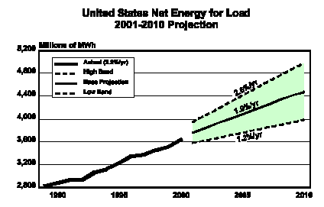

New generation capacity additions are being driven by market signals and not by resource capacity margins. Since generation is not locating close to demand centers, but rather is locating close to a fuel supply, adequate cooling water, and a transmission line interconnection some areas of the U.S. will have a high risk of experiencing outages.

Electric restructuring can have a robust retail market only when end-use customers have the correct signals to curtail their usage voluntarily and only those areas with ample available generation are likely to benefit from early introduction of retail competition.
Transmission

Coordinating markets for balancing energy, capacity, and regulation has proven difficult. The electric transmission system was not designed for open access and interconnection by

hundreds of market participants. Portions of the transmission systems are reaching their limits due to the movement of bulk power over long distances [a result of industry restructuring]. Transmission congestion is expected to continue.

Generation additions have not been planned in an integrated fashion with transmission expansions. This has resulted in increased transmission loading relief (TLR) procedures. The chart below illustrates this increase in Level 2 and higher TLRs. Transmission curtailments do not occur until Level 3 (non-firm) and Level 5 (firm) TLRs are reached.

Fuel Choice

Natural gas has become the fuel of choice for the foreseeable future. Current NERC forecasts predict that natural gas-fired capacity will represent over 20% of the total U.S. electric generating capacity in 2009, up from 13% in 1999.

Natural gas price volatility impacts the reliability of electric supply. Rising natural gas prices not only affect the cost of generation but also the feasibility of new generation projects. Many planned natural gas-fired plant investments were developed when natural gas prices were well below $3 per MMBtu. Any long-term increase in the cost of natural gas could render these power plant investments uneconomic.

PIRA’s View

The lessons learned from the western electric energy crisis are that healthy energy markets should not be politically manipulated by the legislature or state-controlled market participants and that too much volatility is unhealthy. There must, however, be sufficient price volatility to attract investment and trading participants. Markets can survive incompetent market administrators but they will not survive blatant market biases for consumers or suppliers.

The emerging structure of deregulated electric energy must do a better job of motivating participants to balance reliability and competitiveness. Reliability parameters balancing needs and costs must evolve as the market changes. Too much reliability destroys volatility while too little reliability creates too much volatility.

Having a regional scope would help reduce the cost of reliability and enhances the ability to anticipate future reliability risks. Broad regional transmission organizations (RTO) would limit the risk for future state intervention in interstate energy markets and limit meaningless and superficial structural changes.

Future Market Drivers

Emerging market drivers for the price of electricity for 2005 and beyond will be cost of the fuel and the cost of environmental externalities. It is unlikelihood that greenhouse gases will be ignored much longer and current security issues [oil, LNG, and nuclear] make international cooperation more important.

PIRA states that over 50 GW of new coal power plants have been announced, however only 1.5 GW are under construction. Increases in coal prices are unlikely to discourage coal plant investment but long lead times, weak capacity values, weak off-peak power prices (coal plants are rarely taken off-line, just powered down), current natural gas prices and environmental bills may discourage coal plant investments.

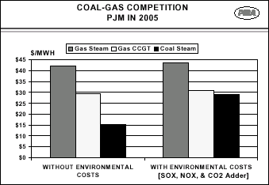

Congress will likely encourage highly efficient gasified coal plants with a combined-cycle back end by offering large tax credits causing many old, small coal units to either re-power or retire. Nuclear power even has a chance of being revived.

Almost half the direct and indirect costs of a natural gas-fired combined cycle plant (excluding fuel) are impacted by technical workers. Labor costs vary widely by region and may not line up with locations with higher power prices. Regional transmission organizations would allow power plants to be constructed in low cost labor areas to serve higher priced power areas.
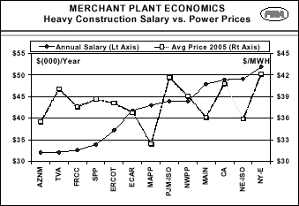

Source: NERC Reliability Assessment 1001-2010, October 26, 2001; PIRA Energy Group, Electric Market Outlook, October 2001

