


Generator Communications and Participating Loads Projects

2nd Annual Vendor Fair

Come and see the latest in telemetry technology
Featuring:

6 Data Processing Gateway (DPG) Vendors

DPG/RIG Third-party Engineering Firms

Revenue Metering Vendors

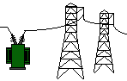Tuesday, October 9, 2001
9:00 a.m. – 3:30 p.m.
at the California ISO Offices

Conference Rooms 101A-A&B

101A Blue Ravine Road, Folsom

Presentations scheduled in the morning
Vendor Fair scheduled in the afternoon will allow guests to visit vendor booths for product demonstrations
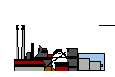

Continental Breakfast & Lunch will be served

Please RSVP to Patricia Hunter at phunter@caiso.com
or (916) 351-4469

