Lamar’s Notes on Monopoly, Competitive,
and Two-Part Tariff Profit Maximization

Clearly, this entire course is about profit maximization. As a manager for a for-profit firm, you seek to maximize profits, and if you don’t, you might just get fired. Unless you work at Boeing, in which case you fit right in. We have spent the semester looking at how firms attempt to maximize profits given their market, industry, and game theoretic situation. These notes will deal with how one should maximize profits given several situations: Monopoly, Competitive, and two-part tariffs. Note that these examples are all short-run profit-maximization. The long-run competitive case will be dealt with in another set of notes.

Monopoly Case-Price Setter KNOW THIS!!!
In the monopoly case, you are the only producer. If customers wish to buy the product you produce, they must buy it from you. If you were a benevolent monopolist, you might maximize social welfare by clearing the market at a price where your supply equals market demand. But you’re not. You’re greedy, and you want more money. So you maximize profit. Here is how you do it. A monopolist always maximizes profits by producing at the quantity where MR=MC. At this point, any additional unit you might produce would earn you less than it would cost you. Thus, in order to solve for your profit maximizing quantity and price, you should complete the following steps:

- Find your inverse demand curve.
- Find your total revenue function(Q times inverse demand)
- Take the derivative of total revenue to find marginal revenue.
- Find your marginal cost. If marginal cost is not given to you, find it by taking the derivative of your total cost function.
- Set marginal revenue equal to marginal cost and solve for Q.
- Take your profit maximizing Q* and plug it into your inverse demand function. This will give you your profit maximizing price.
- Calculate your profit as P*(Q*) –TC

There are numerous examples of this in the problem sets. Any microeconomics text will have other ones. You can also replicate this problem by creating your own demand and cost functions and then solving. Make sure you can solve this type of problem in your sleep. If you can not do this on the test, the micro economics gods will have little pity on you. Below is a graphical illustration of the profit maximizing price and quantity for a monopoly.
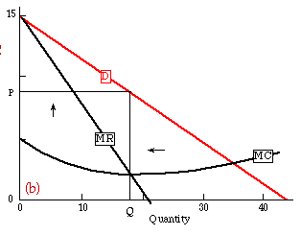

Competitive Market-Price Taker
In the competitive market case, you have no ability to set price. There exists a market price and if you wish to sell any items you can not sell above this price. The first thing to recognize in this case is the P=MR. The amount of revenue you will receive for an additional unit will always equal the market price. Thus, in order to maximize profit, you must only calculate MC. The following steps will guide you through this:

- Find your marginal cost as in the monopoly case.
- Set marginal cost equal to price(MR) and solve for your profit maximizing quantity.
- Your profits will once again be P(Q*)-TC.

Note that constant marginal costs do not work in the case of competitive price-takers. Imagine if your MC=10 and P=30. Where would MC=P? It wouldn’t. In this case you would produce as much as you possibly could. In general, when you have a competitive market problem, marginal cost will be some function of Q. For an example of this, see the oil well problem on one of the first problem sets.

Two-Part Tariffs
When a firm is able to charge a two-part tariff, it can make extraordinary profit by extracting the majority of consumer surplus from its customers. The profit maximizing pricing scheme in a two-part tariff is always to price each item at marginal cost and then to charge a membership fee that equals each buyer’s consumer surplus when p=MC. Thus a profit maximizing firms should charge p=mc and f=CS(p=mc). Below is a graphical example of this pricing scheme. Here p=MC and the membership fee is the consumer surplus.
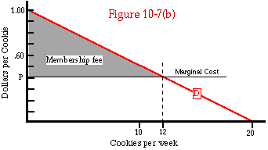

Remember that consumer surplus is always the area under the demand curve yet above the price. This can be seen above. Consumer surplus can always be calculated as a right triangle’s area can be calculated (when there is a linear demand curve). This, as you may remember, is one-half base times height. In economics terms, this will be (1/2)(PI-p)(q) where PI is the price intercept on the demand curve ($1 in the above example).

