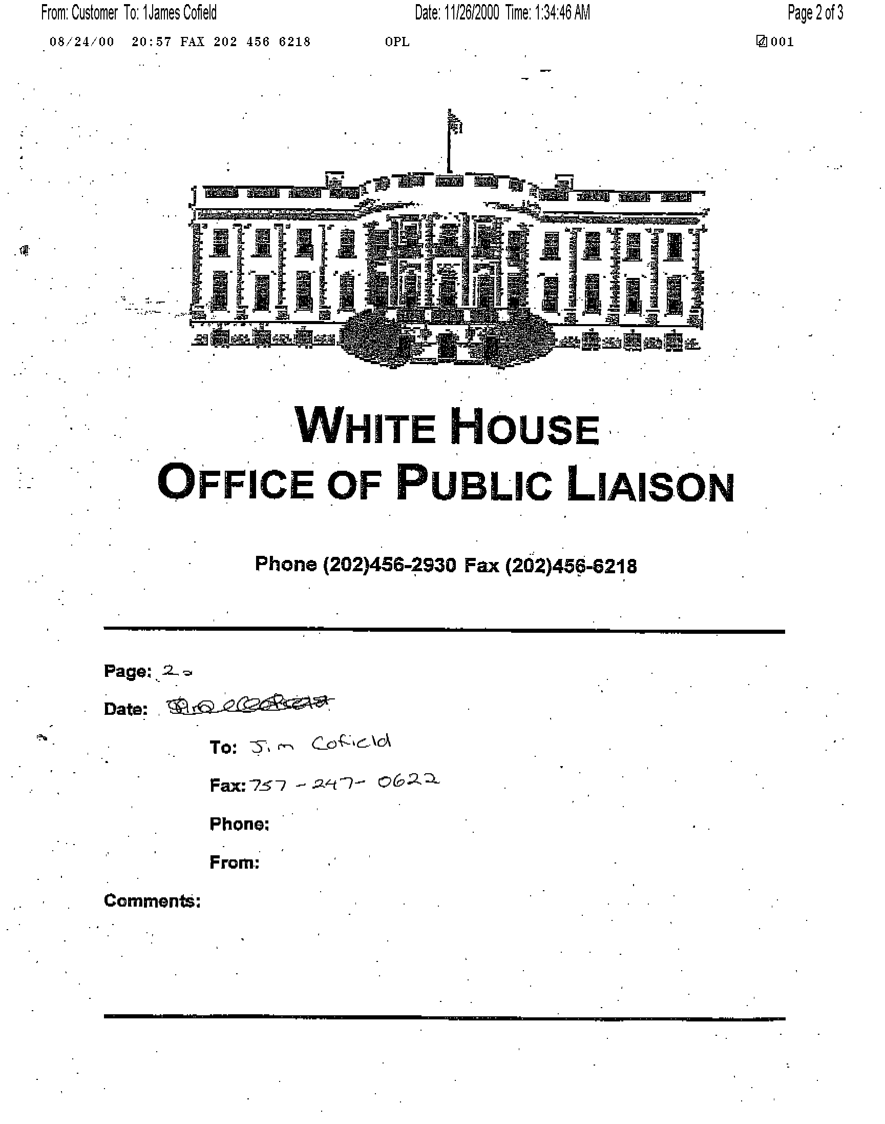

August 21, 2000

TO: Jim Cofield

FROM: Mary Beth Cahill, Director
White House Office for Public Liaison

RE: The President?s upcoming trip to Nigeria
_______________________________________________________________________

I was pleased to hear that you will be visiting Nigeria during the
President?s visit and would like to invite you to the following events in Nigeria.

On Saturday, August 26, you are invited to attend the address
President Clinton will make to the Nigerian Joint Assembly at
3:00. Please note that this invite is dependent on the weather. The rain site for this event can not accomodate an audience.

That evening there will be a reception for the American private
delegation at the Nicon Hilton Hotel to which you are invited.
You are also invited to the State Dinner that follows at the
International Conference Center. Transportation will be provided
from the reception to the State Dinner. The State Dinner is black
tie or dark business suit, but we expect most of the guests to be
in black tie or the equivalent.

On Sunday, August 27, you will be invited to attend the public
signings of important agreements between U.S. and Nigerian private
and public sectors. A Commercial Dialogue will follow those
signings. The day will conclude with a business and trade
reception that the President will also attend. These will all
take place at the Sheraton Hotel.

Please notify Jena Roscoe, Associate Director for Public Liaison in my
office via fax at (202) 456-6218 or email at Jena_Roscoe @ oa.eop.gov by completing the form below if you will be able to attend these events.
Please include your contact information in Nigeria.

We know that this will be a historic visit by President Clinton to Nigeria and I am delighted that you will be able to participate.
_______________________________________________________________________

I will be able to attend:

____ Address to the Joint Assembly.

____ Private Delegation Reception at the Nicon Hilton Hotel.

_____ Commercial Dialogue and Signing Ceremony at the Sheraton
Hotel.

_____ Business/trade reception at the Sheraton Hotel.

_____ I will not be able to attend these events in Nigeria.

I will be in Nigeria the following dates: _________________________.

I can be reached at: _________________________________________.
Phone #: _________________________________________.
Fax #: _________________________________________.

If you have any questions, you can contact Jena Roscoe at (202) 456-6657 or Christine Stanek at (202)-6614. Thank you.
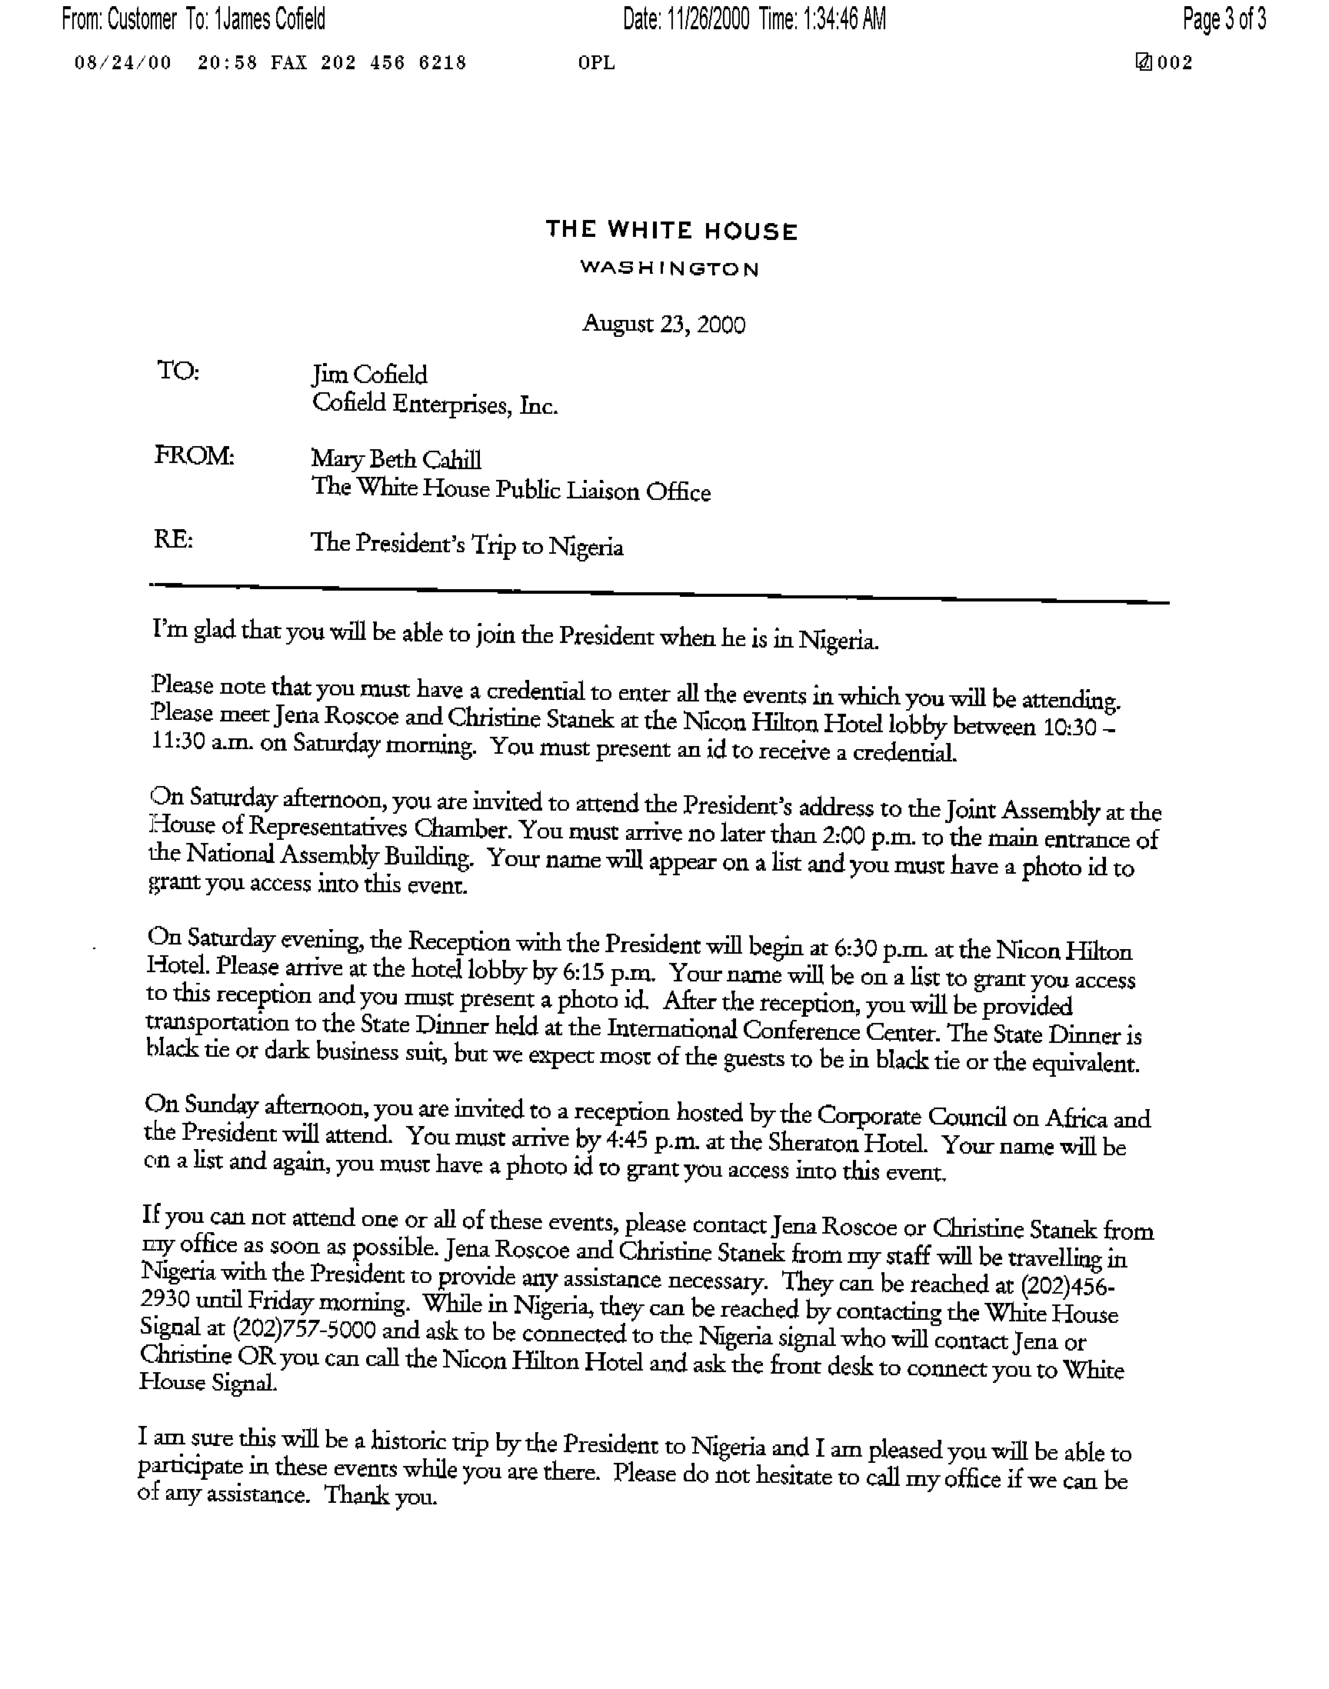
http://www.state.gov/www/regions/africa/fswh_000827_us_nigeria.html
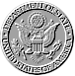 | The United States and Nigeria: Expanding Trade and Investment  Fact Sheet Released by the Office of the Press Secretary  The White House, August 27, 2000

President Clinton today announced new initiatives to expand trade and investment between the United States and Nigeria in a speech before U.S. and Nigerian business representatives. These measures, which include duty-free access to the U.S. market for many Nigerian products and new financing arrangements for Nigerian importers of US products, complement other initiatives announced during the President's visit to deepen the economic partnership between the two countries. These include support for debt relief, assistance to broaden access to education and information technology, and a reinstatement of direct air travel between Nigeria and the United States. His remarks on trade capped a day of business agreement signings and a Commercial Dialogue involving senior private sector and public officials from the two countries.
GSP Trade Benefits on Nigerian Products. The President announced that Nigeria will be added to the list of developing countries whose exports to the United States receive duty-free status under the Generalized System of Preferences (GSP) program. The GSP program provides nonreciprocal tariff preferences to developing countries in order to promote their economic growth and development. More than 4,650 products from approximately 140 designated beneficiary countries qualify for this treatment. Access to the GSP program will help Nigeria expand its export base beyond oil, which accounts for 95 percent of export receipts.
To promote economic diversification, the government has created export processing zones, reduced average tariffs from 24% to 12%, and identified priority products for export promotion. Of these, the following would qualify for duty-free treatment under GSP: Electrical and Electronic Products; Leather Products; Plastic Products; Rubber Products; Garments; Metal Products; Sports Equipment and Materials; Biscuits and Confectioneries; Paper materials; Food Processing; Pharmaceutical Products.
The United States is Nigeria's top export market, accounting for 44% of its export earnings. In 1998, the United States imported $10.5 million in agricultural goods and $3.8 million in textiles and apparel from Nigeria. The elimination of tariffs under GSP will increase the demand for such products as cocoa, cotton, handmade traditional textiles, minerals and metals, and forest products. US tariffs currently range from 2% to 20% on these products.
Nigeria is also being considered for eligibility under the recently enacted African Growth and Opportunity Act, which will confer duty-free treatment on virtually all products exported from qualifying Sub-Saharan African countries, including those ineligible for such treatment under existing GSP product limits. Under this law, African beneficiary countries will enjoy the freest access to the US market of any not part of a Free Trade Area (Canada, Mexico, and Israel). The legislation has the potential to generate billions of dollars in new trade and investment between the U.S. and Africa.
President Obasanjo considers Nigeria's participation in the African Growth and Opportunity Act a centerpiece of his national economic strategy to alleviate poverty through expanded and diversified trade and investment. In July 2000, an inter-ministerial committee reporting to the Vice President was established to oversee Nigeria's qualification for and implementation of the Act.
Since President Clinton signed the African Growth and Opportunity Act into law on May 18, 2000, the Administration has been preparing implementation of the Act. President Clinton is scheduled to announce countries eligible for benefits under the Act in early October and apparel products eligible for duty/quota free treatment in December 2000.
To maximize the commercial potential of GSP and the Africa Growth and Opportunity Act for Nigeria, the President also announced new measures to expand financing and promotion of trade between the two countries:
U.S. Export-Import Bank. Eximbank announced several important new initiatives to finance trade between the US and Nigeria having the potential to facilitate billions of dollars of additional commerce:
Master Guaranty Agreements. Ex-Im Bank has entered into partnership arrangements with four Nigerian banks under the Master Guarantee Agreement. Through these agreements, Ex-Im Bank guarantees loans and guarantees made by Nigerian banks to Nigerian borrowers for purchases of U.S. goods and services. Nigeria is only the second market in Africa whose banks have been approved for these guarantees. The partnership created with these Nigerian banks under the Agreement will help local businesses access financial capital for purchasing goods and services to grow the Nigerian economy.
Project Incentive Agreement ("PIA"). Exim Chairman James Harmon signed a PIA with representatives of the Nigerian government and Central Bank that will create an efficient vehicle for financing infrastructure projects in Nigeria. Under the PIA, the Nigerian government will commit to issue all approvals necessary for the establishment and operation of a payment account for specialized transactions, permitting the transfer of U.S. Dollars freely out of Nigeria and the purchase of U.S. Dollars in a free and lawful market in Nigeria. The PIA includes security arrangements, utilizing hard currency commodity export contracts, such as those generated by oil and gas exports sales. A major benefit of the PIA is that it gives the Nigerian government an opportunity to show the international business community that it is willing to work with the private sector to facilitate more trade, commerce, and investment to support the Nigerian economy.
$6 million Guaranteed Loan to the Government of the State of Jigawa to purchase U.S. equipment for a broadband wireless internet network. A five-year loan made by First International Bank to finance the purchase of a broadband wireless internet access network from TeleCommunication Systems, Inc. of Annapolis, Maryland will be guaranteed by NAL Merchant Bank (a Nigerian financial institution) and the Ex-Im Bank. Ex-Im Bank support for this project is important because it constitutes the first medium-term Ex-Im Bank guarantee approved for a Nigerian buyer in almost ten years. Moreover, this is a project in the telecommunications sector and involves a Maryland-based African-American-owned business.
Department of Commerce. The Department of Commerce will: a) establish a second Foreign Commercial Officer in Lagos, Nigeria in March 2001, augmenting the current Foreign Commercial Service complement of one Senior Commercial Officer and five Foreign Service Nationals; b) support a trade mission to the United States by 40 to 50 members of the Nigerian American Chamber of Commerce which will visit New York, Chicago, Houston, Atlanta, and Washington, DC between October 14 and 25; and c) undertake a $1.2 million Commercial Law Development program of technical assistance and training to support efforts to establish a legal framework for the private sector that will improve investor confidence, open markets, and help to build democratic institutions.
U.S. Trade and Development Agency. TDA is an independent U.S. agency that funds feasibility studies, consultancies, training programs and other business project planning services in emerging market countries. After years of inactivity in Nigeria, TDA signed its first grant agreement July 26, 2000 for an important sugar industry feasibility study project in northern Nigeria. TDA has also recently approved funding for projects totaling over $1.6 million for expansion of Nigerian use of domestic natural gas, refinery modernization to produce upgraded fuels for the Nigeria market, development of a major new cement factory, and management of the radio frequency spectrum for telecommunications access. These commitments could lead to the development of nearly $1 billion in investments in crucial economic sectors:
Sugar Industry Development Feasibility Project - Bauchi and Jigawa States. This cost-shared feasibility will be performed to determine the potential for two new cane sugar factories and estates. Development of the sugar industry has been given high priority by both the Federal Government, for domestic food needs, and Jigawa and Bauchi States for local economic development.
Nigeria Gas Corporation (NGC) Increased Gas Utilization, nationwide. This feasibility study grant, to be competed among U.S. firms by the parastatal NGC, will examine the best markets and uses for presently flared Nigerian natural gas, in particular pipeline extension and increased gas use for power generation, LPG and compressed natural gas.
Warri Refinery and Petroleum Company (WRPC) Modernization, Warri, Delta State. This feasibility study, to be competed among U.S. firms by WRPC, will examine the best refinery upgrade investments needed to produce additional petroleum products for the Nigerian market.
New Cement Factory Feasibility, Kogi State. This cost-shared study will be performed to determine production and market feasibility for a new private cement factory in central Nigeria. This project would offset some 1 million tons of imports annually. Recognizing the importance of the project, Kogi State will be sharing the cost of the study with TDA.
Frequency Spectrum Management. This technical support and feasibility study, to be competed among U.S. firms by the Nigeria Communications Commission, will provide rapid assistance on how Nigeria can most effectively manage the frequency spectrum to expand wireless telecommunications access.
Treasury Department. The U.S. and Nigeria signed an agreement under which the Department of the Treasury will provide technical assistance to the Nigerian government in the areas of budget and fiscal policy as well as government debt issuance and management.
State Department. The State Department will post an additional Foreign Service Officer in Nigeria to work with federal and state governments, Niger Delta communities, and private companies to improve coordination in their effort to ensure that the people of the region benefit from Nigeria's economic resources development.

Proprietary Information Document


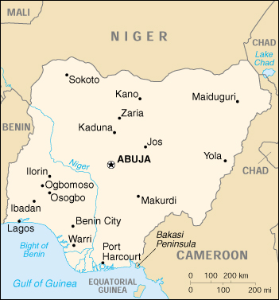
President Olusegun OBASANJO

Ambassador Dele Cole
Chief Advisor to the President
Office Tel: 09 314 0324

Direct Tel: 234 9-314-0372
Fax: 234-9-314-0373
Abuja

Cofield Enterprises, Inc.
World Headquarters

Cofield Building
1016-22nd Street, Suite 200-500
Newport News, VA 23607-5316
Telephone 757 223-0843
Fax 757 223-0844

jcofield@home.com (email)

Website: http://Cofield.my.treeway.com

Proprietary Information Document

To: All key team members

Re: Meeting with Nigerian Ambassador Cole (Chief Advisor to the President)
Our recent private meeting and conversation with Nigeria Ambassador Cole, Chief Advisor to the President, was most productive and enjoyable. Below is a list of the areas he discussed with CEI. These efforts will be “Sole Source” contracting efforts.
1. Development of SWIFT type network
2. Introduction of Visa cash cards via Nigeria Banks
3. Fiber Optic lines to be laid by Chinese company in conjunction with railroad
modernization project
4. Introduction of client company for mobile phone licensing
5. Introduction of client company to develop national ID card system
6. Introduction of Chinese manufacturer to operate and export textile products
through Nigeria
7. Introduction of client company to rehabilitate and increase power generation to
450 – 1000w range under a ROT, IPP, or EPG arrangement
8. Introduction of client company to rehabilitate and expand power distribution
under a ROT or IPP arrangement
9. Market Nigeria to China for increased oil & gas exports
10. Market Nigeria to China for Chinese investment in Nigeria's oil and gas sector

OUR GOAL

Our goal should be to address and package all ten areas by September 20 at the very latest. After gathering feedback on the proposed projects, we can devote next week to drafting the appropriate Expressions of Interest.
I really enjoyed meeting Ambassador Cole this weekend and the conference as a whole. It was fascinating to meet with the new Nigeria in the hopes working together to build the Nigeria of the 21st century.
After our meeting, there was a special contract request for CEI to focus on:
How Nigeria Can Apply These Technologies to Government Functions
1. National ID Card System
Create a national identification card held by all Nigerian
adult citizens that will allow a host of ministerial agencies
to store information on one common card. Ministries will
be able to store boarder-crossing, driver's license, health,
criminal, and tax records all on one card thereby reducing
fraud and lowering administrative costs.
2. Ministry of Defense ID Card
The Ministry of Defense could employ a smart identification
card program for all military and civilian defense personnel.
Such a card would guard against unauthorized access to
buildings and computer networks by storing private encryption
keys and digital clearances for each cardholder. The cards
could also be used for storing medical, dental, training, and
weapon inventory records, again lowering administrative costs.

3. Development of SWIFT type network

Please call me ASAP to expand on this request.
Warmest Regards
Jim Cofield
Office telephone (757) 223-0843

Copy:

Bede U. Ibeh, Senior Counsellor
Embassy of Nigeria
1333 16th Street
Washington, D.C. 20036
(Direct) 202-986-8423
Tel: 202-986-8400
Fax: 202-986-0891
Email: bedeos2000@yahoo.com

Ambassador Dele Cole
Chief Advisor to the President
Office Tel: 09 314 0324

Direct Tel: 234 9-314-0372
Fax: 234-9-314-0373
Abuja

Diplomatic representation in the US:
chief of mission: Ambassador Jibril AMINU
chancery: 1333 16th Street NW, Washington, DC 20036
telephone: [1] (202) 986-8400
FAX: [1] (202) 775-1385
consulate(s) general: Atlanta and New York

Diplomatic representation from the US:
chief of mission: Ambassador William H. TWADDELL
embassy: 2 Walter Carrington Crescent, Lagos
mailing address: P. O. Box 554, Lagos
telephone: [234] (1) 261-0097
FAX: [234] (1) 261-0257

Nigeria: Electrical Power
Overview

Overview
The organisation responsible for electricity production and supply in Nigeria is the National Electric Power Authority, known as NEPA.
Nigeria has 5,881 MW of installed generating capacity.The country has proven gas reserves and around 8 000 MW of hydro development is planned. Nigeria has plans to increase access to electricity throughout the country to 85% by 2010. This would call for 16 new power plants, approximately 15 000km of transmission lines, as well as distribution facilities.
Nigeria exports electricity to neighbouring Niger via a 132 kV interconnection constructed in 1976.
A 950 MW Zungeru hydro facility on the river Kaduna was commissioned in 1994.
Nigeria is reported to suffer from regular power failures and several large thermally fired plants are scheduled for retrofitting.
The World Bank agreed in principle in 1998 to finance a $30 million project to renovate the old 21 MW diesel power station near Port Harcourt. Additional funding is likely to be provided by NEPA.
Mobil is presently negotiating with NEPA over the construction of a 350-MW gas-fired power plant in Rivers State in the south.
The government has entered into an estimated $800 milliondeal with US-based Enron and its Nigerian partners, Yinka Folawiyo Power Limited to build a 560 MW plant. In the first phase, Enron will generate 90 megawatts from two barges at Ijora. During the second phase, due to commence in October 1999, Enron will finance, build, own and operate a new 560-megawatt gas turbine power plant to be located at Morogbo, near Agbara. Enron will also be expected to finance, build, own and operate a 280-km 24-inch offshore natural gas pipeline to supply Independent Power Plants (IPPs). It is expected that the project will be completed in 2001.
The Nigerian government is in the process of privatising existing facilities.

Enron Corp.
1400 Smith St.
Houston, TX 77002-7369
800 231-0215
Phone: 713-853-6161
Fax: 713-853-3129
http://www.enron.com

Key People
Chairman Kenneth L. Lay

VC and Chief Strategy Officer Cliff Baxter
CEO Jeffrey K. Skilling

EVP and CFO Andrew S. Fastow
EVP and Chief Accounting Officer Richard A. Causey

Enron is en route to the peak of the energy heap. The #1 buyer and seller of natural gas and the top wholesale power marketer in the US, Enron also markets and trades other commodities, including paper, coal, chemicals, and fiber-optic bandwidth. Enron's 14,350-MW power portfolio includes merchant plants in the US and interests in energy facilities around the world. The company operates a 32,000-mile gas pipeline system in the US, and it provides energy consulting and construction and engineering services. It holds global water interests through Azurix, and its communications arm (Enron Broadband Services) is building a national fiber-optic network. Enron is selling Oregon utility Portland General Electric.

Top Competitors
AEP | Duke Energy | UtiliCorp ! Cinergy | Entergy | FirstEnergy
The AES Corporation

Electricité de France
2, rue Louis-Murat
75384 Paris Cedex 08, France
Paris City Guide
Phone: +33-1-40-42-54-30
Fax: +33-1-40-42-79-40
http://www.edf.fr

Key People
Chairman and CEO François Roussely
COO for the Customer Branch Loïc Caperan
COO for the Industry Branch Yannick d'Escatha
SEVP and CFO Jacques Chauvin
SEVP and Head of Corporate Services Jean-Louis Joliot

While France has been slow to open its own doors to competition in the utilities industry, state-owned Electricité de France (EDF) has been quick to expand globally. One of the world's top electric utilities, EDF provides power (generating capacity: 103,500 MW) to 31 million French customers and conducts engineering, generation, and distribution activities in Africa, the Americas, Asia, Europe, and the Middle East. The company builds power plants and provides plant management and consulting services worldwide. Nuclear plants provide most of EDF's electricity generation; other sources include hydroelectric and fossil-fueled plants.

