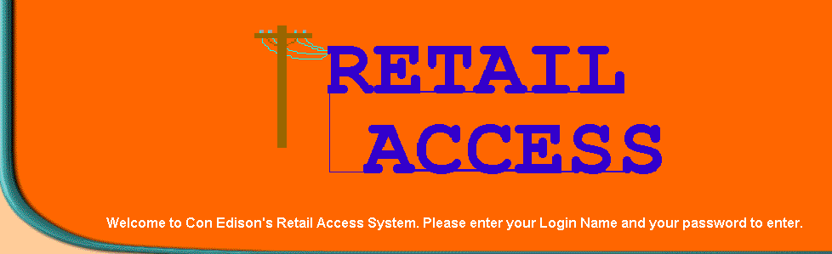

Retail Access Information System

RAIS File Format Changes

Account Listing 1 page

History Output 1 page

Enrollment Output 2 pages

Cycle Usage 1 page

Account Listing Data

This file will contain the list of a marketer’s Active, Inactive (within the last 60 days) and Pending accounts.
It is a comma-delimited file and is zipped.

Each record will contain:
Customer Account Number (15 positions)
Account Activity Code (1 position) A: Active, I: Inactive, P: Pending
Billing Option A: Agency Single ESCO N: Dual Billing R: Single Bill (ConEd)
Date Account became effective (mm/dd/yyyy)
Date Account became ineffective (mm/dd/yyyy) Will display OPEN if account has no expiration date
Reason for customer removal. This is only present if customer expiration date is not OPEN (as above)
Service Classification (3 positions)
Trip Number Customer is Read (2 positions)
Next Scheduled Read Date (mm/dd/yyyy)
Phase Customer Enrolled (1 Position)
Zone Code (1 Position)
Customer Service Address (25 Positions)
Town (21 Positions)
ZIP (5 Positions)
Municipal Code (4 Positions)
Tax Status (1 Position) C, F, M, N, O, P, D, G
Percent Of Residential Use (3 Positions) 0 - 100
Tension Code (1 Position) H, L, M
Minimum Monthly Demand (4 Positions)
ICAP Tag (12 positions) 9999999.9999
Billing History Marketer Output File Layout (All Fields are right justified.)

• Batch Header
- Batch Number - Positions 1-12
- Batch File Name - Positions 13-64
- Submit Date - Positions 65-76

• Error Header
- Account Number - Positions 1-18
- Error Text - Positions 19-55

• Account Detail Header
- Account Number - Positions 1-18
- Account Service Class - Positions 19-29
- Credit Action - Positions 30-44
- Municipality - Positions 45-94
- Tax Status (e.g. F=Full, P=Partial) - Positions 95-109
- Tax Percentage - Positions 110-124
- Stratum Variable - Positions 125-144
- Account Name - Positions 145-167
- Account Service Address - Positions 168-194
- Profile Account Indicator - Positions 195-197
- LBMP Zone - Positions 198-200
- Next Scheduled Read Date - Positions 201-212
- ICAP Tag - Positions 213-226

• Billing History
- Account Number - Positions 1-18
- From Date - Positions 19-32
- To Date - Positions 33-46
- Read Type - Positions 47-49
- Usage - Positions 50-61
- Billed Demand - Positions 62-73
- Bill Amount - Positions 74-88
- Type of Consumption - Positions 89-92
(HI =High Tension, LO=Low Tension, BO=Both, SM=Voluntary Time of Day, or blank)
- Low Tension Secondary Demand - Positions 93-102
- Low Tension G&T Demand - Positions 103-112
- Low Tension Primary Demand - Positions 113-122
- Low Tension Peak Usage - Positions 123-132
- Low Tension Total Usage - Positions 133-142
- High Tension G&T Demand - Positions 143-152
- High Tension Primary Demand - Positions 153-162
- High Tension Peak Usage - Positions 163-172
- High Tension Total Usage - Positions 173-182
- Small TOD On Peak Consumption - Positions 183-192
- Small TOD Off Peak Consumption - Positions 193-202

• Batch Footer
- Batch Number - Positions 1-12
- Batch File Name - Positions 13-64
- "Total Processed" - Positions 65-81
- Number of Processed Accounts - Positions 82-95
- "Total Rejected" - Positions 96-111
- Number of Rejected Accounts - Positions 112-125
- "Total Number" - Positions 126-139
- Total Number of Accounts - Positions 140-153
Customer Enrollment Marketer Output File Layout (All Fields are left justified with a 2-space filler between each field for cosmetic purposes only.)

• Record Type positions 1 - 8
"BATCH"
"HEADER"
"ACCOUNT"
"MESSAGE"
"BTOTALS"
"TOTALS"

• Batch Record Type
Batch Number positions 11 - 19
Batch File Name positions 22 - 63

• Header Record Type
DATE_SET positions 11 - 20 (MM/DD/YYYY)
ACCOUNT_NUMBER positions 23 - 37
CUST_NAME_FROM_MKTR positions 40 - 60
CSS_CUSTOMER_NAME positions 63 - 83
CSS_SERVICE_ADDRESS positions 86 - 106
SC positions 109 - 111
ZONE positions 114 - 117
APP/DIS positions 120 - 127
START_READ_TYPE positions 130 - 148
TRIP positions 151 - 154
DATE_EFF positions 157 - 166 (MM/DD/YYYY)
BO positions 169 - 173
NEW_ACCOUNT_NUMBER positions 176 - 193
TODC positions 196 - 199
TOWN positions 202 - 222
ZIP positions 225 - 229
MUNI positions 232 - 235
USAGE_PRICE positions 238 - 252
MARKETER'S_CUSTOMER_ACCOUNT_NO positions 255 - 284
TAX_RATE positions 287 - 294
ICAP_TAG positions 297 - 308

• Account Record Type
Accepted / Rejected Date positions 11 - 20 (MM/DD/YYYY)
Customer Account No positions 23 - 37
Customer Name from Marketer positions 40 - 60
CSS Customer Name positions 63 - 83
CSS Service Address positions 86 - 106
Customer Service Class positions 109 - 111
Customer Zone position 114 - 117
Approved / Rejected Status positions 120 - 127
Starting Read Type (cycle) positions 130 - 148
Customer Trip Number positions 151 - 154
Customer's Effective Date positions 157 - 166 (MM/DD/YYYY)
Billing Option position 169 - 173 (N: Two Bills, A: ESCO Single Bill,
R: Utility Single Bill)
New Customer Account No. positions 176 - 193
Time Of Day Code positions 196 - 199
Town positions 202 - 222
ZIP Code positions 225 - 229
Municipal Code positions 232 - 235
Customer Usage Price positions 238 - 252 (6.8 positions. Examples: 0.002123,
0.023)
Marketer's Customer Account No. positions 255 - 284
State Sales Tax Rate positions 287 - 294 (1.6 positions Examples: 0.082512, 0.0825)
ICAP Tag positions 297 - 308 (7.4 positions: 9999999.9999)

• Message Record Type
Message Type positions 11 - 17 (Error)
Message Number positions 20 - 26
Message Text positions 29 - 105

• Batch Totals Record Type
"Total Pending" positions 11 - 23
Number of approved customers positions 26 - 35
"Total Rejected" positions 38 - 51
Total No. of rejected customers positions 54 - 63

• Totals Record Type
"Total Pending" positions 11 - 23
Number of approved customers positions 26 - 35
"Total Rejected" positions 38 - 51
Total No. of rejected customers positions 54 - 63

Cycle Usage Data

This file will contain reads retrieved from CSS for the day.

Each record will contain:
Customer Account Number (15 positions)
CSS Service Class (3 positions)
Stratum Variable (10.1)
Next Scheduled Read Date (mm/dd/yyyy)
From Date (mm/dd/yyyy)
To Date (mm/dd/yyyy)
Read Code (A=actual, E=estimated)
Usage (7 positions)
Demand Usage (9.1 positions)
Scaling Factor (8.6 positions)
Type of Consumption (HI =High Tension, LO=Low Tension, BO=Both, SM=Voluntary Time of Day, or blank)
Low Tension Secondary Demand (5.2 positions)
Low Tension G&T Demand (5.2 positions)
Low Tension Primary Demand (5.2 positions)
Low Tension Peak Usage (8 positions)
Low Tension Total Usage (8 positions)
High Tension G&T Demand (5.2 positions)
High Tension Primary Demand (5.2 positions)
High Tension Peak Usage (8 positions)
High Tension Total Usage (8 positions)
Small TOD On Peak Consumption (8 positions)
Small TOD Off Peak Consumption (8 positions)
Profile Account (Interval Meter) Indicator - 1 position (Y or N)
Rebilled Usage Indicator - 1 position (Y or N)
Profile (Interval Meter) Usage - 7 positions
ICAG Tag - 12 positions (9999999.9999)

