Net Exports

Requirements & Dependencies:

- Borland Database Engine

Purpose:

The purpose of the Net Exports application is to estimate the net hourly flow of power into or out of a given “wheel” based on the OASIS data collected by the OASIS reservations harvester.

Uses:

- Selection Criteria will load a listing all Transmission Providers as well as the ability to select specific and/or all service frequencies, status of reservations and the starting date. [Refer to Diag 1]
Note: To select all transmission providers, select the very first option of ‘ALL’ in the listings.
- Clicking on the Submit button will launch up the Imports/Exports form diplaying all sum totals of reservations for the complete day broken into hourly buckets. Note: The figures in red are imports and in blue with the (-) prefix are exports.
- To view the specific reservations, which were a participant of a specific hour, doble clicking on the cell with an amount will launch up a detailed form showing all reservations and their data. [Refer to Diag3]

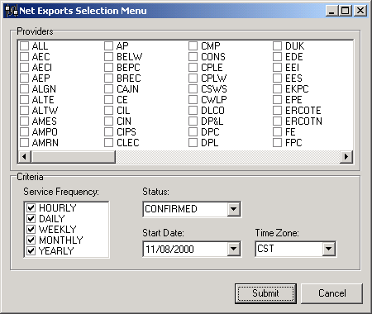
Diag 1
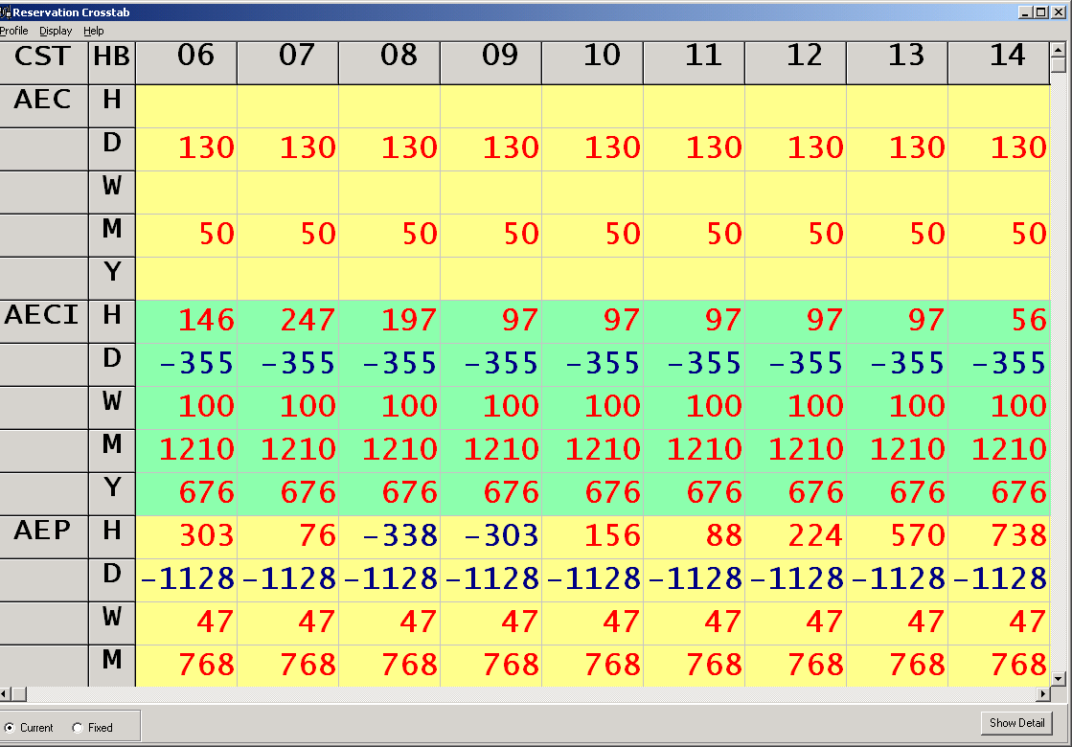Diag 2
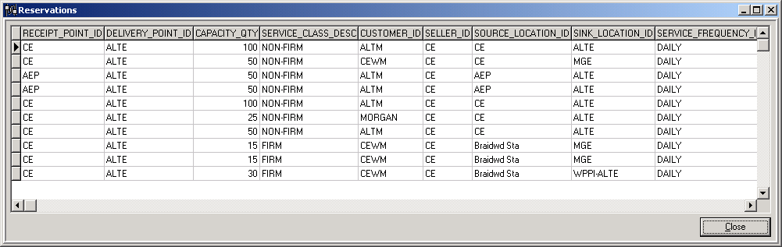Diag 3

