California Energy Commission Workshop

Natural Gas Issues That May Affect Siting New Power Plants In California

January 25, 2001

Introduction

This paper describes natural gas supply, demand and pipeline constraints that may affect the viability of proposals for constructing and operating new thermal power plants in California. The paper also poses questions regarding natural gas utility curtailment rules as they relate to power plant natural gas use. These issues are expected to be discussed at a Siting Committee workshop to be held at the California Energy Commission in Sacramento on January 25th. The purpose of the workshop is to develop the information needed for the Committee to identify appropriate actions, if any, needed to avoid constraints to the licensing of future power plants due to the lack of adequate natural gas supply options.

Background

Growth in demand for power generation in California’s neighboring states has consumed much of the surplus out-of-state generating capacity that once provided large amounts of inexpensive electricity to California. This has forced the state to rely more on in-state generation. Since most electricity generation in California is met by power plants using natural gas, demand for gas has risen to levels that are effectively filling the pipelines serving California, both within and outside the state border. Staff estimates that statewide electricity demand during the next ten years will grow at 2.5 percent per year, requiring significantly more natural gas to meet that demand. With natural gas demand for power generation in Arizona, Nevada, and the Pacific Northwest also growing, staff is concerned about the ability of the existing gas pipeline infrastructure to reliably meet the needs of gas consumers in California, including power plant operators.

Figure 1 illustrates the gas pipeline network in the western U.S. and Canada. Four pipelines (El Paso Natural Gas, Transwestern Pipeline, Kern River Gas Transmission, and Pacific Gas and Electric – Gas Transmission) deliver natural gas directly to California. These pipelines transport up to 7,000 million cubic feet per day (MMcfd) of natural gas to California from Canada, the Rocky Mountains and the Southwest. While each pipeline receives natural gas supply either directly from production facilities or from other pipelines, it is important to note that they also deliver gas to other states before reaching California. Thus, pipeline deliveries to California may be impacted by the demands of customers upstream of the California border, including out-of-state power generators.

Figure 1.
Natural Gas Pipelines Serving California
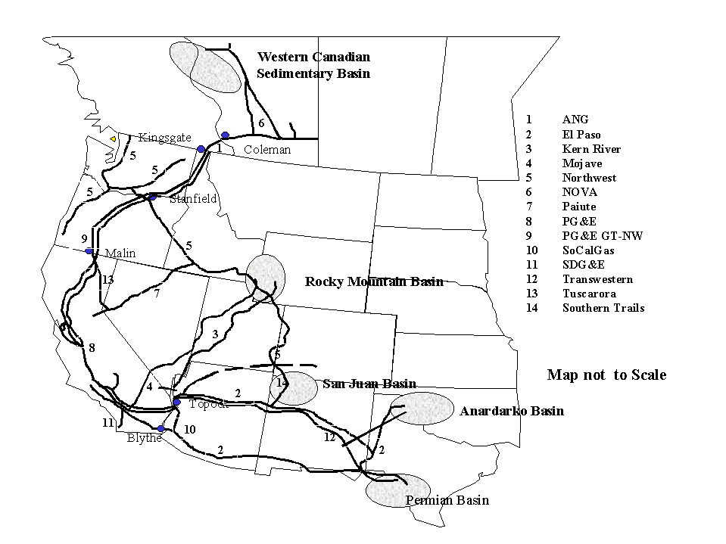

Staff believes that to meet average daily conditions, more interstate pipeline capacity will be needed to transport natural gas from these supply regions within the next five years. Several projects are being considered. Questar Pipeline Company, operator of a number of pipelines in the Rocky Mountain region, has received the approval of the Federal Energy Regulatory Commission (FERC) to convert the Four Corners Pipeline to transport natural gas rather than crude oil. With 90 MMcfd pipeline delivery to California, it extends from the San Juan Basin to Long Beach California and is expected to be operating in late 2001. Williams Companies has filed an application with the FERC to expand its Kern River system capacity by 125 MMcfd, to be operational in spring 2002. Another request for expansion will be filed by Kern River mid-2001 for a yet undisclosed capacity amount.

El Paso Natural Gas recently purchased the Plains All American Pipeline, a crude oil pipeline extending from Santa Barbara, California to Texas. The plans are to convert the pipeline to transport natural gas to the California border and retire El Paso’s older and less efficient Southern System. Initial capacity on this line could be as high as 500 MMcfd. Finally, Pacific Gas and Electric (PG&E) National Energy Group has announced an open season to determine the interest for expanding its PG&E Transmission–NW pipeline capacity by 200 MMcfd. Southern California Gas Company (SoCal Gas) has indicated that it will be adding 70 MMcfd in delivery capacity to San Diego Gas and Electric Company (SDG&E) for use in the 2001 summer. North Baja Pipeline has filed with the FERC and its counterpart in Mexico to provide an initial 500 MMcfd capacity for Mexico and the SDG&E service area.

Table 1 summarizes the interstate pipeline delivery capacity picture to California. While natural gas pipeline delivery capacity to California is 7,000 MMcfd, there is less capacity available within the state to utilize that capacity. Currently there is a 350 MMcfd capacity imbalance at Topock and Needles, major points of interconnection between El Paso and SoCalGas, PG&E, and Mojave Pipeline. Even with projected growth of delivery capacity to 2002 increasing to 7,915 MMcfd, staff is unaware of any proposals seeking to match delivery and receipt capacity at the California border.

Table 1
Interstate Pipeline Delivery Capacity to California
MMcfd
Pipeline | Current Capacity | Capacity Additions | 2002 Total Capacity
PG&E Transmission  El Paso  Transwestern  Kern River  Southern Trails | 1,920  3,290  1,090  700  -- | 200  500  --  125  90 | 2,120  3,790  1,090  825  90
Total | 7,000 | 915 | 7,915
Notes:
1) PG&E Transmission delivery capacity to California is impacted by its deliveries to the Tuscarora Pipeline, which has a rated capacity of 125 MMcfd. Cold weather in the Pacific Northwest can reduce deliveries to California by 350 MMcfd.

2) Kern River has filed with the FERC for 125 MMcfd in capacity additions but can increase its capacity by another 375 MMcfd by adding additional compression stations along its pipeline. Kern River is also exploring extending its pipeline into the Los Angeles basin with a 300 MMcfd pipeline lateral. The pipeline extension would not increase Kern River delivery capacity to California.

3) Southern Trails will also have the capacity to deliver up to 125 MMcfd to points inside the California border. It will have interties with other pipelines in California.

4) El Paso’s Plains All American Pipeline conversion was assumed to be new capacity.

Gas Reliability and the Ability to Meet California Peak Demand

The importance of an adequate and reliable interstate pipeline system is absolutely critical to meeting the criteria of a reliable fuel supply for power plants being considered for licensing. Nearly 85 percent of gas consumed in the state comes from production outside the state. Half of the state’s consumption is satisfied by production in the Southwest, with another quarter coming from Canada. Rocky Mountain production serves about 10 percent of the state’s gas needs.

To balance the supply/demand picture, Figure 2 illustrates California’s natural gas consumption by market sector. Core customers, defined as residential and small commercial customers who need the highest level of service reliability, account for one-third of the total. Noncore customers (large commercial and industrials) who have a lower level of service reliability, represent another quarter of statewide consumption. Electric generation needs and customers served directly by California producers and interstate pipelines, account for the remainder of demand. While data for the full year is not yet available, it appears that the overall 2000 natural gas demand will be substantially higher than 1999 due to high electric generation gas demand. The share of gas demand for electric generation should increase as well.

Figure 2

Beyond the year 2000, California’s natural gas use over the next decade is expected to increase from 6,400 MMcfd in 2000 to 7,500 MMcfd by 2010, a 1.5 percent increase on an annual basis. Virtually all of the increase stems from increased electric generation in California, with that sector experiencing growth in excess of 2.5 percent per year.

In the short-term, it appears that more efficient generation should displace older, less efficient generating units. Through 2003, net annual demand for electric generation is actually expected to decline to 2,400 MMcfd before rising to 3,300 MMcfd by 2010. This estimate could change if, over the next five years, current trends in in-state generation continue, resulting in higher natural gas demand for in-state power generation.

Increasing peak demand for electricity is causing concern about the adequacy of the pipeline infrastructure to deliver needed natural gas to California. Peak summer demand will continue to grow, as well as winter peak demand for space heating. Given the continued reliance on natural gas for electric generation, pipeline capacity to fully deliver gas to California electricity generators and to other customers within the state may not be possible on days of peak demand. This gives rise to questions regarding the reliability of the natural gas infrastructure and its adequacy to serve the state’s peak demand. These issues are discussed in the following section.

Table 2
Forecasted California Power Plant Natural Gas Use
(in Millions of Cubic Feet per Day)
Natural Gas Grouping | 2000 | 2001 | 2002 | 2003 | 2004 | 2005 | 2006 | 2007 | 2008 | 2009 | 2010
PG&E Area | 861 | 881 | 849 | 9518 | 987 | 1,060 | 1,128 | 1,143 | 1,247 | 1,312 | 1,380
SoCal Gas Area | 1,334 | 1,294 | 1,124 | 968 | 970 | 1,060 | 1,094 | 1,142 | 1,168 | 1,245 | 1,351
Coolwater Units | 49 | 48 | 28 | 18 | 19 | 23 | 26 | 24 | 16 | 15 | 17
Southern CA  Production | 2 | 2 | 1 | 1 | 1 | 1 | 1 | 1 | 1 | 1 | 1
Thermal Enhanced Oil Recovery | 156 | 184 | 361 | 392 | 391 | 400 | 394 | 395 | 395 | 395 | 396
SDG&E Area | 160 | 151 | 148 | 78 | 84 | 87 | 92 | 152 | 147 | 147 | 151
Mojave Pipeline | 6 | 6 | 5 | 7 | 7 | 8 | 8 | 8 | 7 | 6 | 6
Total Use | 2,568 | 2,567 | 2,514 | 2,414 | 2,458 | 2,638 | 2,742 | 2,864 | 2,980 | 3,120 | 3,302
Note: Total use may not sum due to rounding.

Source: Memo from Karen Griffin to Bill Wood, Year 2000 Electric Generation Gas Use Forecast, July 2000

Before addressing each region in state, it should be noted that California is not the only western state with new power plant needs. As Table 3 indicates, the regions surrounding California have comparable power plant needs, as indicated by the capacity additions currently under review, under construction, or approved. It can easily be seen why there has not been a lot of surplus capacity for imports to California this year. If only half of the generation shown in Table 3 were developed, natural gas demand in the Western Systems Coordinating Council region would increase over by 5,000 MMcfd. The following section discusses the current ability of each of the natural gas utilities in the state to deliver natural gas to its customers.

Table 3
Proposed Generation within the Western Systems Coordinating Council
(December 2000)
MW
Status | Northwest | Southwest | Rocky  Mountains | California  /Mexico | Total
Under construction/completed  Approved  Applications under review  Starting Application Process  Press releases only  Total | 3,474  2,841  4,509  1,477  1,463  13,764 | 2,264  3,620  6,775  3,640  7,210  23,509 | 783  379  422  0  2,660  4,244 | 5,090  2,020  7,884  2,300  3,812  21,106 | 11,611  8,860  19,590  7,417  15,145  62,623
Source: http://www.energy.ca.gov/sitingcases/index.html

San Diego Region:

The SDG&E service area is at the end of a very long pipeline system. The only links to natural gas supplies are two pipelines from SoCal Gas, with no physical gas storage capability within the region. Hence the flexibility to meet peak demand is limited. Besides supply entering its system, SDG&E can draw upon a small amount of natural gas it can store in its pipeline system by increasing the compression in the pipeline. If that were not adequate, then service would need to be curtailed to some of its natural gas customers.

Although SDG&E can maintain a supply of gas in underground storage facilities located in the SoCal Gas service area, that gas must flow through the same constrained pipeline system, pushing delivery facilities to their limits during peak periods.

In the San Diego area, the natural gas infrastructure has reached the limits of its capability to deliver natural gas. For example, on a cold day in January 1999, natural gas demand in the SDG&E service area almost exceeded the delivery capacity. In addition, during the summer of 2000, SDG&E, on several occasions, barely met its customers’ gas demand without curtailing service. Then on November 13th and the four following days, SDG&E did not have sufficient pipeline capacity to meet all natural gas needs. Noncore curtailment occurred. The situation in San Diego was compounded when in June 2000 SDG&E started delivering natural gas to Mexico to meet power generation gas demand at the Rosarito Beach facilities.

The California Public Utilities Commission (CPUC) has opened an investigation to whether the SDG&E supply and transmission system is adequate to provide service to present and future core and noncore customers. SoCal Gas’s 70 MMcfd to expand delivery capacity to SDG&E and the proposed North Baja Pipeline will enhance SDG&E’s ability to serve its natural gas customers.

Southern California Region:

Currently, the SoCal Gas service area has flexibility to meet its natural gas customer’s needs. This is due to both to its receipt capacity of 3,500 MMcfd and its large natural gas storage capability. But during the past couple of years, the company has had to depend more often and for longer periods of time on its storage to meet summer natural gas demand. This was because its supply receipt points were operating at or near capacity during this time and more gas was needed to meet increased power plant natural gas needs. Without adequate storage when receipt capacity is running full to meet demand, SoCal Gas losses its flexibility to meet peak demand.

Storage injection to meet 2000 winter storage needs were delayed until September and October because of summer gas demand. Full storage was not accomplished due to the continued high electric gas demand and the El Paso pipeline eruption.

The growth in demand for the SoCal Gas system will be driven by electricity generation. The levels of natural gas needed for electricity generation shown in Table 2 will be dependant on how much new southwest generation is built in the next few years and the availability of southwest electricity imports into California. More electricity imports would reduce natural gas demand for electricity generation. Conversely, lower levels of imports would mean a higher need for natural gas for electricity generation.

Congestion is now occurring at Topock because of its desirability as a natural gas delivery point into the SoCal Gas system at the Arizona and California border. Additionally, since mid June SoCal Gas has been running at near capacity to receive natural gas from its various supply sources. This may be indicative that new receipt capacity is needed now. As indicated on the pipeline map shown in Figure 1, expansion options would be at Wheeler Ridge (supply from PG&E, Mojave/Kern River and California production in the San Joaquin Valley), Topock (supply from El Paso) and Needles (supply from Transwestern). The Topock receipt point is always running full and may be the most appropriate location for capacity reinforcement.

Alternatively, the extension of interstate pipeline capacity into the SoCal Gas service could alleviate some supply delivery concerns in the service area. Both Southern Trails and Kern River pipeline system operators have proposed to provide natural gas delivery service into the Los Angeles Basin. The completion of these proposed projects potentially would increase the supply flexibility in the area, reducing the need for SoCal Gas to add new receipt capacity, and increase competition. Each of the pipeline projects could deliver both to SoCal Gas and directly to noncore consumers.

Northern California Region:

PG&E has adequate storage to meet its gas requirements for its residential, commercial and small industrial customers. However, with only seven billion cubic feet (Bcf) available for the growing electric generation sector, PG&E’s storage is rather inadequate to meet its noncore customer needs. The natural gas industry acknowledges this problem and steps are being taken to rectify it through privately constructed and owned gas storage facilities which are being developed. To date, 14 Bcf is available at Wild Goose storage field. Additional storage facilities will soon be developed near Lodi. But the development of the Lodi field may be delayed due to the high prices that would need to be paid to provide the necessary cushion gas for the facility operation.

Another problem looming for PG&E is future capability of the PG&E Gas Transmission line to make gas deliveries at Malin to PG&E. Already up to 125 MMcfd may be taken by the Tuscarora Pipeline from Malin for delivery to the Reno Nevada area. Also, on very cold winter days current deliveries of Canadian gas at Malin, Oregon are limited to about 1,600 MMcfd, about 200 MMcfd below pipeline capacity. The reduction is due to wintertime demand on the upstream portion of the interstate pipeline. As both PG&E and Pacific Northwest winter peak gas demand increases, additional gas transmission capability may be needed to meet peak winter day requirements. In addition, there are a number of new natural gas-fired power plants being sited along the PG&E Transmission pipeline in Oregon and Washington. These new facilities will draw directly from the interstate pipeline. Without the addition of new pipeline capacity in Oregon and Washington, PG&E’s natural gas supply from PG&E Gas Transmission will be correspondingly reduced.

Additionally, given the level of prospective natural gas demand growth for electricity generation in the PG&E service area shown on Table 2, it is most likely that new infrastructure will be needed. This would be in the form of increasing take away capacity, adding more backbone capacity and removing bottlenecks in its system. Additional storage would add flexibility in meeting the large swings in demand.

California produced natural gas could also be used to help meet increasing demand. With the right incentives, producers could move quickly to increase production in California to provide 20 percent of the market share or more. What combination of incentives would be necessary to accomplish this is yet to be determined. Certainly they could include wellhead prices, ease to hook up with the distribution systems, and drilling and exploration tax incentives.

Winter Natural Gas Curtailment for Electric Generators

The present natural gas utility delivery systems were neither designed nor built to meet 100 percent of the natural gas demand 100 percent of the time. The systems were designed to meet core demand on an abnormally cold day. During the winter, demand reaches its peak when core residential and commercial space heating loads are high. A gas utility’s available supply (including that drawn from storage) could be lower than its customers’ needs. In this situation, the gas utility curtailment rules provide that large customers (including power plants) are the first to have natural gas service curtailed.

In the past, when gas was unavailable, power plants had the capability to burn fuel oil. They stored over a month’s supply of fuel oil in a ready-to-use mode. This, however, is no longer the case. Due to environmental and air quality requirements, only a few of the older power plants in California still have dual-fuel capability. Under these circumstances, if gas utilities curtail natural gas service to power plants on a cold winter day with high heating load, electric service reliability maybe adversely affected. The Independent System Operator (ISO) determines when electric curtailments are required and instructs the electric utilities to implement their electricity curtailment plan. However, the natural gas utilities determine the timing and implementation of natural gas curtailment.

In carrying out its responsibility for assuring the reliability of the electric system in California, the ISO completed an August 1999 report on the need for options to insure that there was adequate fuel for electric generation during peak winter natural gas demand periods. The fear was that, in the event of severely cold weather, there might not be enough natural gas for power generation to preserve the reliability of the electric system in certain areas of the State. The report spoke to the need of maintaining limited amounts of fuel oil burning capability at dual-fueled generation facilities located in the PG&E and SDG&E service areas. For all other generation facilities, natural gas is the only fuel that power plants have the capability to burn. Alternative fuels have generally have not been considered an option because of air quality reasons. Other potentially clean burning fuels, such as diesel-like fuels converted from remote natural gas will soon be available for consumption on the West Coast, including California. Should these kinds of fuels be considered for power plant operation?

Natural gas curtailment regulations need to be reviewed in light of this potential problem. The impacts of such curtailment cross several regulatory boundaries. Therefore, to address the problem a coordinated effort is needed between the CPUC, the ISO, the Energy Commission, the California Air Resources Board (ARB), and Air Pollution Control Districts (districts), as well as the utilities. Each of these entities has a responsibility or interest when natural gas service is interrupted. The CPUC regulates the utilities and as such is responsible for overseeing the rules the utilities operate under. The ISO is concerned about the potential loss of generation capacity and the resulting impact on electric system stability during very cold weather conditions. ARB and the districts are concerned with power plant emissions. Utilities have to administer the rules, and other parties may be directly impacted by curtailment actions.

In conjunction with expanding storage and pipelines capacity, a decision on how to best meet the natural gas peaking requirements in the state needs to be made. Should the current curtailment policies of striving to meet the needs of only the residential, commercial and small industrial customers on the designed peak day continue? Or, should the design criteria be expanded to meet a higher and more diverse demand load? If the objective is to meet the growing need for all sectors and reduce curtailment, then new pipeline and storage capacity will certainly be needed to insure that no curtailment occurs to customers that have elected firm gas capacity. The above regulatory agencies may need to adjust their processes to be more responsive to market dynamics, providing gas utilities with the ability to add more receiving, transmission and delivery capacity.

If El Paso does not retire its southern system, this would add up to 500 MMcfd in new delivery capacity to California.
The new capacity would be to meet California’s growing natural gas needs. The announcement indicated that up to 1000 MMcfd in new capacity additions to serve the Pacific Northwest and California would be considered over the next 10 years.
This is particularly true for the PG&E and SDG&E systems that have little or no storage available for noncore customers and have relied heavily on curtailing electric generation plants to meet core demand.
These plants include the Encina and South Bay units in San Diego, Potrero Unit 3 in San Francisco and the Humboldt units at Eureka.
For a further discussion on winter curtailment events see, California Energy Commission, Staff Report, Natural Gas Market Analysis and Issues, November 21, 2000.
Dual Fuel Capability Requirements, Memorandum from Kellan Fluckiger, August 19, 1999.
A design peak day consists of a cold temperature that has been experienced and an estimated demand that would be expected if the temperature were to reoccur. Each gas utility designs for different adverse peak day temperatures.

