Natural Gas Settlement Prices

**Note:
Please be aware that this is a preliminary snap shot of settlement prices. Any updates or revisions are not reflected in this attachment. This attachment is to be used as a tool and represents settlement prices from CQG. It does not confirm that prices have been downloaded into ERMS. Prices that are downloaded into ERMS will be verified by 4:15 p.m. Central standard time, if this deadline cannot be met due to various system constraints you will be notified prior to the 4:15 p.m. deadline.

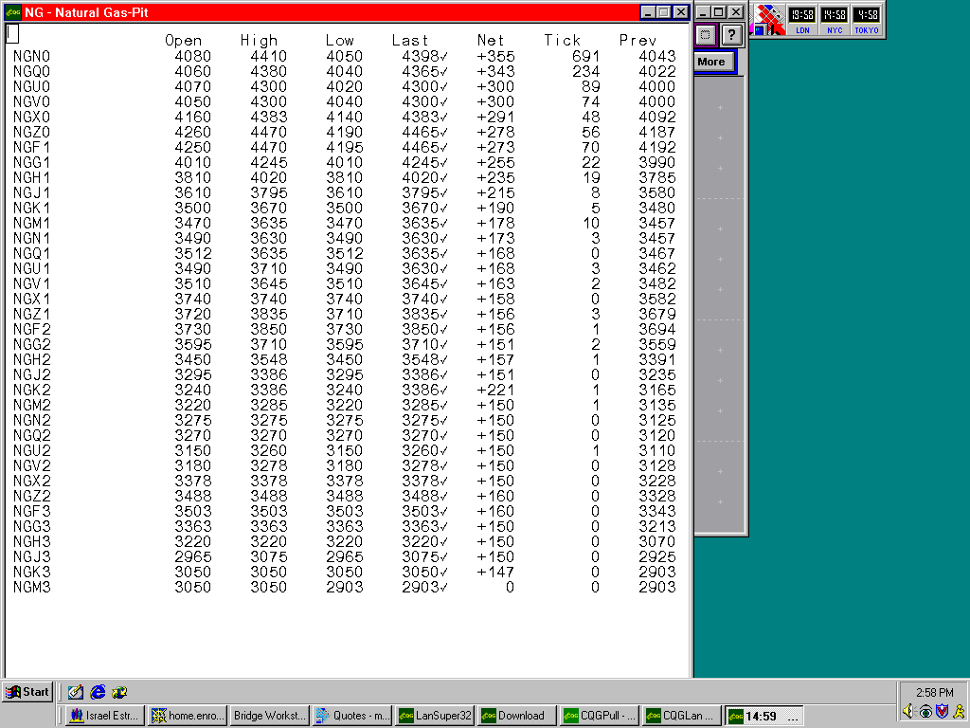
June 5, 2000

