Notice of Request for Bids for Sale of Land and Accompanying Subsurface Mineral Rights
Assumption Parish, Louisiana

Confidentiality:

The information contain in this solicitation for bids is proprietary and confidential information of Enron North America Corp. and is intended solely for the purposes of evaluating a bid for submittal to Enron North America Corp. as specified herein. In no event shall this information be used for any other purposes or disclosed to anyone other than the named addressee(s), except with the express consent of Enron North America Corp.

Description:

The Enron North America Corp. seeks bids for 330.12 acres of land located in Township 12 south, Range 13 east, Sections 41 and 46, in Assumption Parish, Louisiana. This land, currently owned by LRCI, Inc, an Enron North America Corp. subsidiary, sits atop the Napoleonville Salt Dome roughly 50 miles south of Baton Rouge. The land is divided into two sections: a 73.57-acre northern section (Tract 5a) and a 256.55-acre block to the south (Tracts 4a and 4b). Tract 5a borders Grand Bayou to the west and abuts a portion of LA Highway 70 to the southeast. Tracts 4a and 4b, though non-contiguous to Tract 5a, are contiguous to each other and form a rectangular and slightly L-shaped block of land to the south and slightly west of Tract 5a. The surface land is composed primarily of bayou floodplains, typical of the regional geography. Also typical of the regional geography, Tracts 5a, 4a and 4b contain large subsurface salt reserves. Please refer to attached maps for specific locational details.

The Salt:

Conservatively, Tracts 4a and 4b have been estimated to contain about 750 million tons of extractable salt. The salt top is approximately 700 feet below ground level. An independent analysis of the salt quality at Napoleonville was performed by Re/Spec, Inc., and reveals a 97% halite, 3% anhydrite composition with miniscule traces of potassium and magnesium. The crystal size is coarse and generally clear of opaque impurities.

This is high quality salt that an independent study confirms is typical of domal salt in the coastal Louisiana area. Furthermore, salt from the Napoleonville Salt Dome has been shown to be of lower steady-state stress than that of most other domes in the Gulf Coast region, indicating a rich resource for various forms of salt dome development.

Potential Uses of the Land:

Mining—The Napoleonville Salt Dome’s proximity to the ‘chemical corridor’ of Louisiana, including facilities in Plaquemine, Taft, and other towns nearby, makes it geographically ideal for chemical-grade salt development. Existing de-brining infrastructure creates significant cost advantages to parties already operating in the area and may enhance access to the dome for parties interested in developing operations at Napoleonville.

Storage—The Napoleonville Salt Dome is strategically situated to take advantage of nearby gas and liquids pipelines as well as the Henry Hub pooling point.

Submit Bids:

The Enron North America Corp., on behalf of LRCI, Inc. welcomes bids for the purchase of all or portions of Tracts 5a, 4a and 4b. Please submit a written bid, including price, form of payment, and timing to close, as well as any questions or comments, to:

Eva Rainer
Enron Storage Products Group
Enron North America
1400 Smith Street
Houston, TX 77002
tel: 713-853-9679
fax: 713-646-8416
eva.rainer@enron.com

Or

Paul Bieniawski
Enron Storage Products Group
Enron North America
1400 Smith Street
Hosuton, TX 77002
Tel: 713-345-8641
Fax: 713-646-8416
paul.bieniawski@enron.com

The deadline for submission is September 12, 2001.

Nothing in this solicitation for bids shall obligate Enron North America Corp. or its affiliates to accept any bid submitted hereunder and Enron North America Corp. in its sole discretion may reject any and all bids submitted hereunder.

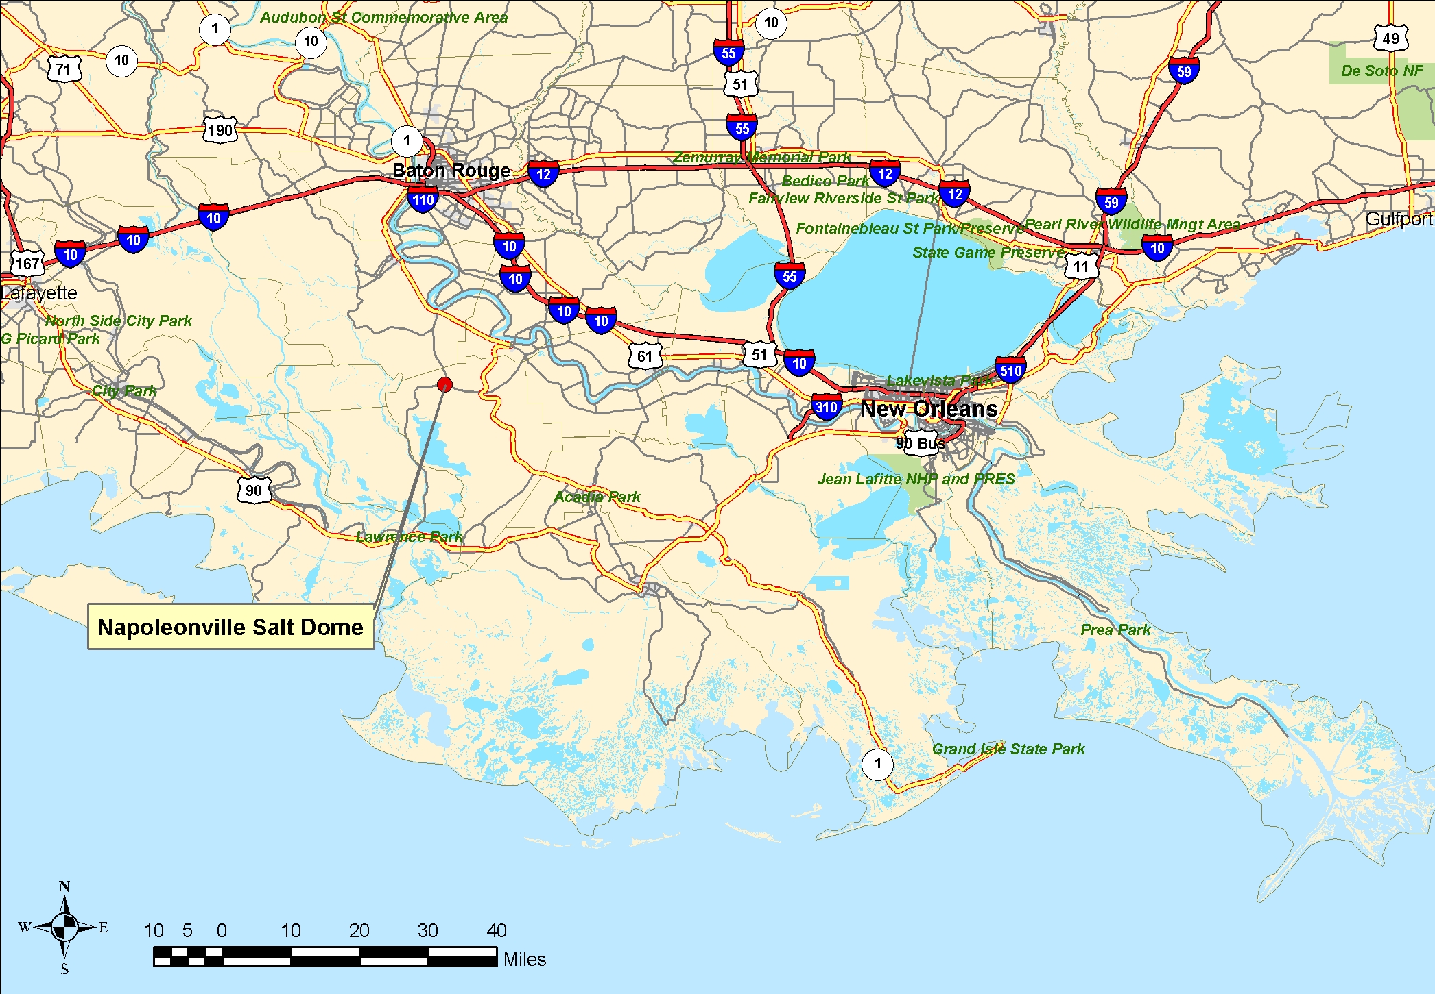
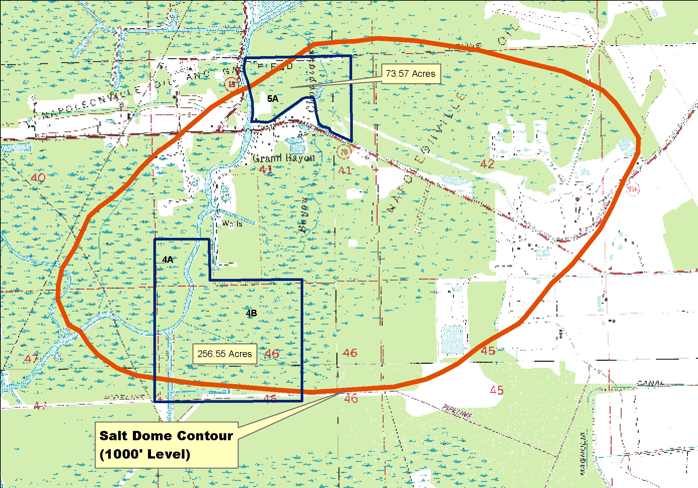

Based on 3,518,592 square feet of mineable surface area at a 3,000 foot producing interval.

