Join NESA at the
NYMEX Brown Bag

Guest Speaker: Deniese Palmer-Huggins

WHO: Anyone involved in the energy services industry.
NESA members and non-members alike are
encouraged to attend, so please spread the word!

WHAT is being covered:

Introduction and overview of the Exchange - where did we come from and how did we get here?

What makes NYMEX different: Clearing and oversight by CFTC. How the Exchange can offer credit guarantees.

Where does NYMEX stand on electronic trading, plus an explanation of the current system and where NYMEX is going?

Explanation of new products: Brent, NG futures, LOX, EFS, EOO, NN and more.

WHERE: KOCH Industries, 20 E. Greenway Plaza, Training Room 1

WHEN: January 15, 2002 COST: Members $50,
11:00 am – 12:30 PM Non-members $75
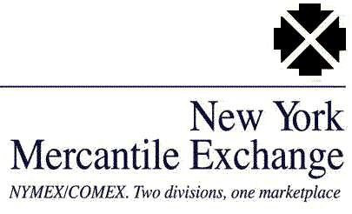 LUNCH IS BEING SERVED!

NYMEX Brown Bag

REGISTRATION FORM

January 15, 2002

To register for the NYMEX Brown Bag, please complete this form and return it to NESA at 6830 N. Eldridge Parkway, Suite 302 / Houston, TX 77041 or fax it to us at (713) 856-6199. The cost is $50 for NESA members and $75 for non-members.

Attendance is limited, with space assigned on a first-come, first-served basis. This tour is sure to sell out, so register today! If you have any questions please contact Lana Moore at (713) 856-6525.

Name

Nickname

Title

Company

Address

City State _________ Zip

Phone # Fax #

E-Mail

- Please check box to become a NESA member. Annual fees are $75.

Method of Payment: $ NO REFUNDS!!

Check or money order made payable to: NESA
Bill my Credit Card VISA Master Card AmEx

CARD # EXP Date

Name on Card (PLEASE PRINT)

Signature

