FEDERAL ENERGY
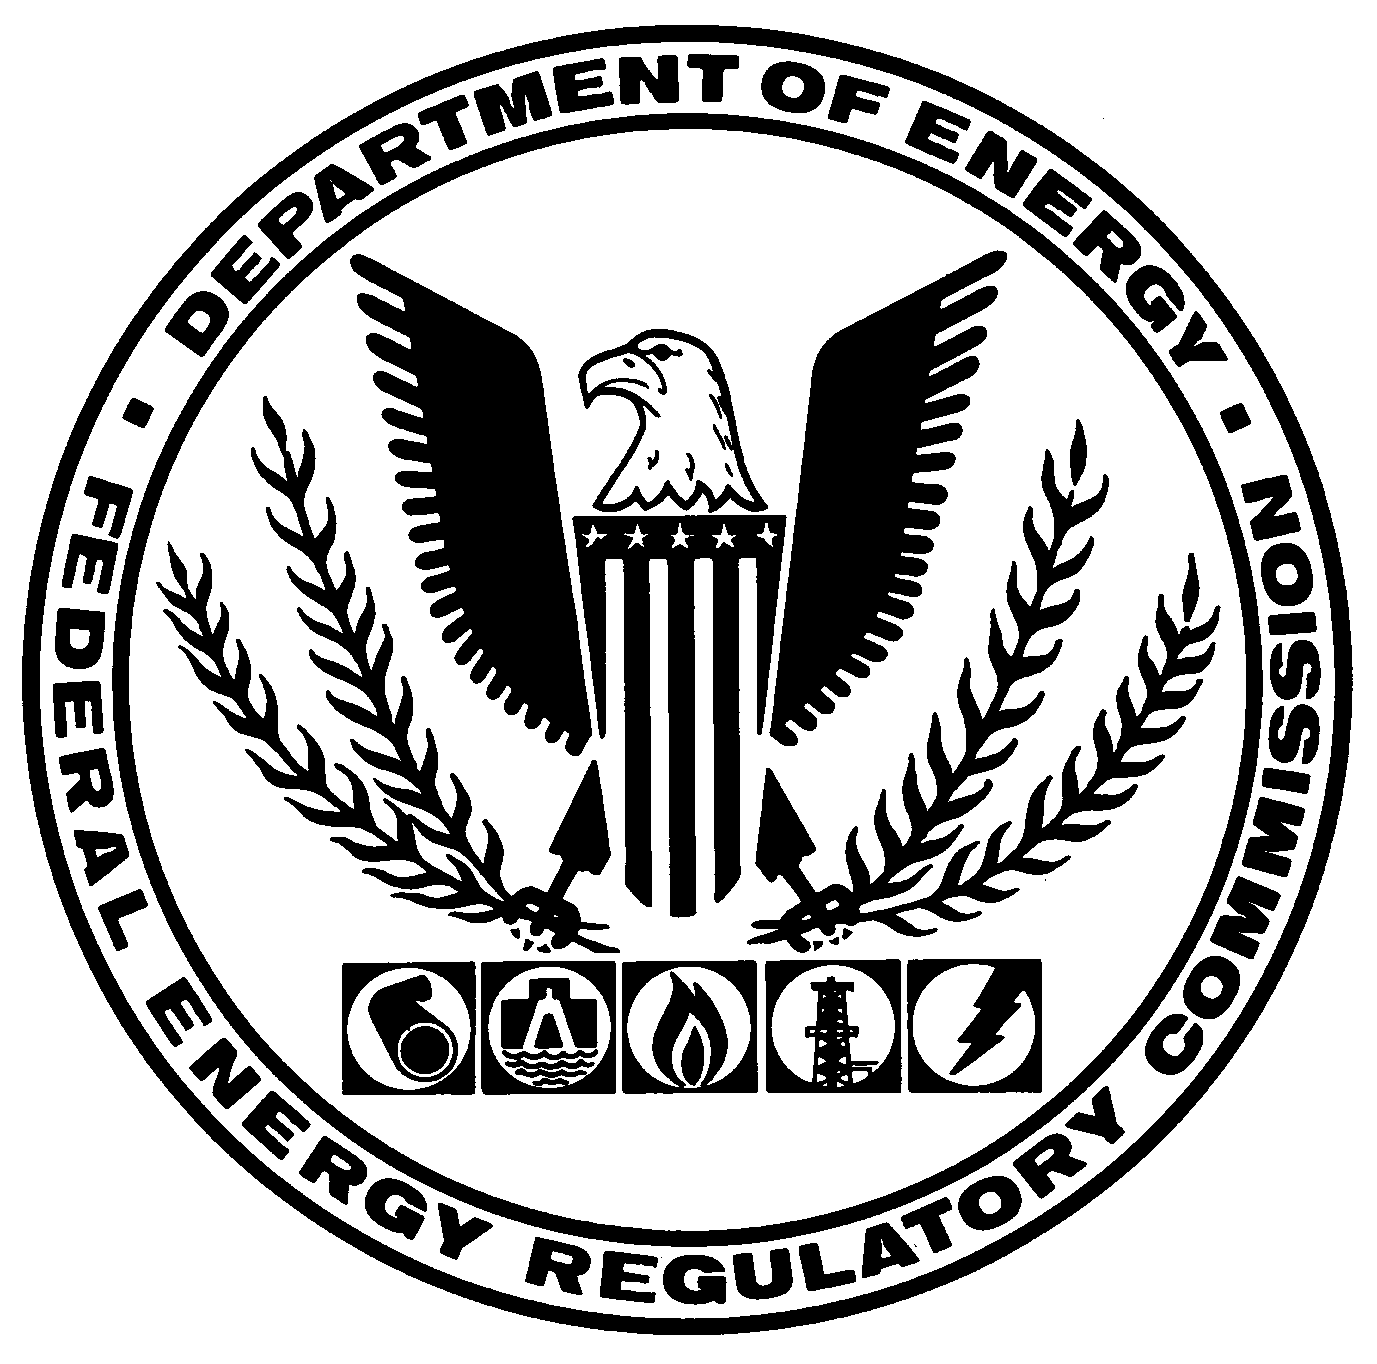
REGULATORY COMMISSION
WASHINGTON, D.C. 20426

NEWS RELEASE
NEWS MEDIA CONTACT: FOR IMMEDIATE RELEASE
Hedley Burrell September 26, 2001
(202) 208-0680

COMMISSION TO STUDY CAPACITY RESERVE CHANGES

The Federal Energy Regulatory Commission decided today to study new ways to ensure sufficient reserve capacity in electricity markets after hearing a staff study team's recommendations.

The team recommended consideration of systems that focus on the purchase of forward reserves, which should avoid market power problems. It also said that demand-side management has the potential for an expanded role in ensuring adequate capacity reserves.

In considering how to ensure sufficient reserve generating capacity, the team reviewed practices under past regulatory regimes and possible mechanisms to ensure sufficient reserve capacity.

Under the present system, generators in some regions face a so-called deficiency charge if reserves are allowed to drop below a certain level.

Comments on new ways to ensure sufficient reserve capacity should be submitted by October 17 under Docket No. EX01-1.

R-01-42 (30)

