NNG Lockridge Site: NW pit area with incinerator/blower unit, equipment building, and recovery AST.
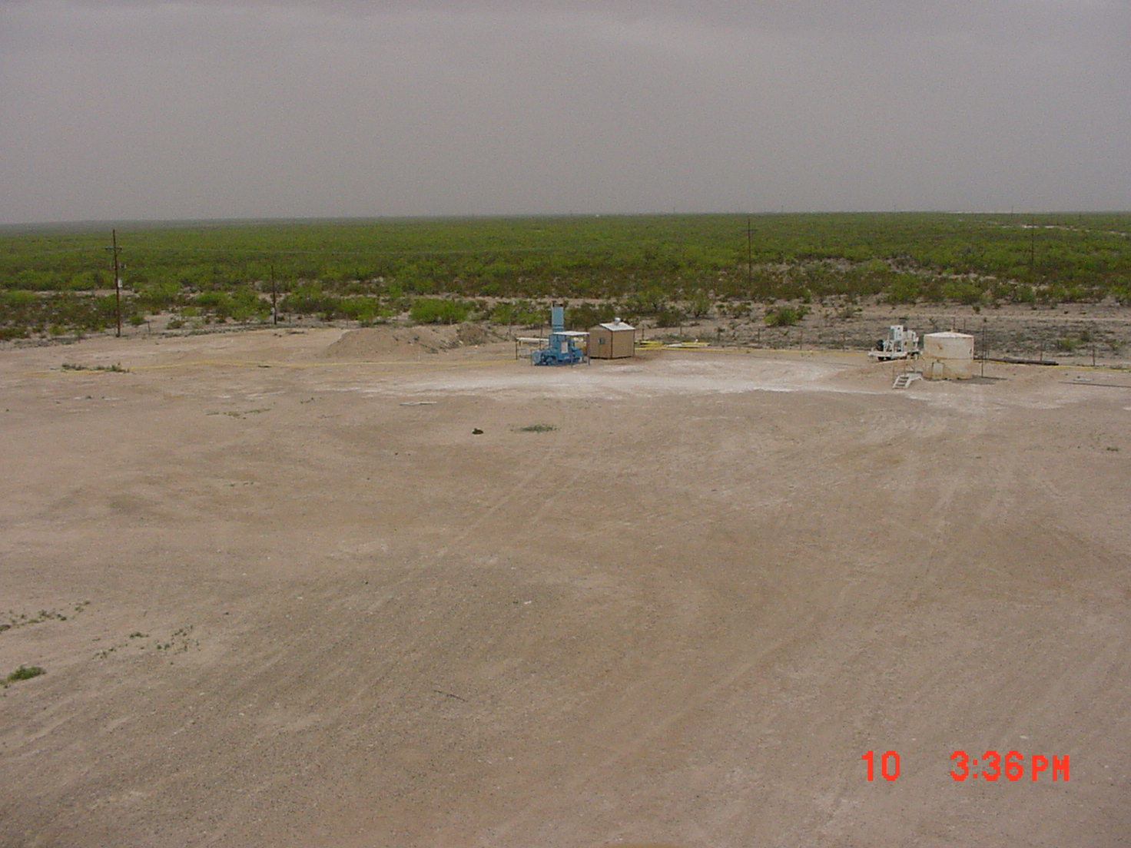

NNG Lockridge Site: SW corner of site. Four of the five proposed well locations are indicated in photo.
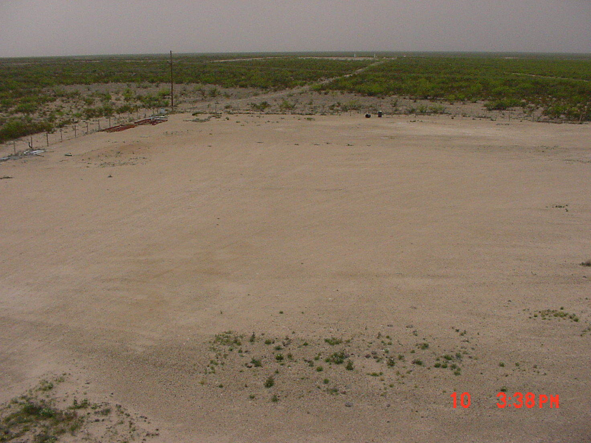
MW-13
MW-12
Proposed
Rec. Well
Proposed
Rec. Well
Proposed
Mon. Well

NNG Lockridge Site: NE pit area. AST and containment are not NNG’s.
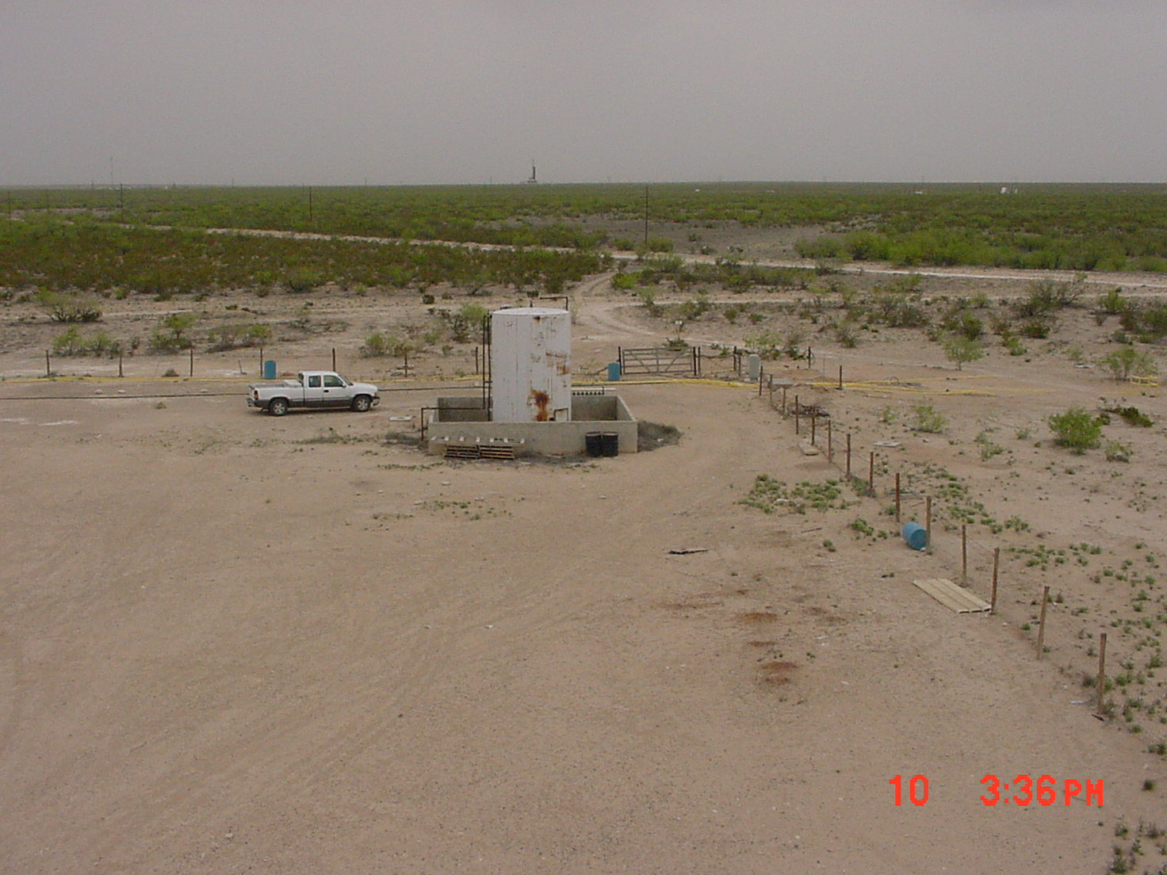

NNG Lockridge Site: NE pit area. One of the new dual completion SVE/AS wells. The air sparge line is the black HDPE pipe sticking up next to the PVC well materials.
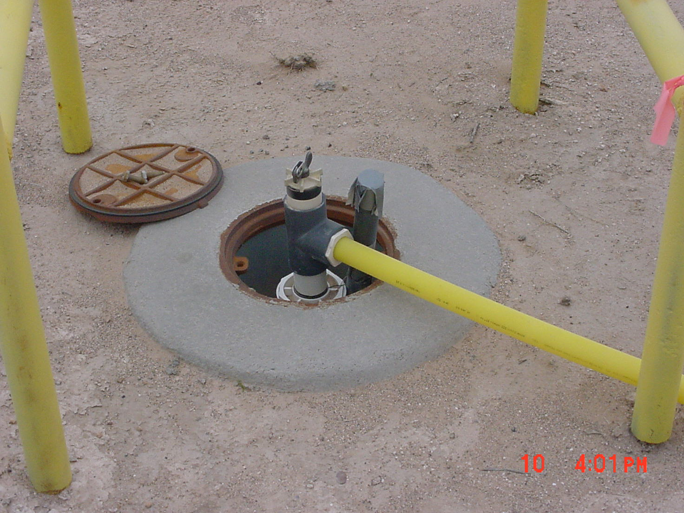
Air sparge line
(not in use)
SVE line to
manifold in
knockout box

NNG Lockridge Site: NE pit area. SVE knockout box and compressed air tank.
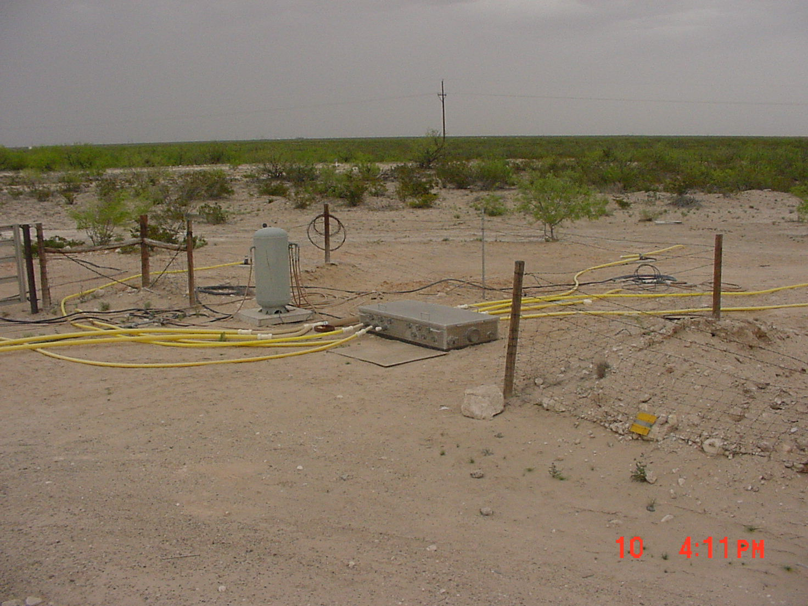

NNG Lockridge Site: NE pit area. SVE knockout box interior. Manifold has slots for six SVE wells.
