Keystone Storage Facility

Non-Binding Proposal to Northern Natural Gas

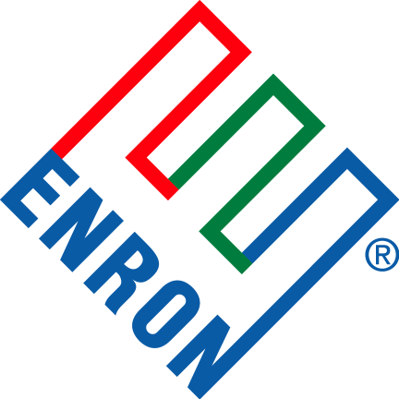
by Enron Compression Services and Enron Storage Products

July 27, 2001

Proposal Summary
Enron Compression Services Company (“ECS”) is proposing a structured service to satisfy the gas storage needs of Northern Natural Gas (“NNG”) at Unocal’s Keystone storage facility in Kermit, TX. ECS has structured the following notional terms based on certain assumptions, which are presented in the body of this proposal. The terms in this proposal are non-binding and are intended for discussion purposes solely between ECS and NNG.

Commercial Terms
The notional terms in this document reflect services that ECS is proposing to NNG, in addition to services that NNG would provide to ECS. In addition to a Compression Services Agreement and a related energy contract, ECS would contract with Unocal for the products and services outlined in this proposal. All services originate or terminate at the Unocal Keystone storage facility.

Contract Term
All products and services provided by ECS to NNG are for a 7-year contract term, assuming a June 1, 2002 start date and May 31, 2008 end date.

Storage Capacity
ECS would provide 1.5 BCF (approximately 75% of the total working gas in Phase I) of firm storage capacity to NNG at Unocal’s Keystone gas storage facility. In exchange for this storage capacity, NNG would pay ECS a Storage Capacity Fee of $1.95 per MMBTU, per year. The resulting payment would be $2,925,000 annually. NNG may elect to fund and construct the required pipeline and associated interconnect from the NNG mainline to the Keystone storage facility. If NNG elects to finance and construct the aforementioned assets, the Storage Capacity Fee paid by NNG would be reduced to $1.20 per MMBTU, per year.

Storage Facility Operations
Unocal would operate the Keystone storage facility 24 hours/day, 365 days/year. The 7,000 horsepower electric compression package being proposed by ECS would enable Unocal to inject a maximum of 100 MMBtu/day and to withdraw a maximum of 200 MMBtu/day. ECS would arrange for NNG to have firm access to its pro-rata share of the facility availability and deliverability (approximately 75%) or injection rights of 75 MMBtu/day and withdrawal rights of 150 MMBtu/day. ECS could arrange for greater than NNG’s pro-rata share to the facility operations on an interruptible basis at a price to be negotiated at a later date. NNG’s access to the storage facility would be limited only by its pro-rata share of the capacity. In addition, ECS would provide NNG with liquidated damages for operational non-performance excluding force majeure. ECS and NNG would have to negotiate the pricing of the aforementioned liquidated damages.

Firm Transportation Backhaul
NNG would provide a Firm Transportation Service (“FT”) to ECS from the Keystone storage facility to the Waha commodity trading hub in Waha, Texas for a term of 2 years beginning June 1, 2002. The volumetric gas for the FT would be 200 MMcf per day. In exchange for the FT, ECS would pay NNG a demand rate of $0.02 per MMBTU transported plus a fuel charge.

Interruptible Forward Haul
NNG would provide an Interruptible Transportation Service (“IT”) to ECS from the Waha commodity trading hub to the Keystone storage facility for a term of 2 years beginning June 1, 2002. The volumetric gas for the IT would be 200 MMcf per day. In exchange for the IT, ECS would pay NNG a demand rate of $0.035 per MMBTU transported plus a fuel charge.

THIS PROPOSAL AND TERM SHEET ARE FOR DISCUSSION PURPOSES ONLY TO FACILITATE THE NEGOTIATION, PREPARATION AND EXECUTION OF A DEFINITIVE AGREEMENT. THIS PROPOSAL AND TERM SHEET ARE NOT AN OFFER OR COMMITMENT BY ECS OR ANY AFFILIATE OF ENRON CORP. ALL PRICES AND TERMS ARE SUBJECT TO CHANGE UNTIL SUCH TIME WHEN A DEFINITIVE AGREEMENT MAY BE SIGNED. THIS PROPOSAL AND TERM SHEET IS NOT INTENDED TO CREATE A BINDING OR ENFORCABLE AGREEMENT OR CONTRACT OR TO BE COMPLETE AND INCLUSIVE OF ALL THE TERMS OF THE SUBJECT TRANSACTION. FURTHERMORE, THIS PROPOSAL AND TERM SHEET IS NOT A COMMITMENT OR AGREEMENT TO ENTER INTO A BINDING AGREEMENT OR CONTRACT IN THE FUTURE.

Enron Contact Information

Ned Higgins
Enron Compression Services
713-853-4503

Paul Bieniawski
Enron Storage Products
713-345-8641

1400 Smith Street
Houston, TX 77002-7361

P.O. Box 1188
Houston, TX 77251-1188

