NNG SHORT TERM SUSTAINABLE CAPACITY
September 18, 2001

OBJECTIVE:

Establish a process to separately identify and report that short-term sustainable capacity which is available for < 30 days from that short-term sustainable capacity which is available for 30 days or longer.

Definitions:

In CAS we have 2 distinctions: Sustainable and Non-Sustainable

Sustainable: that capacity available for sale at least 150 consecutive days (can be referred to as long-term sustainable capacity)

Non-Sustainable: that capacity available for sale for less than 150 consecutive days (can be referred to as short-term sustainable capacity or daily capacity)

In reporting, we have 2 distinctions: Operationally Available and Unsubscribed (ignoring design capacity)

Unsubscribed: that capacity within the long-term sustainable + short-term sustainable level which is not currently under firm contract so it is available to be sold under a firm contract. This information comes from CAS. NNG currently has 3 unsubscribed capacity reports on its web site.

Operationally Available: total level of capacity available to be scheduled on any given day which includes long-term sustainable and short-term sustainable from CAS and any other available capacity determined by gas control each day. NNG’s operationally available capacity report shows the difference between the total level of operational capacity at a point and the amount already scheduled at that point. This difference is then available to be scheduled as IT.

In Gas Control--(do the above definitions match terminology used in Gas Control?)

Ideally

We would want CAS to capture 3 capacity #’s for every point:

Long-Term Sustainable: capacity available for sale at least 150 consecutive days.

Short-Term Sustainable: capacity available for sale for at least 30 consecutive days but less than 150 consecutive days.

Daily Capacity: capacity available for sale for less than 30 consecutive days.

Then, CAS could feed web site reporting with the new “daily capacity” populating the new NNG Unsubscribed Daily Capacity report (modeled off the TW Unsubscribed Daily Capacity Report).

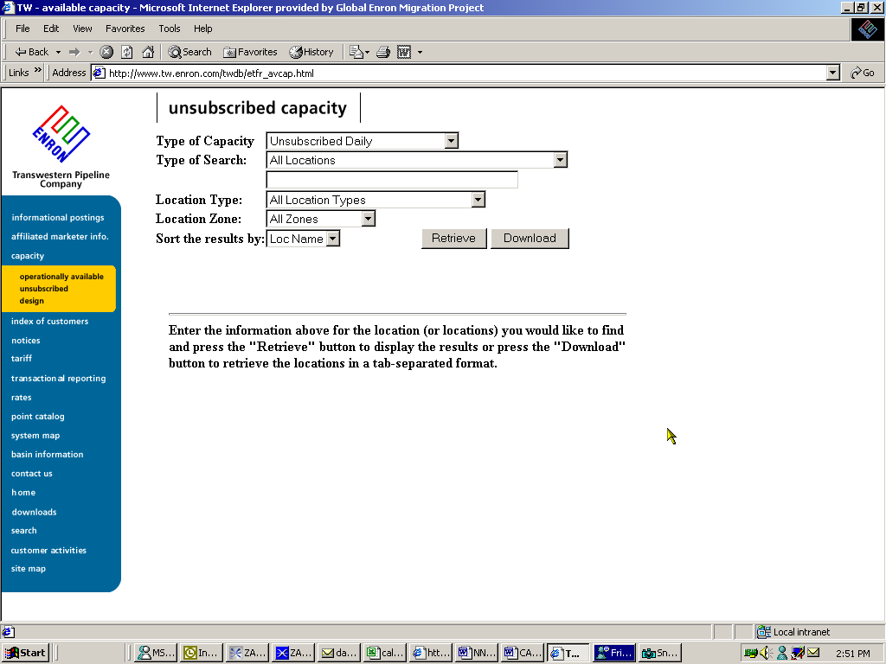

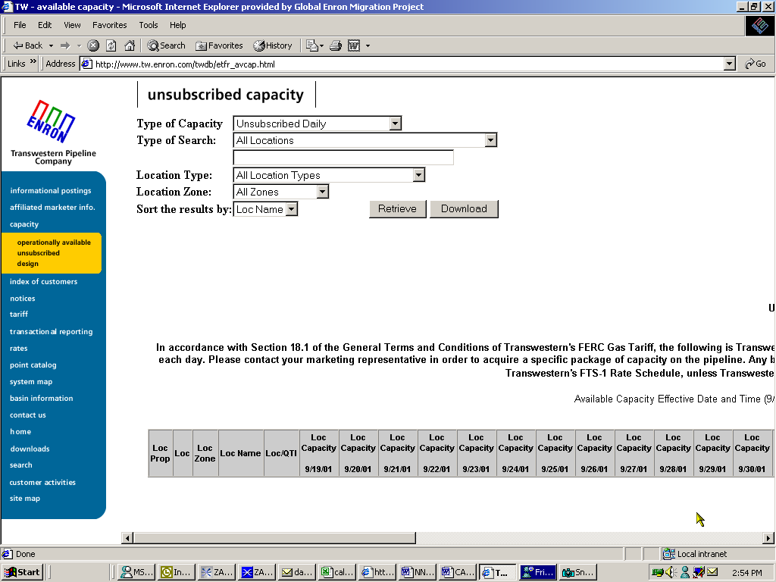

Issue

The “ideal” is not going to happen by October 1, 2001, so how do we define the process and implement manual steps to facilitate gathering this day-to-day data and populating the NNG Unsubscribed Daily Capacity Report by October 1, 2001?

Who knows when we have day-to-day short-term sustainable capacity?

