The sql statements for the FULL day and partial day (last 5 minutes) interfaces are shown here.

FULL Query (trades for the full day)

select
a.transaction_id ID,
to_char(a.transaction_dtm,'MM/DD/YYYY HH24.MI.SS') DATE_TIME,
a.transaction_price_amt PRICE,
a.transaction_qty QTY,
to_char(a.reference_period_begin_dtm,'MM/DD/YYYY') BEGIN_DATE,
to_char(a.reference_period_end_dtm,'MM/DD/YYYY') END_DATE
from
eol_trading_transactions a,
eol_market_products b,
eol_trading_counterparties c
where
a.market_product_id+0 = b.market_product_id and
a.counterparty_id = c.counterparty_id and
c.internal_desk_flag = 'N' and
b.product_type_id+0 = 1182 and -- CAN GAS PHY
b.location_id+0 = 143 and -- NIT location
b.reference_period_id+0 <> 499 and -- specifically removing balance-of-month product
a.transaction_dtm >= to_date(trunc(sysdate))

LAST 5 MINUTES

select
a.transaction_id ID,
to_char(a.transaction_dtm,'MM/DD/YYYY HH24.MI.SS') DATE_TIME,
a.transaction_price_amt PRICE,
a.transaction_qty QTY,
to_char(a.reference_period_begin_dtm,'MM/DD/YYYY') BEGIN_DATE,
to_char(a.reference_period_end_dtm,'MM/DD/YYYY') END_DATE
from
eol_trading_transactions a,
eol_market_products b,
eol_trading_counterparties c
where
a.market_product_id+0 = b.market_product_id and
a.counterparty_id = c.counterparty_id and
c.internal_desk_flag = 'N' and
b.product_type_id+0 = 1182 and -- CAN GAS PHY
b.location_id+0 = 143 and -- NIT location
b.reference_period_id+0 <> 499 and -- specifically removing balance-of-month product
a.transaction_dtm >= sysdate - 5/1440

The following image shows the results of the full query (run at 2:30 CDT on 6/21/01). For illustration purposes, a COUNTERPARTY_ID column has been added. This data, however, is not sent.

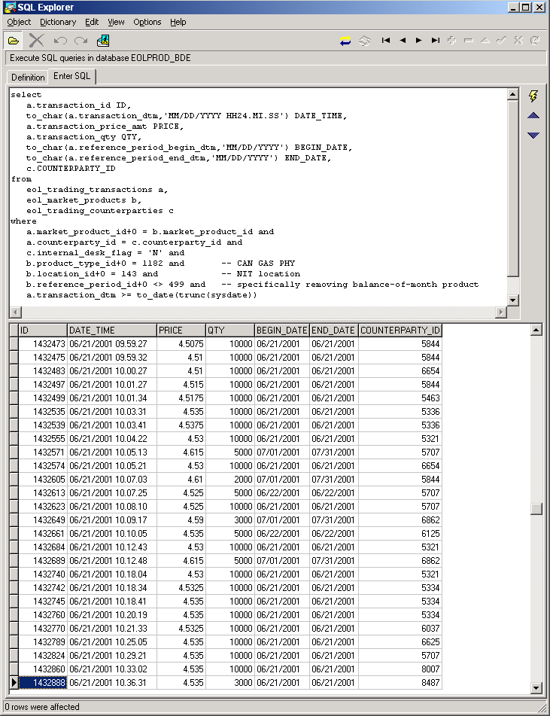

The next image shows the same query with the “c.internal_desk_flag = ‘N’” clause removed. This will pull in all trades, both internal and external. In particular, transaction 1432678 now appears. This is an internal trade executed by counterparty 6365.
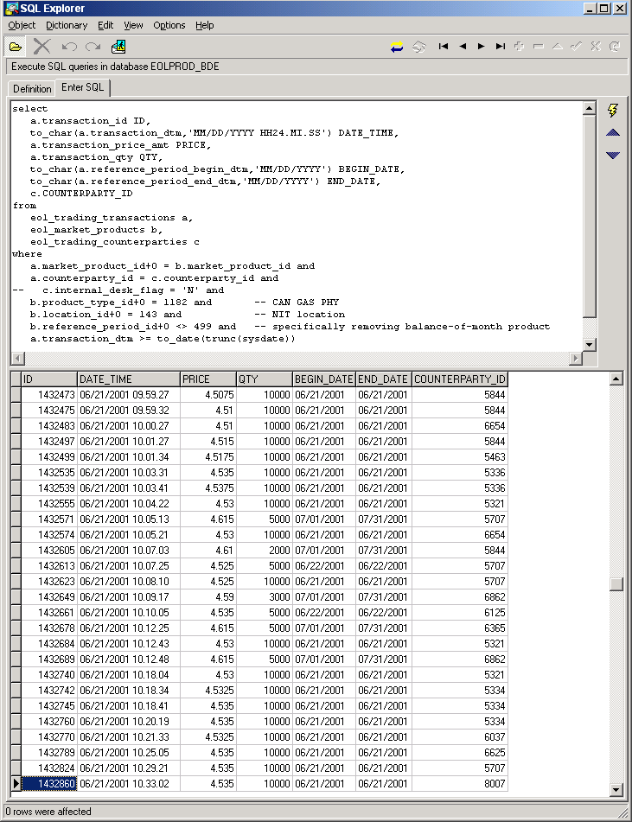

The final image shows a subset of counterparty data. In particular, it demonstrates that counterparty 6365 is internal.
