Natural Gas Technical Commentary
Monday, 30 July 2001

Energy Desk

Tel. 1 212 859 1350

Near Term (Basis September): Neutral, firming

Monday’s upside follow through came about as expected following the little reversal action Friday and a COT report that showed the large specs to have increased their net-short position again. In trading up through $3.340 basis September, we feel this should allow a boost from technical buyers that can take the board into the key 40-day moving average resistance level. With a prior reaction rally high at $3.510 and the 40-day MA sinking close to this level this week, it should make for a key location and showdown on the chart. With a daily stochastic buy signal in place, we like the chances for the bulls here. There should be one more good attempt at holding the market down into the upcoming resistance. If futures can push on through, watch for the ‘fund-types’ to get aggressive on the buy side. The look of a traditional ABC-corrective rally into the 40-day MA is a selling opportunity for the trend followers and other bears. We feel if the market can’t be put under pressure and is still hanging around the $3.500 level or better by Thursday or Friday, we will start looking for reasons to turn bullish.

Long Term: Bearish
Our long-term technical model remains bearish. Major resistance is at $3.670 and $4.380, while support is $2.715 and then $2.080.
Daily Numbers
Last Trade: | 3.350
Change: | +.156
9-Day Stoch: | K= 59.94 D= 41.86
18-Day MA: | 3.214
40-Day MA: | 3.561
Resistance 2nd: | 3.510
Resistance 1st: | 3.430
Support 1st: | 3.320
Support 2nd: | 3.220

Commitments of Traders Data (futures only) as of July 24, 2001
Trader Group | Long | Short | Net
Large Spec | 5,502 | 34,668 | -29,166
Commercial | 396,139 | 386,534 | 9,605
Small Trader | 51,404 | 31,843 | 19,561

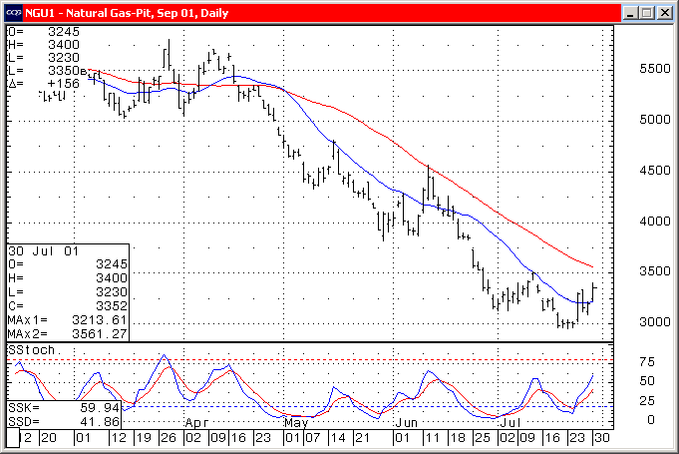

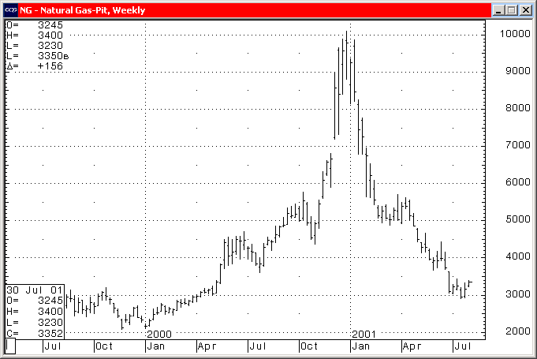
Charts courtesy of CQG, Inc.

