NERC Control Area Certification Procedure

For implementation June 1, 2000

Summary
This document describes and defines the process that will be used to certify an entity as a Control Area. The Control Area Certification Procedure is used for certifying an entity requesting to become a new Control Area. The Certification Procedure is designed around NERC’s established operating criteria, measurements, documentation forms and review protocols, and around the NERC Regions overseeing and implementing data collection, a peer review process, and determining and awarding certification status.
The primary steps in the Control Area Certification Procedure, and entity responsible for each step, is as follows:
- Initiation of Process – Entity seeking certification (the “Applicant”)
- Provision of criteria, process, documentation, etc. – NERC
- Formation of Certification Review Team – Region
- Data collection – Region
- Data review – Region (Review Team)
- Site visit – Region (Review Team)
- Recommendation – Region (Review Team)
- Certification – Region
- Notification and Operations Authorization – NERC
While not specifically referenced in this document, as with all NERC Standards, Regions may adopt specific requirements and guidelines that can be used in conjunction with (but not in place of) the NERC Control Area Certification Procedure. However, in doing so, the Region cannot compromise the NERC-established certification Procedure and requirements without formal approval from NERC. It is expected that all Regionally-adopted Control Area certification procedures and process documentation will be filed with NERC and approved by the NERC Operating Committee.
Finally, the Control Area Certification Procedure establishes a maximum allowable time of six months to complete the certification process. Obviously, the time it takes to certify an entity depends on several factors (availability of certification personnel and resources, equipment modifications, etc.) and in some cases, the process will be completed in less than six months. A typical time line is depicted on page 4.

Control Area Certification Procedure
- Any entity seeking certification as a Control Area (the “Applicant”) will initiate the certification process by making a formal request to the NERC Office.
- The NERC Region in which the Applicant’s facilities reside will be notified by NERC and will be responsible for conducting the formal review process and determining and awarding certification.
- A certification date, including specific milestones, shall be agreed to by the Applicant and the Regional Council.
  - The NERC Control Area Certification Procedure and certification recommendation is expected to be completed within six months of the date when the initial request was received by NERC.
- NERC will notice all appropriate and involved parties and provide each with the necessary information regarding Control Area certification, the certification process, and the duties expected from each entity.
- Applicant registers in the NERC Master Registry. Registration stays on hold until certification is complete.
- NERC staff will begin the process of making any necessary modeling changes for the IDC. The Applicant and Region will supply necessary modeling information, and the changed model will be held in stasis until final certification is obtained.
- NERC will provide forms and questionnaires that will be used by all entities involved in the Procedure. These forms and questionnaires will be used to address the Applicant’s capabilities and actions as they relate to previously established Control Area requirements. The following list of entities will be recipients of the questionnaires as each is a source of necessary certification information and data:
- Applicant (i.e. entity seeking Control Area certification)
- Control Areas physically interconnected with Applicant
- Security Coordinators
- Regional Councils
- NERC will provide its expectations and standards regarding confidentiality and retention of all data reporting, completed questionnaires and forms, reports and recommendations associated with the documentation it provides and receives.
- The Region will select and assemble a Certification Review Team to be charged with the responsibility of determining if the Applicant meets NERC’s Control Area Criteria. The Review Team will typically consist of the following:
- Regional Operating Committee member (Review Team chair)
- Representative from Regional Performance Subcommittee
- Regional Engineering Committee member
- Regional Marketing Committee member
- Regional Security Coordinator
- Representative from NERC
- Representative from another NERC region
  - All Review Team members will be agreed to by the Applicant and the Regional Council, and will subject themselves to confidentiality agreements for any data that is made available to them through the certification review process.
- The Review Team will formulate its certification decision based strictly on data collected from the questionnaires and from observations and information collected during an on-site visit to the Applicant’s facility. The Review Team’s recommendation will be supported by the production of a compliance evaluation review form and a formal report.
- The Review Team will conduct at least one on-site visit to the Applicant’s control center facility. During the visit, Review Team members will:
- Review with the Applicant the data collected through the questionnaires,
- Interview the Applicant’s operations and management personnel,
- Inspect the Applicant’s facilities and equipment, and
- Review all necessary documents and data.
- The Review Team will conclude its initial findings with a report to the Applicant and to the Region containing a recommendation to certify or withhold certification.
  - If the recommendation is to withhold certification, specific areas of deficiency and corrective action items must be identified and communicated.
- The Review Team will re-evaluate the Applicant in deficient areas if the Review Team determines that specific criteria have not been met. The Review Team will be responsible for any follow-up work that is needed and continue such work until a “certify/deny” decision is made.
- The Region will designate the group that considers the Review Team’s recommendation and approves or disapproves the recommendation.
- When it is the decision of the Region to grant certification status to the Applicant, the Region will notify the Applicant and NERC.
- Upon receiving notification from the Region that the Applicant has been certified as a CONTROL AREA, NERC staff will notice all of the necessary entities and authorize the Applicant to begin its CONTROL AREA operations, and announce the date of operation for the CONTROL AREA. CONTROL AREA operations must not begin or continue without this NERC authorization. NERC staff will also release the Applicant’s tagging registration information for use and complete the necessary modeling changes for IDC and all other database pending database changes

Typical Control Area Certification Time Line
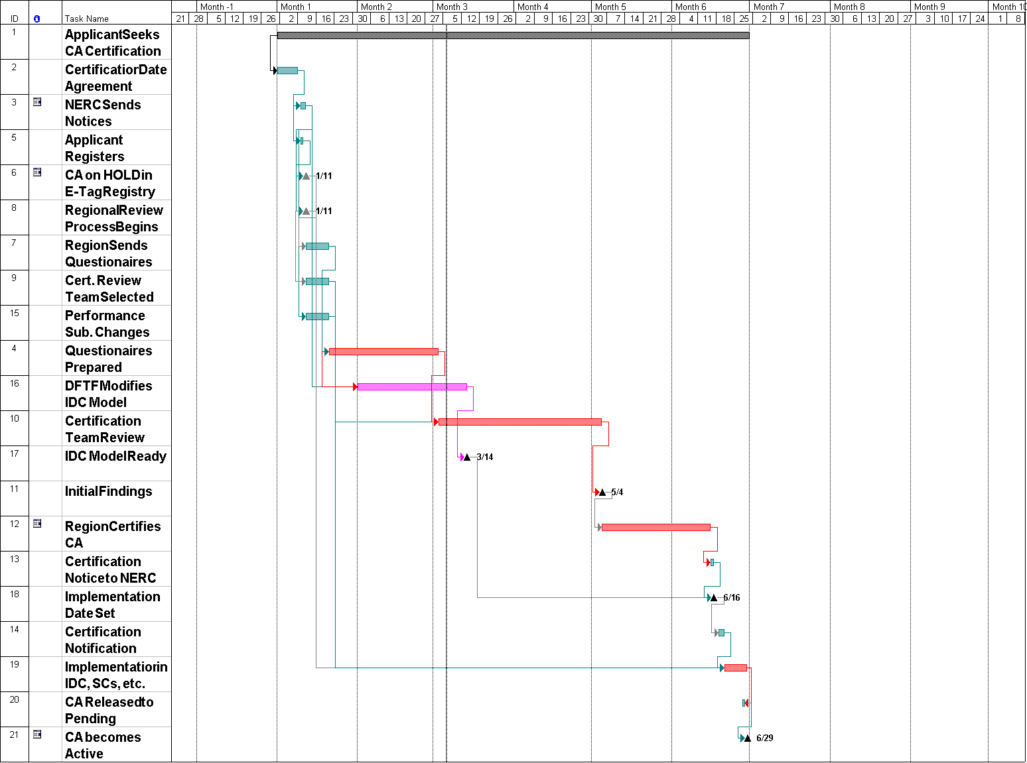

Confidentiality restrictions may not allow a marketer to participate on the review team.

