May 31, 2001

Mr. R. B. Buy
Mr. R. R. Clark
Mr. C. A. Fox
Mr. M. Haedicke
Mr. R. E. Henderson
Mr. S. D. Josey
Mr. A. D. Keel
Mr. L. V. McGuire
Mr. J. G. Melendrez
Mr. M. W. Strickler
Mr. C. J. Thompson
Mr. L. G. Whalley

RE: Special Meeting of the Board of Directors
of Mariner Energy, Inc.

Gentlemen:

At the request of Robert E. Henderson, Chairman of the Board of Directors of Mariner Energy, Inc. (“Mariner”), a special meeting of the Board is scheduled for Thursday, June 7, 2001 at 8:30 a.m. at 580 WestLake Park Boulevard, Suite 1300, Houston, Texas. The purposes of the meeting are to: provide the recently elected Directors with an overview of Mariner’s current and near-term activities and goals; elect certain new committee members; and to ratify the terms of two production hedge transactions recently entered into by Mariner. The meeting is expected to last approximately 3 hours.

Please advise Donna Cagle (281/584-5511) if you will be unable to participate.

Very truly yours,

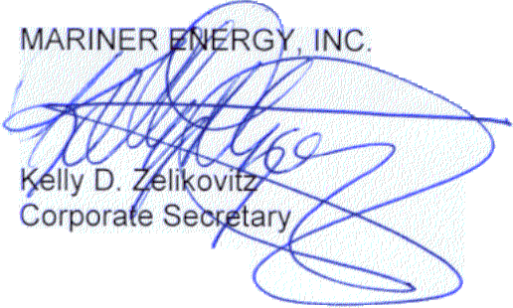

KDZ:dmc2
cc: D. M. Cagle T. G. Bushman - ENAC
G. K. Harless T. Proffitt - ENAC
W. H. Hodge
D. S. Huber
F. A. Pici
R. W. Webb
T. E. Young

580 WestLake Park Blvd., Suite 1300 Houston, TX 77079-2643 Tel (281) 584-5500 Fax (281) 584-5555

