May 17, 2001

Mr. R. M. Bowen
Mr. R. B. Buy
Mr. R. R. Clark
Mr. T. J. Detmering
Mr. J. M. Donahue, Jr.
Mr. C. A. Fox
Mr. M. Haedicke
Mr. R. E. Henderson
Mr. L. V. McGuire
Mr. J. G. Melendrez
Mr. J. B. Sherrick
Mr. M. W. Strickler

RE: Special Telephonic Meeting
of the Board of Directors of
Mariner Energy, Inc.

Gentlemen:

A Special Telephonic Board Meeting of the Board of Directors of Mariner Energy, Inc. will be held on Monday, May 21, 2001 at 3:30 p.m. The purpose of the meeting is to approve Mariner’s offer for an interest in the Argo Prospect (Alaminos Canyon 13/East Breaks 981).

For participating in the Special Telephonic Board Meeting, please dial 1-800-277-3082 approximately five minutes prior to conference time. The reservation number is 18933012, passcode 4702698.

Please advise Donna Cagle (281/584-5511) if you will be unable to participate.

Very truly yours,

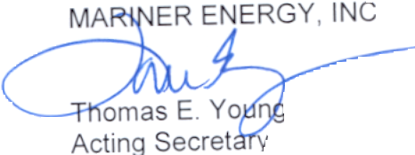

TEY:dmc2
cc: D. M. Cagle
G. K. Harless J. Grace – ENAC
W. H. Hodge T. Proffitt - ENAC
D. S. Huber
F. A. Pici
R. W. Webb
K. D. Zelikovitz

580 WestLake Park Blvd., Suite 1300 Houston, TX 77079-2643 Tel (281) 584-5500 Fax (281) 584-5555

