October 1, 2001

Mr. R. B. Buy
Mr. R. R. Clark
Mr. R. E. Henderson
Mr. S. D. Josey
Mr. A. D. Keel
Mr. J. G. Melendrez

RE: Special Telephonic Meeting
of the Executive Committee of
Mariner Energy, Inc. (the “Company”)

Gentlemen:

A Special Telephonic Executive Committee Meeting of the Company will be held on Tuesday, October 2, 2001 at 3:00 p.m. and is expected to last no longer than 15 minutes. The purpose of the meeting is to approve the Company’s participation in the Roaring Fork Prospect.

For participating in the Special Telephonic Executive Committee Meeting, please dial
1-800-277-3082 approximately five minutes prior to conference time. The reservation number is 19811328, passcode 3793198.

Please advise Donna Cagle (281/584-5511) if you will be unable to participate.

Very truly yours,
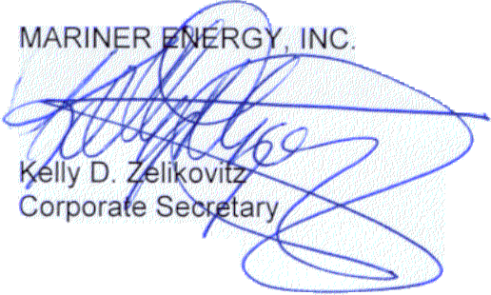
KDZ:dmc2
cc: D. M. Cagle
T. E. Young

580 WestLake Park Blvd., Suite 1300 Houston, TX 77079-2643 Tel (281) 584-5500 Fax (281) 584-5555

