September 28, 2025

Mr. R. B. Buy
Mr. R. R. Clark
Mr. C. A. Fox
Mr. M. Haedicke
Mr. R. E. Henderson
Mr. S. D. Josey
Mr. A. D. Keel
Mr. L. V. McGuire
Mr. J. G. Melendrez
Mr. M. W. Strickler
Mr. C. J. Thompson
Mr. L. G. Whalley
RE: Quarterly Meeting of the Board of Directors
of Mariner Energy, Inc.

Gentlemen:

At the request of Robert E. Henderson, Chairman of the Board of Directors of Mariner Energy, Inc., a quarterly meeting of the Board will be held on Thursday, August 23, 2001 from 10:00 am until 2:00 pm at The Doubletree Hotel at Allen Center, 400 Dallas, Houston, Texas, in the Granger “A” Room. Lunch will be served.

Please advise Donna Cagle (281/584-5511) if you will be unable to attend.

Very truly yours,

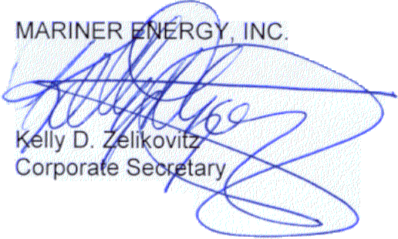

KDZ:dmc2
cc: D. M. Cagle T. G. Bushman - ENAC
G. K. Harless T. Proffitt - ENAC
W. H. Hodge
D. S. Huber
F. A. Pici
R. W. Webb
T. E. Young

580 WestLake Park Blvd., Suite 1300 Houston, TX 77079-2643 Tel (281) 584-5500 Fax (281) 584-5555

