Subject:: Midlife crisis

I've seen two shows lately that went on and on about
how mid-life is a great time for women.
Just last week Oprah had a whole show on
how great menopause will be....

Puhleeeeeeeze!


I've had a few thoughts of my own
and would like to share them with you.
Whether you are pushing 40, 50, 60
(or maybe even just pushing your luck) you'll probably relate.

Mid-life is when the growth of hair on our legs slows down.
This gives us plenty of time
to care for our newly acquired mustache.
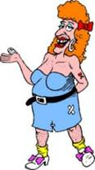

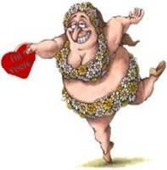
In mid-life women no longer have upper arms,
we have wingspans.
We are no longer women in sleeveless shirts,
we are flying squirrels in drag.


Mid-life is when you can
stand naked in front of a mirror
and you can see your rear without turning around.

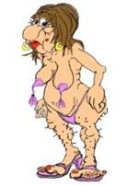

Mid-life is when you go for a mammogram
and you realize that this is the only time
someone will ask you to appear topless.

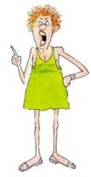
Mid-life is when you want to grab
every firm young lovely in a tube top and scream,
"Listen honey, even the Roman empire fell
and those will too."

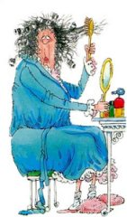

Mid-life brings wisdom to know
that life throws us curves and
we're sitting on our biggest ones.
Mid-life is when you look at your-know-it-all,
beeper-wearing teenager and think:
"For this I have stretch marks?"

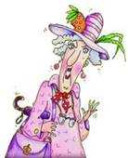
In mid-life your memory starts to go.
In fact the only thing we can retain is water.



Mid-life means that your Body By Jake
now includes Legs By Rand McNally --
more red and blue lines
than an accurately scaled map of Wisconsin.

Mid-life means that you become more reflective...
You start pondering the "big" questions.
What is life? Why am I here?
How much Healthy Choice ice cream can I eat
before it's no longer a healthy choice?

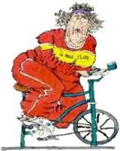

But mid-life also brings with it
an appreciation for what is important.

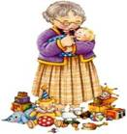

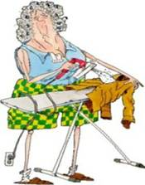
We realize that breasts sag, hips expand and chins double,
but our loved ones make the journey worthwhile.
Would any of you trade the knowledge that you have now
for the body you had way back when?

Maybe our bodies simply have to expand
to hold all the wisdom and love we've acquired.
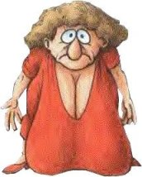

That's my philosophy and I'm sticking to it!
REMEMBER: "Stressed" spelled backward is "desserts."
Send this to four women and you will lose two pounds. Send this to
all the women you know (or ever knew), and you will lose 10 pounds.
If you delete this message, you will gain 10 pounds immediately.
(That's why I had to pass this on-I didn't want to risk it! :)

