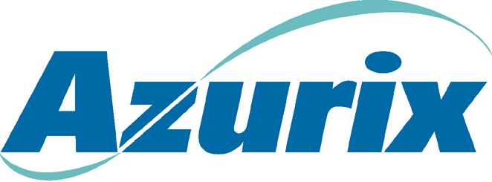
To: | Mike Moran & Drew Fossum
From: | John Ale
Date: | March 29, 2001
Subject: | Azurix Corp. Legal Issues
In advance of our meeting this afternoon, I thought it would be good to set out some items we should discuss and give a briefing:
- Overview of Azurix
- Assets
- Financial
- Ownership structure (Marlin)
- Azurix Corp. Legal Department
- John Ale – General Counsel
- Allan Conge – SEC lawyer; involuntary termination scheduled but extended
- Tim Dorsey – has committed to stay through year end if needed
- Greer Mendelow – accepted job at Duke Energy effective May 1
- Norma Tidrow – company secretary, director level
- 2 administrative assistants
- Major Litigation
- Azurix Buenos Aires
- Synagro Litigation (2-week trial set for September 4) – Susman Godfrey
- IPO Litigation – Gibbs & Bruns/V&E
- Lurgi CFA claim – Clifford Chance Frankfurt
- Ongoing Corporate Legal Issues
- Asset Sales
- Bonds/SEC filings
- HR and retention

