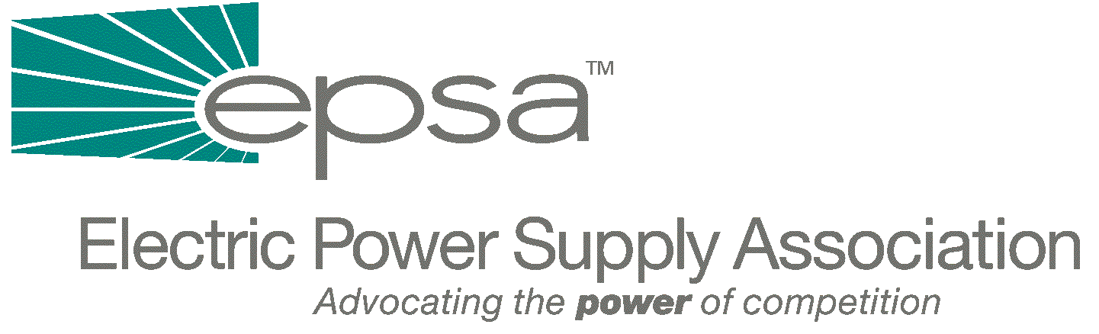

1401 New York Avenue, NW
11th Floor
Washington, DC 20005
202/628-8200
202/628-8260 fax
www.epsa.org

Memorandum
TO: | EPSA Legislative Affairs Committee  EPSA Renewables Committee
FROM: | Scott A. Weiner, Legislative Affairs Committee Chair  Andrew Chau, Renewables Committee Chair  Andrea L. Spring, Manager of Government Affairs
DATE: | September 28, 2025
RE: | House Ways and Means Passage of Economic Security Bill

Today, the House Ways and Means Committee passed out of committee “The Economic Security and Recovery Act of 2001” by a vote of 23 to 14. Democrats opposed the plan, saying that it was not written on a bipartisan basis and that the bill is too targeted towards business.
There are a number of corporate tax provisions in the bill, however the only electricity-specific provision in the bill is an extension of the Section 45 tax credit. The existing Section 45 tax credit, for wind, closed-loop biomass, or poultry waste, currently applies only to facilities placed in service before January 1, 2002. This bill would extend that deadline to January 1, 2004.
It’s also worth noting that the special depreciation allowance for qualified property in this bill only applies to property acquired after September 10, 2001 and placed into service before December 31, 2004. This three year time period is a relatively short one for industries such as ours.
The bill text can be found at: http://waysandmeans.house.gov/fullcomm/107cong/hr3090/hr3090sub.pdf
A Joint Committee on Taxation summary and analysis of the bill can be found at:
http://www.house.gov/jct/x-69-01.pdf

If you have any questions, please contact Andrea Spring (202-628-8200 or aspring@epsa.org).

