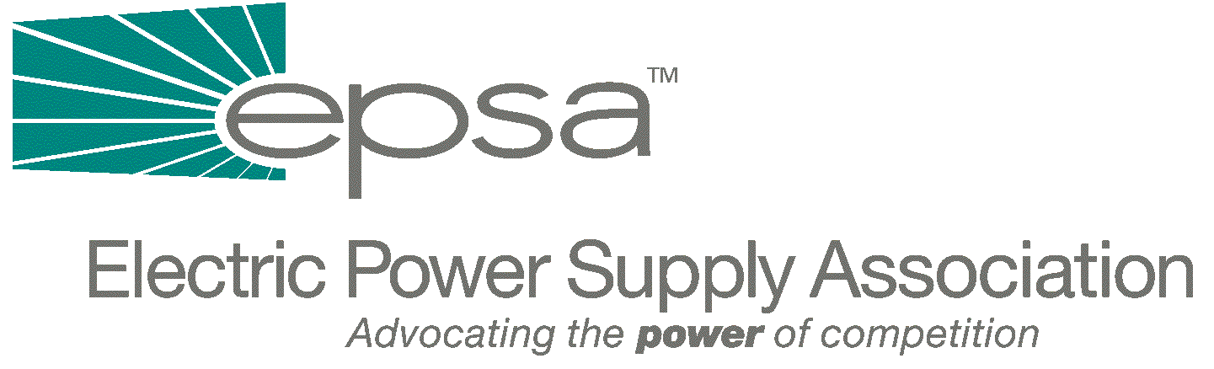

1401 New York Avenue, NW
11th Floor
Washington, DC 20005
202/628-8200
202/628-8260 fax
www.epsa.org

Memorandum
TO: | EPSA Legislative Affairs Committee
FROM: | Scott A. Weiner, Legislative Affairs Committee Chair  Andrea L. Spring, Manager of Government Affairs
DATE: | September 28, 2025
RE: | Analysis of Draft Barton Electricity Legislation

We have attached a brief analysis of the draft legislation which House Subcommittee on Energy and Air Quality Chairman Joe Barton (R-TX) released on Friday.
This legislation is missing crucial language – it does not clarify FERC’s authority over all transmission and ability to order utilities into RTOs. It is absolutely vital that we stress to Chairman Barton and to the Committee Members that such language be in this bill. The legislation does include good interconnection language, FERC-light, PUHCA repeal, and positive clarification of the tax treatment of interconnections.
We will discuss this legislation during our regular Legislative Affairs Committee Conference Call/Meeting this Thursday, September 27th, at 3:00 p.m. EDT. The call/meeting will be held at EPSA (1401 New York Avenue, 11th Floor). To access the call, dial 1-800-937-6563 and ask for the EPSA call moderated by Gene Peters. As always, there is no need to RSVP.
If you have any questions or additions to this analysis, please contact Gene Peters (202-628-8200 or gpeters@epsa.org).

Major Provisions in Barton Legislation

Transmission jurisdiction
- Does not include any provision dealing with the transmission component of a bundled retail sale, but says that proposals on this issue “are sought from Members and stakeholders, with the understanding that this issue is closely tied to RTO policy.”
- We need to talk to Barton and Committee members to urge inclusion of a transmission provision which clarifies that the interstate transmission grid be open under consistent, non-discriminatory rules and regulations for all uses and users of the grid, including the transmission component of a bundled retail sale.

FERC-light
- Require open access for all transmitting utilities, and puts municipals and cooperatives under limited FERC regulation. Municipals and cooperatives can continue to set their own rates, but FERC must ensure that rates are comparable, consistent with H.R.2944 from the 106th Congress.

RTOs
- The bill does not include an RTO provision, and says that an RTO section will be provided soon.
- Obviously, this is a crucial issue for EPSA members. We need to stress both to Barton and to Committee Members, especially Republicans, that the bill must include language making RTO participation mandatory for all interstate transmission.

Interconnection
- Direct FERC to establish uniform, non-discriminatory interconnection standards for both distribution and transmission facilities.
- We support this provision, which contains the language negotiated by Trigen, EEI and industry participants.

Transmission Expansion - Incentives
- FERC must conduct a rulemaking to establish incentive rate policies and standards to promote expansion and improvement of interstate transmission facilities.
- EPSA objects to the language in this provision which says that incentive rates should be used to “promote the voluntary participation in and formation” of RTOs, since we believe both that RTO participation must be mandatory and that FERC currently has the authority to mandate such participation.

Transmission Expansion - Siting
- FERC may extend eminent domain authority for transmission siting to an applicant seeking to construct transmission, but only if States have not responded within 12 months or rejected a proposal in the public interest.

Investigation and Correction of Anticompetitive Conduct
- Provide FERC with uniform investigation and information-gathering authority over all wholesale sellers of electric energy.
- Provide FERC with uniform refund authority over all wholesale sellers, including public power.
- Increase and expand criminal penalties for Federal Power Act violations, from $5,000 to violation to $1 million per violation and maximum jail time from 2 to 5 years. Also increases the maximum fine from $500 per day to $25,000 per day. Expands civil penalty authority to include all violations of Part II of the Federal Power Act.

Reliability
- FERC shall certify an electric reliability organization or organizations with the ability to develop, implement and enforce reliability standards for the bulk-power system.
- This language does not make clear to what extent and how FERC and the EROs will share enforcement authority remains unclear. One possible interpretation is that the ERO will exercise primary jurisdiction. This could lead to the undesirable result of reducing FERC to essentially a rubber stamp organization on ERO actions. The language also does not allow for proper stakeholder input into standards development. The 30 day comment period seems too short. Language does not need to state that reliability rules are automatically approved after a certain period of FERC inaction. Furthermore, nothing should preclude FERC from directly amending or rewriting standards as the need to reconcile and integrate reliability and market practices may require.

PUHCA and PURPA
- This repeals the Public Utility Holding Company Act of 1935 (PUHCA) and provides for federal and state access to holding company books and records.
- Prospectively repeals PURPA, but upholds contracts entered into before January 6, 1999.
- Does not require the utility to provide backup, standby and maintenance power in states without retail competition, and does not explicitly uphold contracts entered into after 1998.

Tax Provisions
- Relieve certain municipal utilities from private-use restrictions in tax-exempt bond financing, consistent with H.R.1459.
- Reform tax treatment of sale of transmission facilities to join an RTO, form an independent transmission company, or meet FERC or State restructuring requirements, consistent with H.R.1459.
- Reform tax treatment of contributions in aid of construction (CIAC), consistent with H.R.1459.
- Reform tax treatment of nuclear decommissioning fund contributions and costs, consistent with H.R.1459.
- Provide rural electric cooperatives relief from “85-15” business activity rules for certain purposes.
- We strongly support reforming the tax treatment of contributions in aid of construction (CIAC) in this matter, however, this section of the bill is not jurisdictional to the Energy and Commerce Committee.

Other
- Net metering provision.
- Advanced metering proposals are sought from Members and stakeholders.
- FERC directed to implement price-responsive demand management programs in consultation with the States and others.
- Privacy protection rules for electric consumers shall be promulgated by the Federal Trade Commission (FTC). Consistent State plans would be exempted.
- “Slamming” and “cramming” protection for electric consumers shall be promulgated by the FTC.
- Includes TVA/TVPPA title, which has a number of provisions with which EPSA does not agree and does not specifically state that TVA must participate in an RTO.
- Includes the BPA regional title, which – among other things – authorizes BPA to participate in an RTO.

