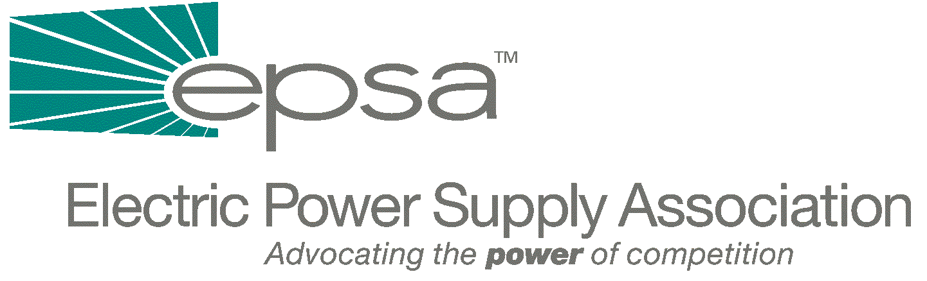

1401 New York Avenue, NW
11th Floor
Washington, DC 20005
202/628-8200
202/628-8260 fax
www.epsa.org

Memorandum
TO: | EPSA Legislative Affairs Committee
FROM: | Scott A. Weiner, Legislative Affairs Committee Chair  Andrea L. Spring, Manager of Government Affairs
DATE: | September 28, 2025
RE: | Analysis of Draft Barton Electricity Legislation

We have attached a brief analysis of the new RTO language which House Subcommittee on Energy and Air Quality Chairman Joe Barton (R-TX) released yesterday.
The only major substantive change between this draft and his first draft is the addition of an RTO section. Although this section has the laudable goal of mandating participation in RTOs, it establishes a complicated, lengthy and cumbersome process to do this. Additionally, it might tie FERC’s hands by enshrining a modified version of Order 2000 into law, possibly rolling back more recent FERC actions (such as the move towards fewer, larger RTOs) and preventing future FERC flexibility and action on this issue. It also forbids FERC to order transmission divestiture.
We will discuss this legislation during our regular Legislative Affairs Committee Conference Call/Meeting this Thursday, October 11th, at 3:00 p.m. EDT. The call/meeting will be held at EPSA (1401 New York Avenue, 11th Floor). To access the call, dial 1-800-937-6563 and ask for the EPSA call moderated by Gene Peters. As always, there is no need to RSVP.
If you have any questions or additions to this analysis, please contact Andrea Spring (202-628-8200 or aspring@epsa.org).

Attachment

Some Key Provisions of the New RTO Section:

- All transmitting utilities must participate in RTOs within 18 months of enactment.

- Any transmitting utility who is not in a FERC-approved RTO (pursuant to Order 2000) on the date of enactment of this bill would start a process:
  - Utility must file an RTO application with FERC within 6 months of enactment. Failure to file would result in FERC choosing an RTO for the utility.
  - FERC must approve all RTOs that meet standards specified in the legislation.
  - If FERC finds that a proposed RTO does not meet these standards, FERC proposes modifications (in consultation with States).
  - Utility can accept modifications, or:
  - Negotiate with FERC for 6 months.
  - Then submit to an evidentiary hearing.
    - Hearing either establishes that FERC has established its case on preponderance of evidence or utility is right as to whether RTO meets the standards.
    - Hearing can be appealed to Federal court.

- This procedure is lengthy, cumbersome, and limits FERC’s ability to form RTOs to the standards in this legislation. Also, this language would not allow FERC to order any changes in RTOs which exist at enactment, as long as they have been approved pursuant to Order 2000. This freezes the market and the industry structures in place.

- FERC is directed to establish uniform market rules, including seams regulations within 3 months of bill enactment. These rules may not modify the scope, configuration or governance structure of an RTO that already has met the aforementioned standards, and also may not have the effect of requiring a transmitting utility to join a specific RTO.
Again, this ties FERC’s hands and makes it difficult to deal with seams issues.

- Savings clause which, by saying that nothing in this section limits the authority of a State to address “other utility functions in a manner consistent with this Act,” could possibly make some of the positive sections of this bill, such as the provision requiring that all load within the boundaries of the RTO must take service under the RTOs tariff, unenforceable.

