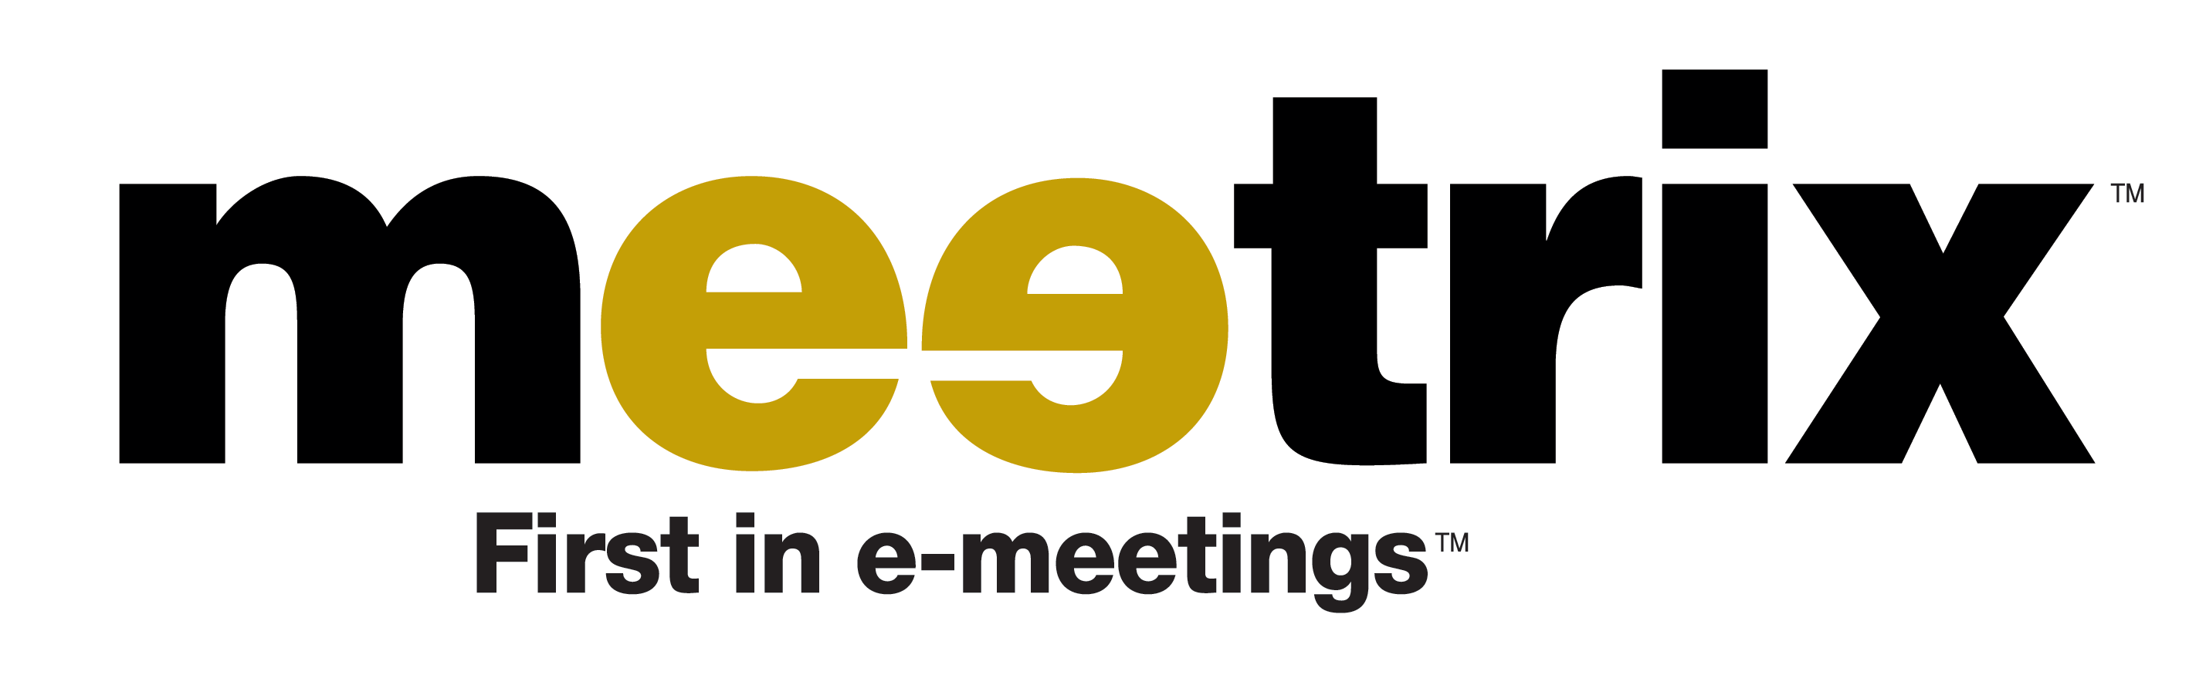

Location:
5450 Northwest Central, Suite 230
Houston, Texas 77092
Industry:
Multi-point videoconferencing service for businesses, utilizing the internet to drive broader availability and lower costs.
Contacts:
Kerry Brooks
713-462-5565
kbrooks@meetrix.com

Dave Throckmorton
713-462-5565
dthrockmorton@meetrix.com

Offering:
45.5% of company offered for $5,000,000 equity investment at a pre-money valuation of $6,000,000; to be used for operating expenses to start the company.
Management:
1) Kerry Brooks: Chairman & CEO, “turn-around” specialist with 24 years of experience managing businesses for Procter & Gamble, Coca-Cola, and Citibank; founding partner with Eyes of Texas Partners.
2) Dave Throckmorton: President & COO, business leader and problem solver with 28 years of experience managing businesses for Procter & Gamble and Coca-Cola; commanding officer and pilot in the U.S. Army.
3) Eric Cumming: VP, CTO, entrepreneur and business founder with 24 years of management experience at INC Group and IBM; founding partner with Eyes of Texas Partners.
4) Tom Dye: VP, Business Development, entrepreneur and business founder with 22 years of management experience with Interactive Silicon, Cirrus Logic, Austek Microsystems, Design Technology, Dell, Motorola, and Texas Instruments.

Company Status:
Meetrix will be formed as a Delaware Corporation in September of 2001. A business plan has been developed and the startup of operations is underway.
Mission:
Our mission is to develop the first, and thereafter, the dominant internet-based, multi-point visual communications company; offering live, interactive video and audio connectivity to expanding communities of business users.
Service:
Meetrix will provide a unique, interactive, real-time videoconferencing service for the business market utilizing the internet as a low cost platform. This service fills a huge need for companies who are demanding more effective, real-time communications capabilities with employees, suppliers, customers and partners. Our value proposition also includes greatly improved personal productivity, and significantly reduced communications and travel expenses. Using a personal computer with low cost video camera and microphone, high-speed internet access, and web access to our proprietary software; we offer:
1) Secure multipoint videoconferencing; enabling up to 8 participants simultaneously with synchronized, high quality video and audio plus full duplexing.
2) Real-time collaboration tools to enhance the videoconferencing experience; including graphics, spreadsheets, documents and whiteboards.
3) Text chat and instant messaging sidebar allowing participants to conduct private communications.
Technology:
We will file 7-10 patents for our proprietary software and technical platform. Phase 1 applications will include on-the-fly MPLS-based virtual private network (VPN) provisioning, secure peer-to-peer (P2P) video and audio communications, feedback-based dynamic quality of service adjustments, and innovative scheduling and resource management. This platform offers nearly unlimited scaling in the support of simultaneous conferences. We are also obtaining an exclusive license of a patented compression and decompression (codec) methodology to enable higher quality video than any other internet-based system. Phase 2 applications will include a Linux-based conference server/MPLS/firewall appliance to support campus videoconferencing and external Meetrix.com communications, and a camera/mobile phone device to provide both local (directly attached) and remote (traveling) input via direct wireless uplink to the network. $9 million of development spending and beta testing by a former company also supports our effort.
Market:
The market for real-time collaboration services is huge ($9 billion) and growing quickly (+20% per year). Videoconferencing is about 50% of the total, with both data and audio conferencing delivering the remainder.
Competition:
The videoconferencing market is fragmented, with over 25 companies providing various products and services. However, none have the capability to provide our service package of high quality, low cost, multi-point videoconferencing over the internet with a full suite of collaboration tools. Almost all video-conferencing today is done through high cost conference room equipment systems that are point-to-point using expensive telephone circuits.
Distribution Channels:
Our customer acquisition activities will be managed by a small direct sales team, supplemented by a “reseller” network of broadband internet providers and ASP/ISP companies. This will deliver us faster access to companies that are already ongoing customers for this network of providers, while also adding important value to their own businesses.
Revenue Model:
Our Meetrix-hosted videoconferencing service is provided to geographically dispersed businesses for an unlimited monthly usage fee of $125 per user. Our supplemental service for co-located campus customers hosting their own services on a LAN will be offered for a reduced monthly fee of $25 per user.
Financial Estimates (Unaudited):
$Millions Yr. 1 Yr. 2 Yr. 3 Yr. 4 Yr. 5 Revenue 0.0 11.3 39.8 130.2 414.3
Op. Income (4.3) (3.2) 11.4 54.5 193.0
Margin -- -- 29% 42% 47%

