Discussions with Northwest Natural Gas
(West Coast Project)

Enron Global LNG 11/06/2001

Itinerary & Participants

- Date: 11//2001 10:30AM ~ 2:00PM
- Place: Northwest Natural Gas Office in Portland
- Participants:
  - Northwest Natural: Nick Potts, Director Gas Storage Operations, Charles Stinson, General Manager Engineering Services & Storage, Randolph Friedman, Manager Gas Supply
  - Enron: Jeff Slaughter, Director ENA Portland Office, Zdenek Gerych, Kyu-bong Lee

Major Discussion Points

General Information on Northwest Natural Gas Co.

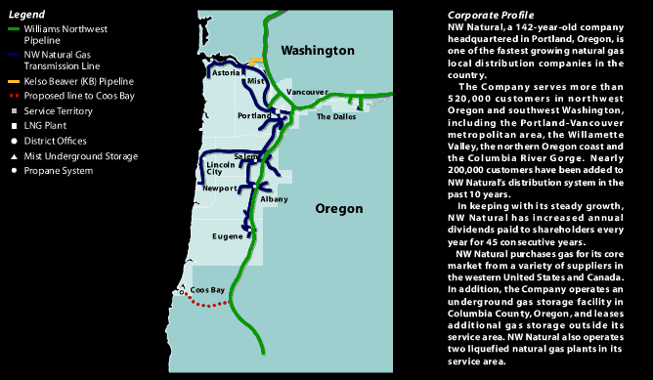

NW Natural's Pipeline & Storage System

- 99% dependent on Northwest Pipeline (Williams) with a mixture of spot, short-term and long-term contracts
- Annual gas supply: 110 Bcf (75 Bcf for core customers)
- 12,000 miles of gas mains
- Pipeline: 24” maximum
- 10.5 Bcf Underground storage at Mist

Information on Newport, Coos Bay

- Skeptical on prospects for LNG terminals in Newport
- Newport LNG facility built in 1977, including an LNG tank of 47,700 cu.m.
- Newport bridge with a vertical clearance of 136 feet will restrict access to most LNG tankers [Jim Fernie to confirm]
- Newport distant from main pipelines with possible local resistance to an LNG project
- Coos Bay LNG terminal location would be ideal for them but they could only take some 50 MMcf flowing north; connection with the PGT pipeline would be over 150 miles long and would have to overcome the Costal Range and the Cascades

NW Natural’s View on LNG Facility in Pacific Northwest

- In general, LNG from the Columbia River area does not represent a good option for supplying their core customers in Portland as their system is set up to flow gas from the Northwest Pipeline in the east. They mentioned they would have to expand the connection pipeline between Mist and the Portland area to carry the revaporized LNG, thus forfeiting the premium saved on the postage stamp tariff.

- Would like to see the terminal somewhere south of Portand but could only take limited amount of gas

- Not opposed to the idea of an LNG terminal at Point Westward; however to buy gas from us for the existing and planned direct customers in the area (Longview, St. Helens, Port Westward), they would need to get the following price formula:

The Lower Price of Sumas and Stanfield MINUS Discount from the Postage Stamp Tariff Applied by NW Pipeline

- Current storage also helps them to handle the peak gas demand:
- Plymouth & Portland Peak Shavers for short-term demand, which is less than 30 days
- Jackson Prarie for 30 ~ 60 days Peak Demand
- Mist for 60+ days Peak Demand

  - NW Natural Gas perceives LNG supply risky if it is linked to Nymex with no floor for the producer. Generally does not want to decontract with NW Pipeline.

  - View on the pipeline connection to PGT line: positive in terms of pricing at Malin, negative on prospects for building the connecting line to PGT due long distance and environmental concerns.

