SCHEDULING AND NOMINATIONS

INFORMATION MEETING

PURPOSE:

SoCalGas is hosting an information meeting to describe its revised scheduling and nomination procedure to be implemented November 1, 2001. The changes reflect eliminating the windowing procedures and allowing customer nominations to determine which receipt points are utilized to the greatest extent.

WHO SHOULD ATTEND:

Gas Schedulers and those managing day-to-day gas supplies verses customer demands should attend.

WHEN:

9:00 a.m. – 12:00 noon on Thursday, October 18th.

WHERE:

Southern California Gas Company’s

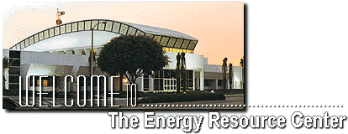

Energy Resource Center (ERC)
9240 East Firestone Boulevard
Downey, California 90241
800-427-6584

RSVP:

Please RSVP to Joyce Lloyd at 213-244-3717 or jlloyd@socalgas.com by October 15th.

Hotel Accommodations:

Embassy Suites - Downey

Biltmore Hotel – Los Angeles

