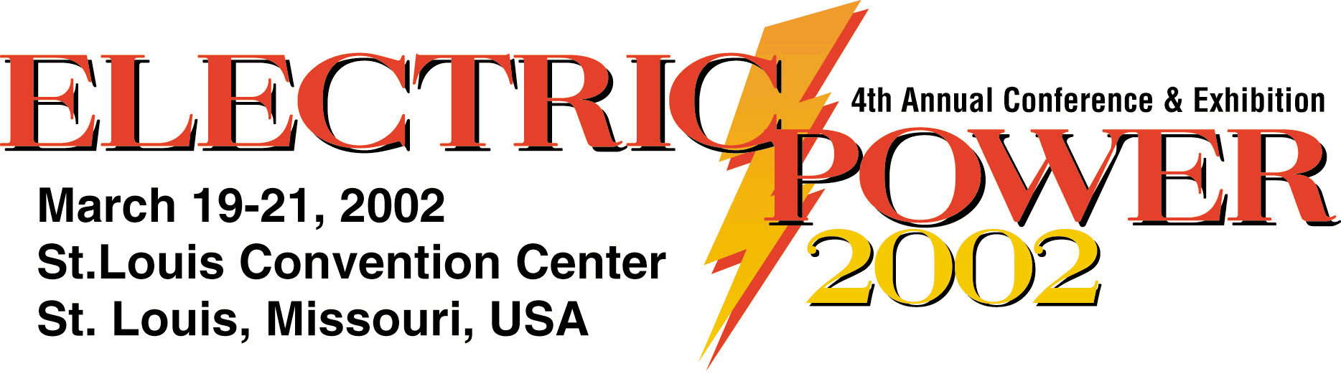

Program Committee Meeting Agenda

August 7, 2001
10:00 a.m. – 3:00 p.m.

St. Louis Airport Marriott

I-70 at Lambert Airport

St. Louis, MO 63134

Phone (314) 423-9700

8:00 a.m. – 10:00 a.m. Meeting room open for early arrivals

10:00 a.m. – 11:30 a.m. Meeting Commences
- Review/Approve minutes from June 27 meeting
- Review/Approve conference outline
- Review Plenary sessions and nominate panelists

11:30 a.m. – 12:30 p.m. Lunch is Served

12:30 p.m. – 3:00 p.m.
- Break into sub-committee groups to develop session topics and nominate chairs and speakers
- Review abstracts
- Ensure track and session descriptions are completed
- Assign responsibility for contacting proposed speakers/panelists and session chairs

Goal for the August 7 meeting - Review abstracts, identify speakers and topics for invitation and establish a provisional conference program.

Goal for 3rd meeting, October 9 - Finalize conference program with track and session descriptions.

