Post Office Realty

.Mixed Use Building With Post Office
McAllen, Texas

Hidalgo County Population located on the U.S.- Mexican border in south Texas Population 100,589- 26% growth since 1990, New Air Terminal, community college, foreign trade zone, agriculture

Contact Jim Wills 210-403-2190, jwills3@swbell.net
Price $1,310,000 per current appraisal
Cap Rate 12% at current occupancy
Building Size 32,000 Sq. Ft. (200 ft front. X 80ft side) 2story
Land area 4 lots of 7,000 sq. ft. for total of 28,000 sq. ft.
Building description Substantial reinforced concrete walls -dark grey
Date constructed Early 1980's
Vacancy 12,000 sq. ft. upstairs

The building is located in the central business district close to the court house and The Chase bank tower. The surrounding streets and building are well maintained. The building was formally used as a retail center. The old post office is located across the street. The owner is currently discussing the possible lease of the vacant space on the second floor with the Postal authorities. The USPS after leaving it’s old location has it’s operations spread around the down town in several locations and desires to consolidate those operations.
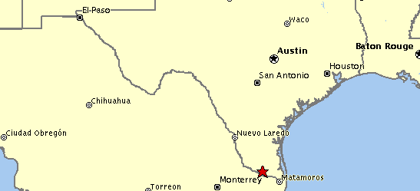
Note: This property information has been provided by the seller and is subject to errors, omissions; Post Office Realty makes no warranties as to it’s completeness or accuracy.

Post Office Realty

Mixed Use Building With Post Office
McAllen, Texas

Major tenants and monthly rentals are:
Post Office 7700’ $5,312 9 years remaining
Mail Boxes Etc. 200’ 850
La Victoria Adult Day Care 4,800
Principal 1,000
Albert Chavez 3,000 3 years remaining
Vacant- upstairs 12000’ 0
Total 14,962
Annual revenue 179,544
Annual expenses:
Taxes 16,750
Insurance 2,250
Other 4,400
23,400
Net operating income 156,144

Selling Price 1,310,000

Note: This property information has been provided by the seller and is subject to errors, omissions; Post Office Realty makes no warranties as to it’s completeness or accuracy

