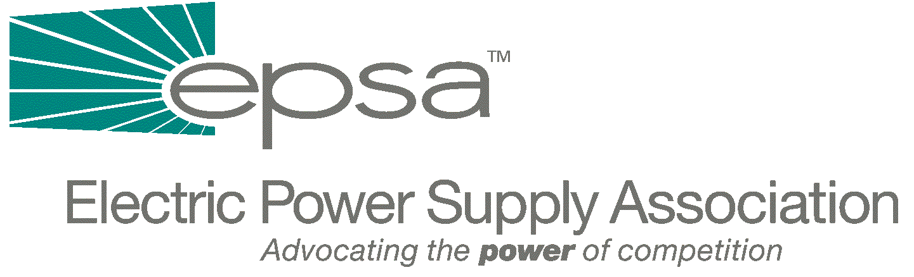
1401 H Street, NW
Suite 760
Washington, DC 20005
202/789-7200
202/789-7201 fax
epsa@mindspring.com
www.epsa.org

Memorandum
TO: | Regulatory Affairs Committee  Power Marketers Working Group
FROM: | Jim Steffes, Regulatory Affairs Committee Chair  Bob Reilley, Power Marketers Working Group Chair  Julie Simon, Vice President of Policy
DATE: | September 28, 2025
RE: | Revised Top Regulatory Issues List

EPSA has again been invited to participate in a set of outreach meeting being held by FERC’s Office of Markets, Tariffs and Rates (OMTR). In preparation for our meeting, which is scheduled for Wednesday, May 30th from 2:00 to 3:30 p.m., we have attached a redrafted and updated version of the leave-behind developed for these meetings. Entitled “Key Principles and Priorities to Achieve Well-Functioning Competitive Markets,” the document largely tracks the one we prepared for our meeting last year. We will discuss this draft on our conference call on Wednesday, May 16th, 2001 at 2:30 p.m. (EDT). To access the call, dial 1-800-937-6563. Ask for the EPSA/Julie Simon call.

If you cannot be on the call and have any questions or concerns, please contact Julie Simon at 202-628-8200 or jsimon@epsa.org. In addition, if you are interested in attending the May 30th meeting, please let us know.

Attachment

