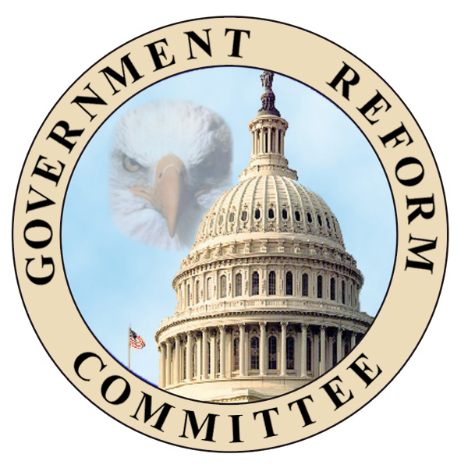 | Subcommittee on Energy Policy, Natural Resources and Regulatory Affairs  www.house.gov/reform/reg  Doug Ose (CA-03), Chairman

PRESS RELEASE

CONTACT: Yier Shi FOR IMMEDIATE RELEASE
202-226-6884 May 23, 2001

OSE TO INTRODUCE LEGISLATION FOR CALIFORNIA ENERGY CRISIS

Chairman Outlines Plan in Letter to FERC

WASHINGTON, D.C.— House Subcommittee on Energy Policy, Natural Resources and Regulatory Affairs Chairman Doug Ose (R-Sacramento) this week called on Federal Energy Regulatory Commission (FERC) to expand and modify its market mitigation plan and said he will introduce legislation that will help stabilize the California energy market during the summer energy crunch.

In a comprehensive letter to the FERC, Ose explained his intent to introduce legislation that will prevent unjust and unreasonable rates in California and the Western United States.

“The purpose of this legislation is to assure Californians that they can get the maximum supply of electricity at reasonable rates this summer,” Ose said. “I have found this to be a responsible middle ground between those who argue for a wholesale electricity price cap and those who desire a free, unfettered open market. This plan eliminates price-gouging by preventing excessive profiteering on the spot market. Yet, it also uses free-market mechanisms to encourage the most efficient and environmentally sound electricity generation.”

This legislation is based on five principles:

- Uses market-based principles to eliminate profiteering so that Californians will pay just and reasonable electricity rates for their electricity.

- Rewards the most efficient and environmentally friendly generators.

- Encourages power producers to sign cheaper bilateral long-term contracts by reducing the incentives to sell into the spot market.

- Grants FERC new authority to assess penalties for overcharges and directs FERC to report to Congress on ways to prevent unnecessary outages.

- Provides a sunset date that will allow the Bush Administration time to implement long-term energy solutions and the Davis Administration time to fulfill its pledge to build more power plants and solve the power crisis in California.

The bill will expand FERC’s April 26th order that sets a market clearing price each day based on the highest-cost, least efficient generators. The legislation will also extend FERC’s market mitigation plan in California to the States in the Western States Coordinating Council and expand FERC’s order by directing the mitigation plan to be in effect 24 hours a day, 7 days a week. Currently, the FERC order only applies to periods of energy emergencies. The bill is structured to assure that other States do not suffer the same problems that California has endured for the past year.

Ose’s Subcommittee, along with the House Government Reform Committee, held three field hearings on April 10th, 11th, 12th in Sacramento, San Jose and San Diego. Ose based his proposal on testimony from those hearings.

-- ATTACHED IS THE OSE LETTER TO FERC --

