FROM HOTEL TO ASE:

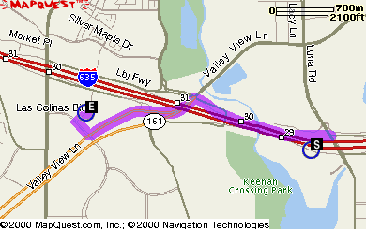

DIRECTIONS DISTANCE

1: Start out going West on ramp. 0.3 miles

2: Merge onto I-635 W. 0.3 miles

3: Take the exit, exit number 30, towards TX-161 S/VALLEY VIEW LN. 0.4 miles

4: Merge onto LYNDON B JOHNSON FRWY. 0.1 miles

5: Turn LEFT onto VALLEY VIEW LN. 0.9 miles

6: Turn SLIGHT RIGHT. 0.0 miles

7: Turn SLIGHT RIGHT onto LAS COLINAS BLVD. 0.1 miles

8: Turn RIGHT onto LAS COLINAS RDG. 0.1 miles

TOTAL ESTIMATED TIME: 6 MINUTES
TOTAL DISTANCE: 2.2 MILES

FROM DFW AIRPORT TO ASE

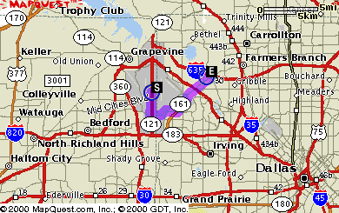

DIRECTIONS DISTANCE

1: Start out going South on INTERNATIONAL PKWY S by turning left (Portions toll). 1.8 miles

2: Take the ramp towards RENTAL CAR RETURN. 0.0 miles

3: Merge onto S SERVICE RD. 0.2 miles

4: Take the ramp towards EAST AIRFIELD DRIVE/AIRPORT ADMINISTRATION/AIRPORT PUBLIC SAFETY. 0.2 miles

5: Merge onto S AIRFIELD DR. 1.5 miles

6: Turn RIGHT onto W WALNUT HILL LN. 1.0 miles

7: Take TX-161. 4.1 miles

8: Turn LEFT onto LAS COLINAS BLVD. 0.2 miles

9: Turn RIGHT onto LAS COLINAS RDG. 0.1 miles

TOTAL ESTIMATED TIME: 17 minutes
TOTAL DISTANCE: 9.1 miles

FROM LOVE FIELD TO ASE

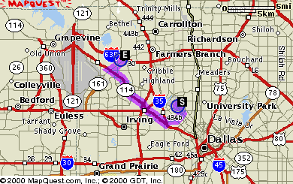

DIRECTIONS DISTANCE

1: Start out going Southeast on CEDAR SPRINGS RD. 1.1 miles

2: Turn SLIGHT RIGHT. 0.0 miles

3: Turn SLIGHT RIGHT onto W MOCKINGBIRD LN. 2.2 miles

4: Turn RIGHT onto E JOHN W CARPENTER FRWY. 0.6 miles

5: Turn SLIGHT LEFT to take the TX-183 W ramp. 0.1 miles

6: Merge onto TX-183 W. 1.5 miles

7: Take TX-114 W towards GRAPEVINE/D/FW AIRPORT NORTH ENTRY. 0.2 miles

8: Merge onto TX-114 W. 5.3 miles

9: Take the TX-161 exit. 0.3 miles

10: Merge onto W JOHN W CARPENTER FRWY. 0.1 miles

11: Turn RIGHT onto VALLEY VIEW LN. 1.4 miles

12: Turn LEFT onto LAS COLINAS BLVD. 0.2 miles

13: Turn RIGHT onto LAS COLINAS RDG. 0.1 miles

TOTAL ESTIMATED TIME: 23 minutes
TOTAL DISTANCE: 13.1 miles

FROM DFW AIRPORT TO HOTEL

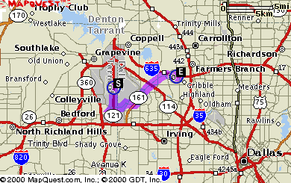

DIRECTIONS DISTANCE

1: Start out going South on INTERNATIONAL PKWY S by turning left (Portions toll). 1.8 miles

2: Take the ramp towards RENTAL CAR RETURN. 0.0 miles

3: Merge onto S SERVICE RD. 0.2 miles

4: Take the ramp towards EAST AIRFIELD DRIVE/AIRPORT ADMINISTRATION/AIRPORT PUBLIC SAFETY. 0.2 miles

5: Merge onto S AIRFIELD DR. 1.5 miles

6: Turn RIGHT onto W WALNUT HILL LN. 1.0 miles

7: Take TX-161. 4.6 miles

8: TX-161 becomes VALLEY VIEW LN/TX-161 N. 0.2 miles

9: Take the I-635 E ramp. 0.5 miles

10: Merge onto I-635 E. 0.2 miles

11: Take the LUNA RD exit, exit number 29. 0.5 miles

12: Turn LEFT onto LUNA RD. 0.2 miles

13: Turn LEFT. 0.0 miles

TOTAL ESTIMATED TIME: 21 minutes

TOTAL DISTANCE: 10.9 miles

FROM LOVE FIELD TO HOTEL

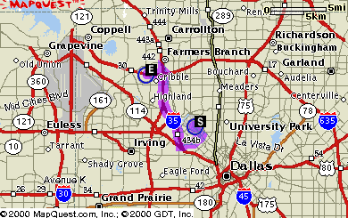

DIRECTIONS DISTANCE

1: Start out going Southeast on CEDAR SPRINGS RD. 1.1 miles

2: Turn SLIGHT RIGHT. 0.0 miles

3: Turn SLIGHT RIGHT onto W MOCKINGBIRD LN. 2.0 miles

4: Turn SLIGHT RIGHT. 0.0 miles

5: Turn SLIGHT RIGHT onto N STEMMONS FRWY. 0.0 miles

6: Turn SLIGHT LEFT to take the I-35E N ramp. 0.1 miles

7: Merge onto I-35E N. 6.4 miles

8: Take the I-635 W exit, exit number 440C, on the left towards D/FW AIRPORT. 0.4 miles

9: Merge onto I-635 W. 0.9 miles

10: Take the exit, exit number 29, towards LUNA RD. 0.3 miles

11: Merge onto LYNDON B JOHNSON FRWY. 0.1 miles

TOTAL ESTIMATED TIME: 20 minutes
TOTAL DISTANCE: 11.5 miles

