FROM HOTEL TO ASE:

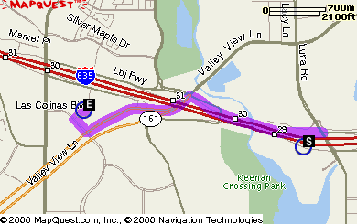

DIRECTIONS DISTANCE

1: Start out going West on ramp. 0.3 miles

2: Merge onto I-635 W. 0.3 miles

3: Take the exit, exit number 30, towards TX-161 S/VALLEY VIEW LN. 0.4 miles

4: Merge onto LYNDON B JOHNSON FRWY. 0.1 miles

5: Turn LEFT onto VALLEY VIEW LN. 0.9 miles

6: Turn SLIGHT RIGHT. 0.0 miles

7: Turn SLIGHT RIGHT onto LAS COLINAS BLVD. 0.1 miles

8: Turn RIGHT onto LAS COLINAS RDG. 0.1 miles

TOTAL ESTIMATED TIME: 6 MINUTES
TOTAL DISTANCE: 2.2 MILES

FROM DFW AIRPORT TO ASE

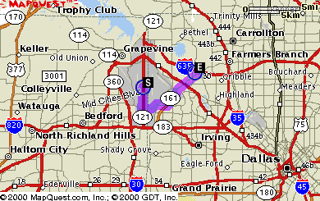

DIRECTIONS DISTANCE

1: Start out going South on INTERNATIONAL PKWY S by turning left (Portions toll). 1.8 miles

2: Take the ramp towards RENTAL CAR RETURN. 0.0 miles

3: Merge onto S SERVICE RD. 0.2 miles

4: Take the ramp towards EAST AIRFIELD DRIVE/AIRPORT ADMINISTRATION/AIRPORT PUBLIC SAFETY. 0.2 miles

5: Merge onto S AIRFIELD DR. 1.5 miles

6: Turn RIGHT onto W WALNUT HILL LN. 1.0 miles

7: Take TX-161. 4.1 miles

8: Turn LEFT onto LAS COLINAS BLVD. 0.2 miles

9: Turn RIGHT onto LAS COLINAS RDG. 0.1 miles

TOTAL ESTIMATED TIME: 17 minutes
TOTAL DISTANCE: 9.1 miles

FROM LOVE FIELD TO ASE

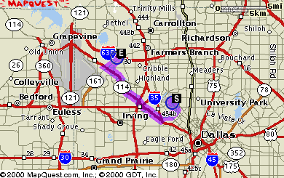

DIRECTIONS DISTANCE

1: Start out going Southeast on CEDAR SPRINGS RD. 1.1 miles

2: Turn SLIGHT RIGHT. 0.0 miles

3: Turn SLIGHT RIGHT onto W MOCKINGBIRD LN. 2.2 miles

4: Turn RIGHT onto E JOHN W CARPENTER FRWY. 0.6 miles

5: Turn SLIGHT LEFT to take the TX-183 W ramp. 0.1 miles

6: Merge onto TX-183 W. 1.5 miles

7: Take TX-114 W towards GRAPEVINE/D/FW AIRPORT NORTH ENTRY. 0.2 miles

8: Merge onto TX-114 W. 5.3 miles

9: Take the TX-161 exit. 0.3 miles

10: Merge onto W JOHN W CARPENTER FRWY. 0.1 miles

11: Turn RIGHT onto VALLEY VIEW LN. 1.4 miles

12: Turn LEFT onto LAS COLINAS BLVD. 0.2 miles

13: Turn RIGHT onto LAS COLINAS RDG. 0.1 miles

TOTAL ESTIMATED TIME: 23 minutes
TOTAL DISTANCE: 13.1 miles

FROM DFW AIRPORT TO HOTEL

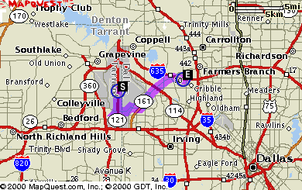

DIRECTIONS DISTANCE

1: Start out going South on INTERNATIONAL PKWY S by turning left (Portions toll). 1.8 miles

2: Take the ramp towards RENTAL CAR RETURN. 0.0 miles

3: Merge onto S SERVICE RD. 0.2 miles

4: Take the ramp towards EAST AIRFIELD DRIVE/AIRPORT ADMINISTRATION/AIRPORT PUBLIC SAFETY. 0.2 miles

5: Merge onto S AIRFIELD DR. 1.5 miles

6: Turn RIGHT onto W WALNUT HILL LN. 1.0 miles

7: Take TX-161. 4.6 miles

8: TX-161 becomes VALLEY VIEW LN/TX-161 N. 0.2 miles

9: Take the I-635 E ramp. 0.5 miles

10: Merge onto I-635 E. 0.2 miles

11: Take the LUNA RD exit, exit number 29. 0.5 miles

12: Turn LEFT onto LUNA RD. 0.2 miles

13: Turn LEFT. 0.0 miles

TOTAL ESTIMATED TIME: 21 minutes

TOTAL DISTANCE: 10.9 miles

FROM LOVE FIELD TO HOTEL

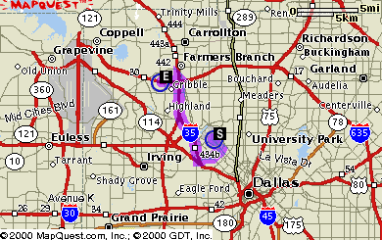

DIRECTIONS DISTANCE

1: Start out going Southeast on CEDAR SPRINGS RD. 1.1 miles

2: Turn SLIGHT RIGHT. 0.0 miles

3: Turn SLIGHT RIGHT onto W MOCKINGBIRD LN. 2.0 miles

4: Turn SLIGHT RIGHT. 0.0 miles

5: Turn SLIGHT RIGHT onto N STEMMONS FRWY. 0.0 miles

6: Turn SLIGHT LEFT to take the I-35E N ramp. 0.1 miles

7: Merge onto I-35E N. 6.4 miles

8: Take the I-635 W exit, exit number 440C, on the left towards D/FW AIRPORT. 0.4 miles

9: Merge onto I-635 W. 0.9 miles

10: Take the exit, exit number 29, towards LUNA RD. 0.3 miles

11: Merge onto LYNDON B JOHNSON FRWY. 0.1 miles

TOTAL ESTIMATED TIME: 20 minutes
TOTAL DISTANCE: 11.5 miles

FROM DFW TO COOL RIVER CAFÉ

1045 Hidden Ridge Road, Las Colinas TX 75038

Take the north exit out of the airport

Take Hwy 114 East toward Dallas

Travel approximately 4 miles and exit MacArthur Boulevard

Turn right at the light and travel south for 2 miles

Cool River is located on the left at the intersection of Hidden Ridge Road and MacArthur Boulevard

