Map to The St. Regis

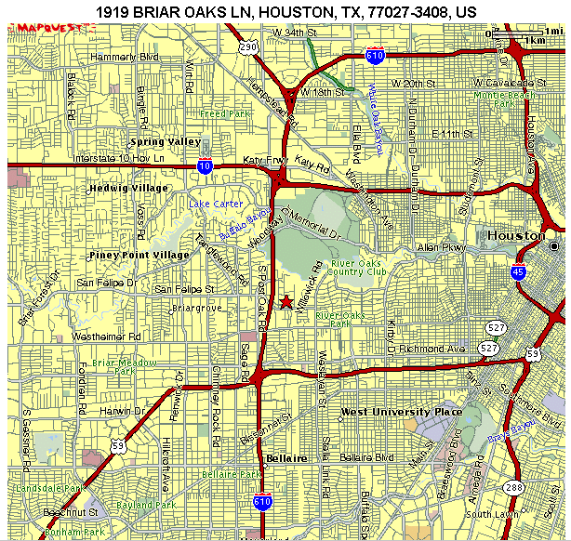
If you are driving North on 610, exit San Felipe and make a right on to San Felipe. You will pass Post Oak Park Dr. and the next street will be Briar Oaks Lane. Take a left on Briar Oaks Ln. The St. Regis will be on your right.

If you are driving South on 610, exit San Felipe and take a left on to San Felipe. You will pass Post Oak Park Dr. and the next street will be Briar Oaks Lane. Take a left on Briar Oaks Ln. The St. Regis will be on your right.

