

Merlin Offshore Holdings Inc. (the "Company" or "Merlin") is a Cayman Islands company formed in March 1999 for the purpose of owning and operating mobile offshore production units (“MPU's”). The Company was initially capitalized with an equity placement of approximately $7.3 million by a group of private investors including members of management. Merlin's management is led by its founder and chief executive officer, Steven R. Meheen. Merlin has one wholly owned subsidiary, Merlin Production Inc., headquartered in Houston, Texas.

To date, Merlin's business activities have been focused on analyzing the MPU market, developing a business strategy and senior management team, identifying assets for acquisition and developing a design for mobile offshore liquefied natural gas ("LNG") liquefaction and regasification facilities.

Merlin believes that an independent contract production industry will develop over the next several years that will be larger than the current offshore contract drilling industry which has a current equity market capitalization in excess of $45 billion. Historically, almost all MPU's have been owned and operated by major and large independent oil companies or state oil companies. The growth in the independent contract production industry will be driven by growth in the worldwide production of oil and gas offshore and an increased emphasis by the oil and gas producing industry on improving returns on capital employed. Outsourcing and asset sales are the means by which they have attempted to improve returns.

MERLIN'S GOAL AND STRATEGY

Merlin's goal is to build an industry leading, publicly owned, independent MPU contracting business that will generate equity returns at or near the top of the range of those returns generated by other oilfield contracting businesses. Merlin's strategy is to:

- Acquire existing MPU assets at or near the end of their initial deployment and re-contract these units at higher returns.
- Build high-capacity new floating production units below replacement cost pursuant to long-term contracts utilizing existing vessels or hull structures that have substantial remaining fatigue-life. These units would be intended to be deployed in areas where additional incremental oil and gas production could be developed and tied-in.
- Develop a proprietary design to build and operate several new offshore LNG liquefaction and regasification facilities pursuant to long term contracts.

MERLIN'S QUALIFICATIONS

Merlin has assembled a senior management team with over 150 years of energy industry experience. This team's experience spans all disciplines necessary to successfully run a growing energy service company. Most significantly, this team is the same core management team that previously built Falcon Drilling Company's deepwater drilling business from scratch in 1995 to one of the industry's largest in 1997 at the time of its merger with Reading & Bates Corporation. During this period, Steve Meheen and his team identified the market opportunity for new deepwater drilling capacity, and acquired the assets, personnel and contracts necessary to build a successful deepwater contract drilling business.
 | Position | Age | Energy Industry Experience
Steven R. Meheen | President/CEO | 42 | 21
Robert F. Fulton | Exec. Vice President/CFO | 49 | 21
Steven E. Souza | VP Human Resources/Admin | 55 | 32
Steven A. Allaire | VP Business Development | 46 | 25
J. Bryce Donaldson | VP Health, Safety & Environment | 39 | 13
Rolf Meier | Operations Manager | 56 | 33
Vernon G. Westerhout | Manager, Special Projects | 42 | 20
Sumanohar N. Muddusetti | General Manager (Asia) | 42 | 15

Steven R. Meheen (42) – President and Chief Executive Officer

Mr. Meheen is the founder of Merlin. He was Vice President of the R&B Falcon Corporation (1998) in charge of South American Operations and Worldwide Projects. Prior to the Reading & Bates and Falcon Drilling merger in 1998, he served as Executive Vice President of Falcon Drilling Company, Inc. in charge of Worldwide Deepwater Operations, Projects, and Business Development. Prior to joining Falcon Drilling, he was a consultant with Mobil Oil Company (1993-1994), Chief Operating Officer of Maretech Ocean Services (1991-1993), General Manager with Pars Global (1988-1991), and served in various management and engineering capacities with Santa Fe International (1979-1988). He holds a B.S. in Ocean Engineering from UCLA (1978).

Robert F. Fulton (49) - Executive Vice President and Chief Financial Officer

Mr. Fulton was Executive Vice President-Finance for R&B Falcon Corporation and Chief Financial Officer of Falcon Drilling Company (1995-1999), prior to joining Merlin. Prior to joining R&B Falcon, he was Vice President-Finance of Noble Drilling Corporation and Senior Vice President and Chief Financial Officer of Chiles Offshore Corporation (1991-1995). From 1985 through 1990 he served as a commercial banker for Bankers Trust Company and First City National Bank of Houston. Prior to 1985 he served as Vice President-Finance for Anderson-Myers Drilling Company. He holds a B.S. in Accountancy from the University of Illinois and an MBA from Northwestern University.
Steven E. Souza (55) – Vice President of Human Resources/Administration

Mr. Souza was previously Human Resources Manager for R&B Falcon Corporation (1997-1998). Prior to R&B Falcon, he was Superintendent of Area Offices for the Kuwait Foreign Petroleum & Exploration Company (1995-1997), Personnel Director for the Kuwait Santa Fe Company (1991-1995), self-employed (1988-1991). From 1966 to 1988 he was with Santa Fe Drilling Company: HR Manager of the drilling division Alhambra, California (1985-1988), Regional HR Manager Europe & Africa based in London (1978-1985), Regional HR Manager, Middle East based in Bahrain & Saudi Arabia (1975-1978), held various human resources and administrative positions (1966-1975). He studied for a B.A. at the University of Alberta, Canada.

Steven A. Allaire (46) – Vice President of Business Development

Mr. Allaire was Manager of Sales/Marketing at R&B Falcon Corporation (1998). Prior to the merger with Falcon, he served as Manager of Marketing at the Reading & Bates Drilling Company (1994-1997) and spent 18 years with Cameron Iron Works as Territory Sales Manager in Rio de Janeiro, Brazil (1991-1994), Technical Marketing Representative in New Orleans, La. (1988-1991), and Sales Representative in Stavanger, Norway (1986-1988), Aberdeen, Scotland (1982-1986), London, England (1980-1982) and Houston, TX. (1976-1980). He holds a B.A. from Texas A&M University.

J. Bryce Donaldson (39) – Vice President of Health, Safety, and Environment

Prior to joining Merlin, Mr. Donaldson was Manager of HSE-North and South America, for the R&B Falcon Corporation (1998). Prior to 1998, He was Manager of HSE & Quality for Falcon Drilling Company (1995-1997), owner of BR Communications Ltd., a safety consultancy to the oil and gas industry (1994-1995), Safety Officer of Manning Services Australia Ltd. (1992-1993), Safety Officer/Medic of Premium Drilling (1990-1992), and held various operational and safety positions for Maretech Ocean Services, Maersk Drilling and Westbridge Drilling from 1986-1990. He served in the military from 1980-1985.

THE MPU MARKET

Merlin believes that the offshore production contracting business is entering a period of rapid growth. This growth will be driven by several significant industry trends:

- First, and most important, oil and gas production companies are increasing their commitment to deepwater offshore production to take advantage of large prospects that can now be drilled and produced as a result of recent industry technological innovations. These drilling and production technology innovations have also reduced expected field life, which reduces the attractiveness of investing in non-mobile facilities due to the high cost of field abandonment.

- Second, oil and gas producers are attempting to improve their returns on capital employed by limiting their capital expenditures on non-oil and gas "iron" assets. Merlin believes that this trend will drive the oil and gas production contracting business to evolve in a manner similar to the offshore contract drilling business. Offshore drilling began in the 1940's and 1950's primarily as an internal department of the larger oil companies. This commitment of capital was found to be inefficient. These internal drilling departments were spun off or sold and became the foundation of today's independent contract drilling industry. Almost all offshore drilling rigs are now owned and operated by independent contractors. The primary difference between offshore contract drilling and offshore contract production is the duration of customer need. Offshore oil and gas wells are typically drilled in 30-180 days. Offshore production facilities are needed for the life of a field, which can extend for 15 years or longer. A second meaningful difference between offshore contract drilling and offshore contract production is that an offshore drilling rig works for only one customer at a time, whereas an offshore MPU can serve as a hub facility processing production for more than one customer. This difference provides a production contractor with the opportunity to realize enhanced returns through third party processing agreements.

- The third industry trend that will drive the growth of the independent production contracting business is the emergence of natural gas as a worldwide energy commodity rather than a localized fuel source. Abundant supplies of natural gas reserves exist worldwide. However, like oil, they do not often exist near end use markets. Historically, due to the high cost of transportation, natural gas reserves were only developed when and if a local market for the fuel became apparent. As a result, natural gas became a less valuable commodity than oil despite the fact that it is the most environmentally friendly of all hydrocarbon fuel sources. Today, the outlook for worldwide natural gas consumption has changed dramatically. Driven by growth in the electricity generation sector and environmental concerns, natural gas is expected to be the fastest growing worldwide fuel source over the next twenty years.
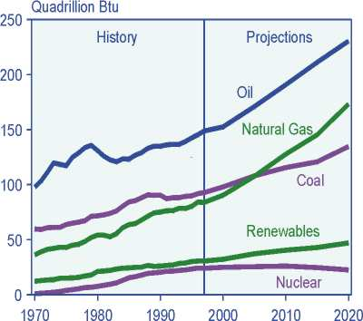
Source: Energy Information Administration
International Energy Outlook 2000
WORLD ENERGY CONSUMPTION BY FUEL TYPE

Natural gas is expected to displace coal as the world's second leading source of energy after oil by the middle of this decade.

An independent offshore oil and gas production contracting business began to emerge in the mid 1980's after world oil prices collapsed and technological innovation began to extend the industry's reach in to deeper water depths. Most of the MPU's built and installed since that time have been owned and operated by the oil and gas producers who found and developed the field. Many of these units are now becoming available as they have come to the end of their original employment. In addition, many other requirements for units are emerging as a result of the industry's recent exploration success in West Africa, Brazil, the U.S. Gulf of Mexico and south east Asia.

Merlin plans to develop its MPU contracting business in two market segments - existing MPU's and the construction of new mobile offshore LNG liquefaction and regasification units. Existing MPU's present the opportunity to acquire long-lived assets that will generate substantial returns on redeployment. These units typically have processing plants large enough to facilitate redeployment on new fields. Merlin has identified a pool of MPU acquisition candidates that it believes provide substantial earnings potential and which it believes can be acquired at values significantly below replacement cost. Acquisition proposals have been made to several of the existing MPU owners and negotiations are underway.

Development of offshore LNG facilities provides Merlin with an opportunity to participate in what could be the industry's most rapidly growing segment. Merlin, in conjunction with Moss Maritime, a leading maritime engineering firm that pioneered the development of LNG gas carriers, has developed a design for both an offshore LNG liquefaction vessel and offshore regasification vessel.

INDUSTRY BACKGROUND

After oil and gas has been discovered in sufficient quantities to be deemed worthy of production, a production facility must be put in place as near as possible to the wells that are to be produced. A production facility is a system of separators, heaters, compressors, pumps, pipes, meters and tanks designed to condition well stream fluids for safe transport. Natural gas is separated from oil. Water, hydrogen sulfide, carbon dioxide and produced solids are reduced to levels acceptable for transport and disposal. The size, complexity and cost of a production facility is determined by the quantity and quality of oil and gas to be produced. The lower the oil’s specific gravity and the higher the impurities, the greater the cost of a production facility.

Oil and gas was first produced offshore in 1938. Producing oil and gas in an offshore marine environment requires the installation of a structure on which the production facility can be located. Early offshore production structures were simple, fixed platforms secured to the ocean floor with a production deck above water level. As world energy demand increased, technological and engineering advances made it possible to find and produce oil and gas in progressively greater water depths. Today, oil and gas is being produced in water depths greater than 6000 feet.

As offshore oil and gas production moves to greater water depths, the cost of fixed platform installations increases exponentially. Today, the deepest offshore production via fixed platform is approximately 1,800 feet the U.S. Gulf of Mexico. The cost of this unit was in excess of $200 million and was installed in 1999. Merlin estimates that the cost to dismantle and dispose of this unit could exceed $50 million. In addition, over time the application of new technologies such as 3D seismic and horizontal drilling has enabled oil and gas producers to locate smaller fields and produce them more rapidly. These advances have reduced the attractiveness of fixed installations in favor of mobile production units that can be re-deployed for future use rather than dismantled.

The worldwide count of MPU's today totals 139 units consisting of five main types - jackups (20), semi-submersibles (40), spars (3), tension-leg platforms (12) and ship-shaped, Floating Production Storage & Offloading (FPSO) units (64). The preferred type of unit for a particular field depends upon marine environmental conditions, size of field, and the need for well-site storage. Offshore oil and gas provinces with a well developed pipeline infrastructure such as the U.S. Gulf of Mexico and the North Sea have been the primary users of floating production semi-submersibles (FPS’s), spars, tension-leg platforms (TLP’s) and fixed platforms. Offshore oil and gas provinces without well-developed local energy markets or that cannot access an existing pipeline grid, employ primarily FPSO's to facilitate exports via shuttle tanker. Currently FPSO’s are not permitted to operate in the U.S. Gulf of Mexico. The Minerals Management Service of the Department of Interior is reviewing the suitability of FPSO’s for use in the Gulf as industry sees the FPSO as an economical alternative to technical problems and excessive cost of laying pipelines in water depths beyond 5,000 feet. Merlin believes that FPSO’s will be approved for use in the U.S. Gulf of Mexico.

One of the biggest obstacles that oil and gas producers face when developing large offshore oil fields is the disposition of associated natural gas which is commonly found with crude oil. A necessary part of crude oil production is the process of separating out the natural gas from the crude oil. This process is necessary so that the crude oil can be stabilized and made safe for transportation via pipeline or tanker. In areas where a large natural gas pipeline infrastructure exists, oil fields with commercial quantities of associated natural gas will be produced into the pipeline system. In oil fields with quantities of associated natural gas too small to justify the costs of pipeline tie-in, produced natural gas is either flared, i.e. burned off, or injected back into the producing reservoir. In some jurisdictions, like the U.S. Gulf of Mexico, flaring is prohibited by regulation. Although generally permissible by regulation, re-injection of produced natural gas is not an ideal solution. Re-injection requires a significant capital investment for on-site compression equipment. In addition, depending upon individual reservoir characteristics, re-injection can impair the oil producing capability of a reservoir. Large quantities of re-injected gas at high pressure can displace oil in place and potentially reduce the ultimate recoverability of a reservoir.

Many of the recently announced significant offshore oil discoveries are located in areas where no significant local natural gas market or pipeline infrastructure exists. Other large natural gas-only discoveries have also been made in the same or similar areas. Today, over 900 million standard cubic feet per day (a btu equivalent of 150,000 barrels of crude oil) of natural gas is being flared offshore Angola alone. Finding a solution to the natural disposal problem is both an economic and environmental issue facing the oil and gas producing industry.

MPU ECONOMICS

The mobile production business is capital intensive. Annual operating costs are relatively small compared to the capital cost of a new unit. The main components of operating costs are labor, repairs and maintenance, insurance, catering, crew transportation, fuel and communications. Unit operating costs do not vary significantly with production. Operating costs vary from unit to unit depending upon crew size, location, and unit complexity. On a daily cash basis, operating costs can range from as low as $8,000 per day to as much as $40,000 per day. Crews typically work 28 days on and 28 days off requiring two crews for each operated unit. Merlin plans to operate units with crew sizes ranging from 15 to 35.

The capital cost of new MPU's is made up of three major categories: the cost of the production plant, the cost of the vessel or structure including mooring and the cost of integrating the production plant with the vessel or structure. The overall estimated newbuild cost today depends on the size and complexity of the unit and can be expected to range from $100 million to in excess of $500 million.

Historically, many MPU's have been constructed from conversions of existing assets, either drilling rigs, accommodation units or crude oil tankers. Converted units can represent a cost-effective alternative to newly constructed units. The most important consideration is the integrity of the hull structure, as these units must be certified to remain on locations for ten or more years. Fatigue-life is a critical element of this certification. Det Norske Veritas (DNV), a leading maritime classification society, has done extensive work on fatigue-life studies of tankers that are trading and being considered for conversion to FPSO service. DNV has also determined that the single-hull construction, rather than double-hull, is better suited for FPSO service on Very Large Crude Carriers (VLCC) due to accessibility for maintenance purposes of all spaces in a single-hull vessel. Merlin has conducted preliminary surveys on several suitable tanker candidates for conversion and has contracted DNV to conduct fatigue-life studies as part of the selection process.

LNG MPU ECONOMICS

LNG is one of the most capital-intensive segments of the energy business. In addition to the exploration and development costs associated with all oil and gas activities, LNG requires a significant additional investment in specialized liquefaction,
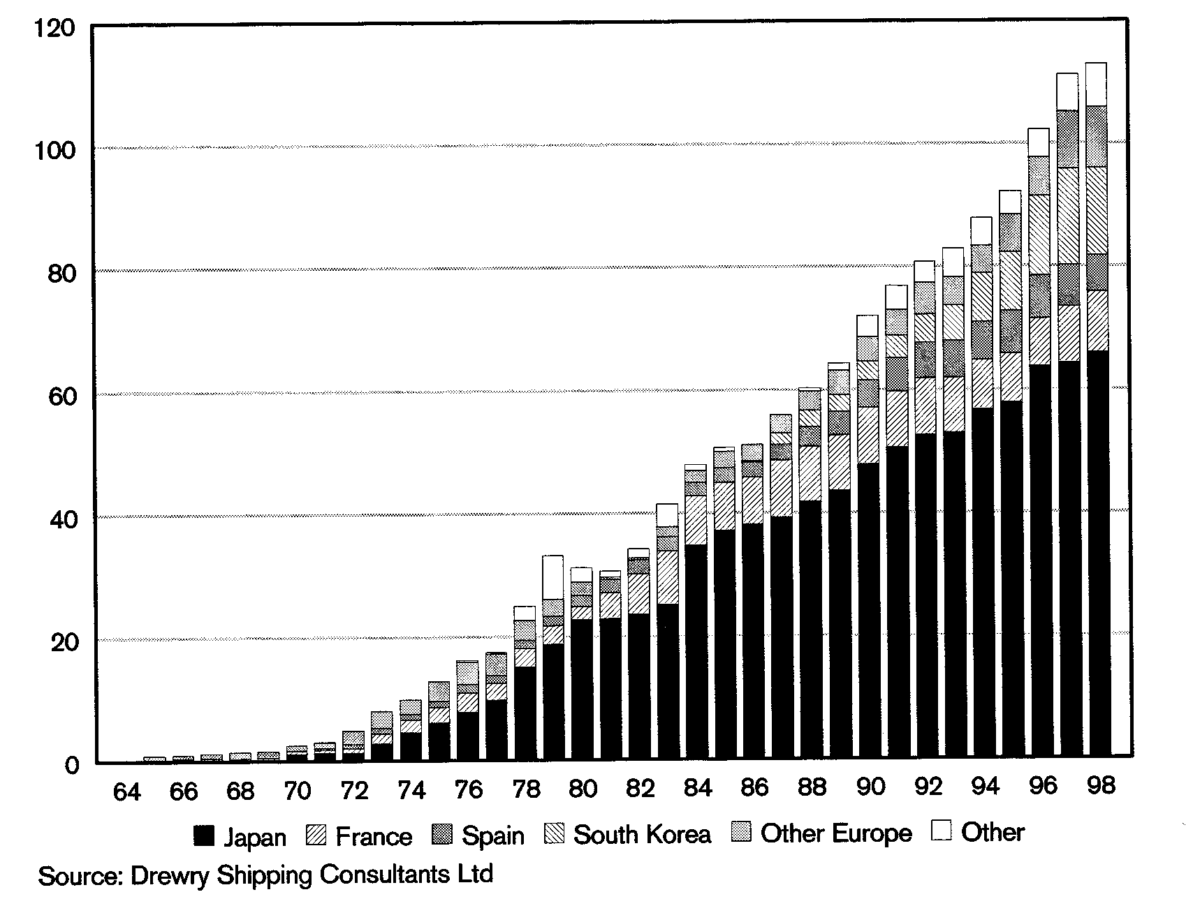
transportation and regasification facilities. The technology to liquefy natural gas has existed for some time. The U.S. issued a patent in 1914 for the carriage of gas by barge. In 1964 the first commercial delivery of LNG was made from Algeria to England. LNG trade has grown steadily over the subsequent years. By 1998 the world's annual LNG trade had grown to the equivalent of 113 billion cubic meters of gas which equates to approximately 4 Tcf of gas per year. This represents approximately 15% of total current U.S. gas consumption.

LNG IMPORTS (BILLIONS OF CUBIC METERS OF GAS EQUIVALENT)

Japan accounts for approximately 58% of all LNG imports. Indonesia, Algeria and Malaysia are the world's largest LNG exporters.

As of June 1999, there were 27 liquefaction plants worldwide, all shore based, representing approximately 115 million tons per annum of capacity. In addition, 17 new plants or existing plant expansions are planned for start-up between 2001 and 2007 adding potentially another 105 million tons per year of capacity.

Historically, substantially all LNG trade has been conducted on a integrated term contract basis where end users have committed to long-term (20 year) take or pay contracts. During the 1990's a spot LNG market began to develop as producers have sought to maximize throughput and consumers have sought to dispose of excess supplies. For LNG to be profitable long term on a spot market basis, natural gas must sell for a high enough price per mcf ex-regasification to justify the expenditure in the facilities and pay for feed gas at the wellhead. With a high transportation cost component, LNG economics are very dependent upon the location of the feed gas.

Merlin believes that natural gas is becoming a global commodity energy source like oil. Deregulation of electric power generation and a substantial environmental advantage will continue to spur the growth of natural gas consumption. Over time, as natural gas markets mature, Merlin expects LNG to trade at a price close to the btu equivalent value of crude oil.

Increased demand for natural gas has also generated a need for mobile offshore LNG facilities. A significant portion of the world's stranded natural gas reserves lie offshore. In addition, environmental and economic considerations are leading to a prohibition on natural gas flaring. In many remote areas such associated gas production is simply flared (burned). Flaring of associated gas wastes a potentially valuable non-renewable commodity and produces significant greenhouse gases. This practice is banned in the U.S. Gulf of Mexico and in the proposed Kyoto accords.

Merlin in conjunction with Moss Maritime has developed a proprietary design for both offshore liquefaction and regasification. Both units are based on the same hull configuration and use existing proven technology. Merlin's offshore liquefaction vessel is designed to process up to 550 million cubic feet per day of natural gas intake and store up to 180,000 cubic meters of LNG. Merlin's offshore regasification vessel is designed to store up to 275,000 cubic meters of LNG and re-gas up to 500 million cubic feet of natural gas per day.

LNG FPSO LIQUEFACTION AND REGASIFICATION

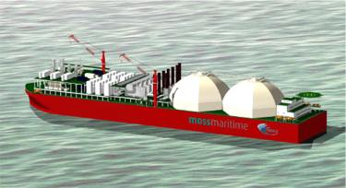
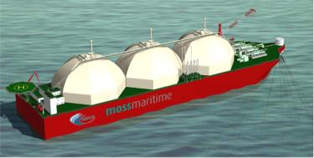

Offshore LNG facilities offer several advantages over conventional shore based facilities.
- As movable units, they can be re-deployed at low cost to either a new resource location or end user market.
- Offshore facilities are less likely to be affected by local political instability.
- Offshore locations are safer to both people and the environment.

CUSTOMERS AND CONTRACTS

Almost all contracts for MPU's are competitively bid through a tender process. The tender process usually involves pre-qualification, technical review and commercial bid. This process can take from several months to a year or more. Customers for MPU's are oil and gas production companies, including the major international firms, independent producers and state oil companies.

Contracts for MPU's are typically negotiated for a specified fixed term and may include renewal options in favor of the producer. There is no meaningful spot market for MPU's. Occasionally, units may be contracted for short periods of time to serve as early production test units. The cost of mobilizing a unit from one location to another is typically borne by the customer.

Pricing for production services under an MPU contract can be based on a daily rental rate, throughput fee or both. Production services contracts are operating contracts not bare-boat charters. Contract terms typically include operating warranty provisions that require the contractor's equipment to be available to process the client production 95% of the time under contract. Downtime in excess of the minimum allowable usually triggers penalty provisions in the contract that result in a reduced daily contract service fee.

MARKET OUTLOOK

Offshore oil and gas production has become a major source of the world's energy supply. Technological advances have pushed offshore oil and gas production into deeper waters. In North America, U.S. deepwater (1,000 ft.) offshore oil and gas production's share of total offshore production increased to approximately 45% in 1999 from 4% in 1989. Internationally, offshore production accounts for substantially all oil and gas production in Northern Europe and accounts for a growing percentage of production in West Africa, Brazil and South East Asia. West Africa recently achieved the world’s largest offshore deepwater discoveries while Brazil holds the record deepwater production at over 6,000 feet.

The world's offshore oil and gas provinces have garnered an increasing share of the industry's exploration spending since the late 1930's when offshore oil and gas production first began. Over time, onshore prospecting has become less attractive as available acreage has become increasingly picked over with large new exploration prospects increasingly difficult to find. Offshore provinces are more attractive because they are less exploited than onshore prospects and offer large, exclusive exploration areas through competitive lease sales or negotiated concessions with national governments. In addition, offshore production reduces an oil and gas producer’s exposure to the politically motivated onshore domestic supply disruptions that occur in many of the world's oil and gas exporting countries.

Offshore oil and gas prospecting received a significant boost in the early 1990's with the widespread application of new, powerful computer-aided seismic data acquisition and processing technologies. These technologies allowed oil and gas producers to more accurately map subsurface prospects and reduce their dry-hole risk. This reduction in risk coupled with an improved oil and gas commodity price environment has lead the producing industry to increase its exploration spending offshore. This increase in exploration spending has resulted in numerous, new offshore oil and gas discoveries that will require MPU's to be installed in the future.

There are presently over 200 floating production systems either planned or under study. A conservative estimate by industry analysts indicates that the worldwide fleet of floating production systems could increase from approximately 139 units today to in excess of 200 units by 2005. In addition, Merlin estimates that more than half of the 95 MPU's currently owned by oil companies could be sold during this period. This turnover can be attributed to two main reasons. The first, a desire on the part of the oil companies to monetize these assets and continue to employ them on a contracted basis. Second, sales of these assets allow the oil company owners to minimize or eliminate disposal costs giving predictability to the task of winding-up joint ventures following field abandonment.

COMPETITORS

The offshore contract production industry is fragmented and has no dominant industry leader. There are two major segments of MPU owners, oil company owners and independent contractors. As of June 2000, independent contractors owned 44 units or 32% of the worldwide fleet of 139 MPU's. The largest independent contractor with seven units is SBM Production Contractors, a wholly-owned subsidiary of IHC Calland N.V., a large Netherlands based holding company whose subsidiaries provide services to the offshore oil, dredging and marine industries.

MPU FLEET
*=some units partially owned

JPU = Jackup Production Units
TLP = Tension Leg Platform
FPS = Floating Production Semi-submersible
FPSO = Floating Production Storage and Offloading

Oil companies who own MPU's built them to service their own producing fields. Petrobras, the Brazilian national oil company, is the largest owner with 24 units. Oil company owners typically have not pursued redeployment once a unit has completed its service on an exiting field. Historically, upon completion of their initial service, oil company owned MPU's have either been sold or scrapped.

BOARD OF DIRECTORS

Merlin Offshore Holdings Inc. was organized in the Cayman Islands on February 22, 1999. The Cayman Islands was chosen as the jurisdiction for organization due to its favorable corporate income tax regime. Merlin's Articles of Association provide for a Board of Directors composed of seven persons each to be elected by the members (Appendix 4). Merlin's current Board of Directors is composed mainly of individuals with extensive oil and gas industry experience who were also initial shareholders in the Company. They are:

Non-Executive Members:

Juan H. Kelly - Chairman of the Cammell Laird Group. Former Managing Director of Shell International Marine Co. Ltd of the Royal Dutch Shell Group.

Desmond Watkins - Former Director of Shell International Petroleum Co. Ltd, former Managing Director (Equity Investments) Citibank N.A.

Barry Finnegan - Principal, Finnegan Design Group. Former executive with British Airways. Representative for Merlin’s largest group of investors.

Kenneth T. Hern - Former President Texaco Producing Company (Brazil and Nigeria).

Daniel P. Sullivan - Principal, Ocean Trades & Shipping Ltd. Former Vice President Irving Trust Company N.Y.

Executive Members:

Steven R. Meheen - President and Chief Executive Officer of Merlin.

Robert F. Fulton - Executive Vice President and Chief Financial Officer of Merlin.

