WEATHER RISK By Ross McIntyre and Stephen Doherty
There is further evidence, this time from the UK, for a single pricing method for weather derivatives.

An Example

from the UK

The weather derivatives market is a highly specialised field. A small number of participants have derivative desks that employ specialist mathematicians evaluating the fair value of weather derivative contracts. But few players are interested in revealing their sophisticated proprietary models, which creates problems.

There is little transparency to the market. Potential hedgers may not enter the market because they do not know how to price the instruments that they are buying. How can they determine fair value – the ask price can be two or three times the bid price – or marked-to-market if they do not have a model? Secondly, even if the major players distributed their models they would be useless. Hedgers would need to employ a rocket scientist to use them.

The market is therefore on a cusp. In one direction leads the path to liquidity and transparency, where a secondary market exists and hedgers and speculators sit side by side. The other path leads to a stagnant market, created from a lack of price discovery. This could cause weather derivatives to be a permanently illiquid tailored insurance product.

To avoid the latter and attract more participants a relatively unsophisticated treatment for the core weather products needs to be accepted by the hedgers and speculators. This article aims to show that empirical evidence for a simple model exists. The model belongs to the family recently conjectured by Bob Dischel (see EPRM October 1998, Special Report Weather Risk and EPRM March 1999). He showed how a form of this equation could be used by a trader to evaluate fair value. This article provides the reason why it is valid.

The weather derivatives market has evolved around temperature derivatives, and specifically heating degree-days – although there can also be cooling degree-days. Degree-days are a measure of one day’s temperature against a standard reference temperature. This model is able to evaluate the fair value for heating degree-day derivatives as well as the more exotic payoffs that are structured for highly specialised requirements. A typical example of a specialised payoff that the model can evaluate is one where the holder of the option receives a sum of money if on four consecutive days the average daily temperature is above a certain level. Otherwise the option expires worthless.

It is worth reiterating here that one cannot use classical Black-Scholes option theory because most importantly there exists no underlying commodity to hedge with and the daily returns are not log normally distributed. Whereas the latter is an irritation to the derivation of a closed-form solution using the Black-Scholes technique, the former means that one cannot create a risk-free portfolio by combining the derivative with its underlying. The treatment of Black-Scholes to evaluate weather derivatives is not valid - one cannot buy or sell sunshine.

In establishing the evidence for a simple model we must choose data that is meaningful and representative of a greater sample. This demand ensures that the results presented below provide an understanding of both its data and of the generic class it belongs to. We focus on the UK, where the weather derivatives market is in its fledgling state. There has only been a handful of trades and these have been focused on energy companies hedging against a fall in cumulative heating degree-days. Unlike the US, the UK’s daily average temperature may be sufficiently correlated as to allow the choice of one locality to be representative for the largest proportion of traded temperature related contracts. The focus of participants on one index – locality – increases the liquidity of the contracts. As liquidity deepens bid-offer spreads tighten and the prices of the contracts settle to equilibrium.
If one index does evolve for UK temperature derivatives then participants in the market may face basis risk. This is the financial error that results from using the index site as a proxy for the area requiring the hedge. Due to the high correlation of UK temperatures across all regions this basis risk will be relatively small. Furthermore, the economic disadvantage that may remain from the basis risk is compensated by the economic advantage of tight bid-offer spreads and liquidity. The bond futures market is testament to this behaviour: 10-year futures are used to hedge areas of the yield curve where non-parallel, but correlated, shifts occur.

The south-east of England is a natural choice for the representative locality. It is densely populated, and has companies that are economically exposed to both heating degree-days and cooling degree-days. Using data from the UK Meteorological Office’s Heathrow weather site – situated in south-east England – figure 1 displays the time series plot of the daily average temperature for the for the last 35 years.

Figure 1.

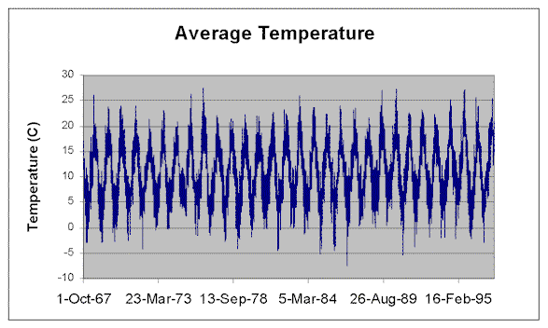

The apparent repetitive nature of the above becomes clear by viewing the autocorrelation function of the data (see figure 2) The autocorrelation function (ACF(k)) of a time series $X_{t}$at lag$k$, is defined to be the covariance between $X_{t}$ and $X_{t−k}$ normalised by the variance of the time series. Thus for each lag k, the ACF(k) gives the linear correlation between the time series and the time series k units later. The overall structure of the ACF is more important than any individual value. The Heathrow temperature data (Figure 2) displays highly significant autocorrelation at large lags. The recurring maxima of the ACF provide evidence that the time series is periodic with a period of around 365 days. Significant correlation at large lags indicate that the time series has a long-term memory. I.e. one cannot ignore what has happened in the past to understand the future.

Figure 2.

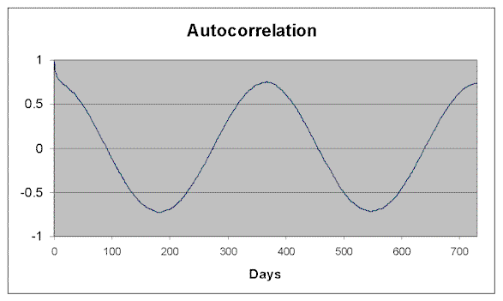

This memory effect is further quantified with the nonlinear technique of Hurst exponents$(H)$. Hurst exponents give a measure of whether a trend will persist or mean revert to some historical average. The values at the beginning of a time series are as important to the dynamics as the most recently observed.

A truly random time series will have a Hurst exponent of a half. An exponent that lies between a half and one, describes a dynamically persistent, or trend reinforcing series. As $H$approaches one the certainty increases as to the direction of change that has been currently seen will continue. A straight line with non-zero gradient will have a Hurst exponent of one. An exponent that lies between zero and a half describes an anti-persistent, or mean reverting system. At the limit of zero the time series must change direction every sample.

For the Heathrow weather data, there exists two distinct regions pivoted around a sample size of 365. The first region for data samples of size less than 365 days produces a gradient close to one. This means that in any 365-day sample the average daily temperature is likely to persist. The second region has a Hurst exponent of 0.25. This indicates an anti-persistent or mean reverting process.

The marked discontinuity is strong evidence of a cycle. Physically, this corresponds to the inescapable movement of the seasons around the solar cycle. Typically the cycles indicated by nonlinear techniques are non-periodic. However, with there being persistent periodic maxima in the Autocorrelation function at around 365 days, we can, for simplicity, assume that the temperature on each date tries to revert to its annual historical average.

Figure 3.

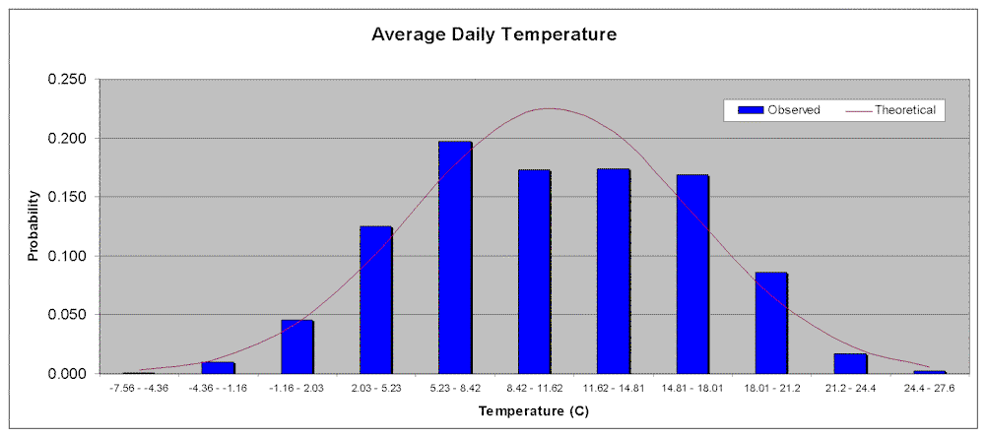

The distribution implied by Figure 1 is displayed in Figure 3 alongside the theoretical normal distribution with mean and standard deviation evaluated from the observed time series. The observed distribution is not too dissimilar to the normal distribution. Moreover, the daily change in temperature also has a distribution that displays a striking similarity to the normal. It is desirable to assume a normal distribution because of the mathematical tractability it gives when implementing a model to discover an options fair value.

The mathematical model that we wish to find must be able to reproduce the above temperature characteristics. It does not have to predict the weather, which is a deterministic problem that uses a highly sophisticated branch of mathematics called chaos theory. With reproduction and not prediction as our aim we can describe the main characteristics by assuming that temperature follows a random process. Temperature derivatives can then be evaluated by finding a suitable stochastic differential equation. The simplest equation that allows negative temperatures and satisfies the above empirical evidence is

(1)
$$\text{dT}=α\left(θ(t)−T\right)\text{dt}+σ\text{dz}$$

where $α$is a constant that represents the rate at which the daily average temperature, $T$, reverts to its historical average $θ(t)$. The parameter $θ(t)$is the time-varying daily average temperature averaged over its anniversary dates. $σ$is the volatility and $T$ is a variable that follows a Wiener process. i.e. $\text{dz}$ is a random variable, drawn from a Normal distribution with a mean and variance of the order $\text{dt}$. Eqn 1 resembles Vasicek’s model for interest rates. Vasicek showed that his equation could be used to obtain a closed-form expression for the price of a zero-coupon bond. In its discrete form Eqn 1 may be written similar to the simplified Dischel equation

(2)
$$\begin{aligned}T(t+δt)=T(t)+δT \\ =αθ(t+δt)+(1−α)T(t)+σ\sqrt{δt}ε\end{aligned}$$

Where $ε$is drawn from a standardised normal distribution. On implementation of his equation, Dischel used the observed distribution of the average temperatures (see EPRM March 1999). Also note that Dischel imposes on his equation that $β=1−α$. Hence, $β$can be substituted out of his equation. Using standard Monte Carlo methods, it is easy to implement Eqn (2) to evaluate any option payoff based on average daily temperatures. One simply puts the latest value of $T(t)$ and $θ(t+δt)$ into the right-hand side of Eqn 2 to calculate the next value $T(t+δt)$. This is then repeated at the next time step to build up a simulation path. This enables the payoff for a derivative to be evaluated. Lastly, the simulated path itself is repeated many times to average the derivatives value. Dischel described how such methods could be used to discover fair value for an option payoff and illustrated with a heating degree-day option.

The above model is easily simulated in code or spreadsheets, reproduces the underlying distribution and describes the dynamics of the time series. Importantly, there are only a small number of parameters to assign values to. It also uses the mathematics that financial players have grown up with in the last 30 years.

The authors acknowledge The Meteorological Office for the Heathrow weather data.

Ross McIntyre and Stephen Doherty are directors of Speedwell Derivatives Ltd in London. Speedwell provides consultancy and niche software for Capital, Money, Foreign Exchange and the Weather markets.

E-mail: ross@speedderivs.com
joe@s-a-l.com

Web: www.speedderivs.com

Tel: +44 (0)171 929 7979

Fax: +44 (0)171 929 181

A full discussion of Hurst exponents, including the mathematics, is found at www.speedderivs.com

